­­­

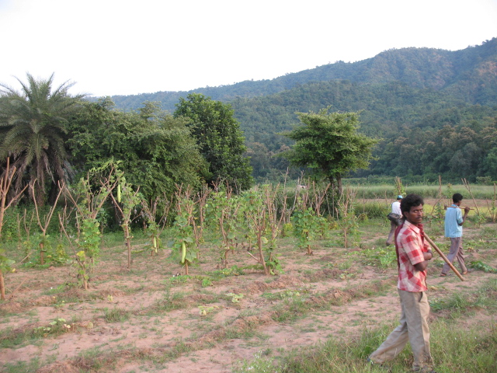

a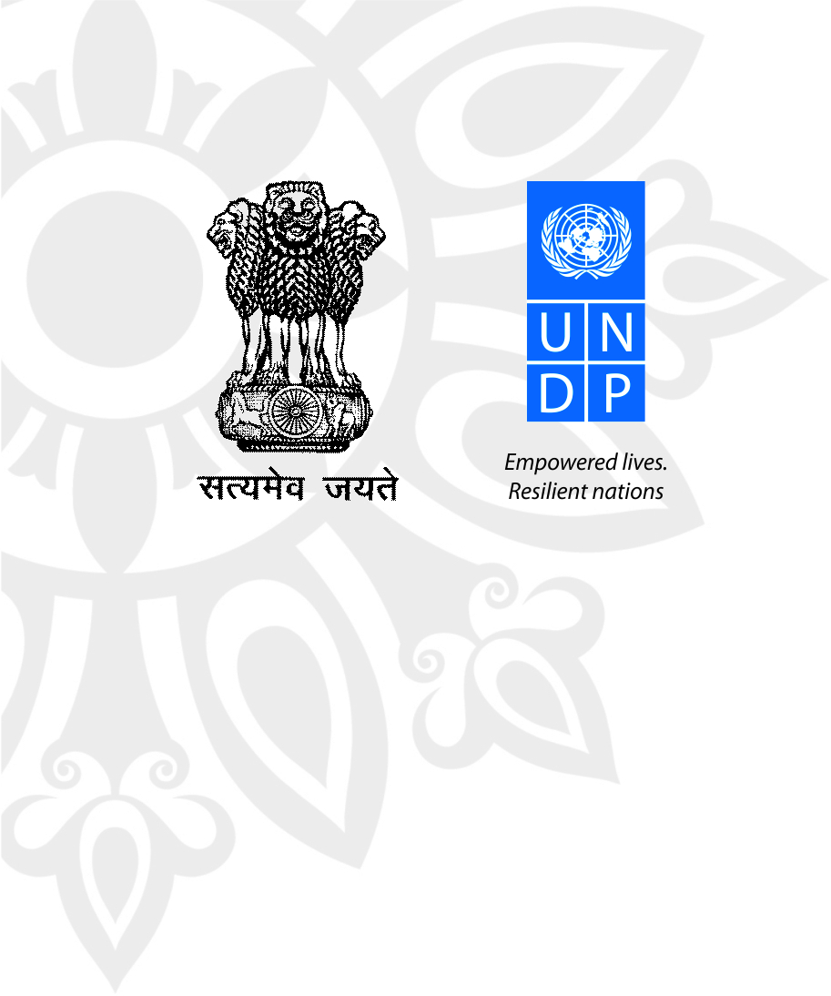

**Millennium Development Goal:**Goal no.7: Ensure Environmental Sustainability

**Integrated Land and Ecosystem Management to Combat Land Degradation and Deforestation in Madhya Pradesh**

**Relevant India Development Goal:**

As a signatory to the United Nations Framework Convention on Climate Change, United Nations Convention to Combat Desertification and the Convention on Biological Diversity, India is committed to meet objectives under these agreements to address the impacts of climate change, biodiversity loss and desertification

**Targets:** Integrate the principles of sustainable development into country programmes and reverse the loss of environmental resources

**Project Background**

Madhya Pradesh encompasses a major part of the highlands of Central India and constitutes parts of the upper catchments of five principal river systems – the Yamuna, Ganga, Mahanadi, Godavari and Narmada. It is endowed with rich and diverse forest resources with forest types ranging from dry thorn, dry and moist deciduous to sub-tropical semi-evergreen and tropical moist evergreen forests.

Despite the thrust towards watershed development in the last decade, catchments continue to degrade and rates of soil erosion continue to be high in the State with negative downstream externalities. Unsustainable land management practices, especially deforestation and overgrazing, have been both cause and consequence of the livelihoods crisis among tribal and rural communities living in and around forest areas. In areas of intensive land use, soil erosion, forest degradation, and reduction of soil fertility in agricultural land have become increasingly evident.

Within this broader landscape, the project is focusing on five districts that are prominent for their combination of human poverty and fragile ecosystems -- Betul and Chhindwara in the southern part of Madhya Pradesh and Sidhi, Singrauli and Umaria in the eastern part of the state. The selected village clusters of the five target project districts have a forest cover of roughly 45-50% of geographical area, and are primarily located in dry deciduous zones, with high precipitation and temperatures. The rural landscape is highly susceptible to soil erosion, surface soil run-off, and seasonal floods owing to its characteristically undulating terrain, fragile geological conditions, and heavy rains.

**Project Objectives:** The project aims to remove barriers to promoting sustainable rural livelihoods that are ecologically sustainable and provide a broader range of livelihood options for the tribal/rural poor. It will demonstrate how (i) unsustainable dependency on the forests and pasturelands can be reduced; (ii) ecosystem services can be sustained and agricultural productivity increased through sustainable practices so as to increase long-term food security and reduce poverty; and (iii) increased participation and empowerment of women and vulnerable and marginalized groups through a greater sensitivity to the participation constraints of these social groups can lead to more sustainable livelihood systems in the long term.



**Project Information**

**Area:** Energy and Environment

**Budget:** USD 5.76 million

**Project Duration:** 2010-2014

**Implementing Partner:** United Nations Development Programme

**Partner:** Department of Forest, Government of Madhya Pradesh

**Location(s):** Betul, Chhindwara, Sidhi, Singrauli and Umaria

**Results (2010 till date)**

* So far, about 7400 ha of degraded bamboo forests have been treated by about 800 poor families living in and around these forest areas. By earning Rs 2500 per month for the maintenance, beneficiaries are able to repay loans, buy cattle or irrigation pumps, meet health care needs, build new houses, etc. Community participation has also resulted in improved protection and management of forests. Those engaged in illicit grazing and felling have turned protectors of the forests. Other benefits witnessed include reduced forest offence, reduced distress migration for labour in agriculture or mining, reduced incidence of forest fires, etc.
* In Ambada and Tamiya ranges of South and West Chhindwara forest division that cover about 100 hectares, micro check dams have been constructed inside the forests that help to recharge groundwater and also regulate and optimize its flow. These structures have changed the microclimate of the region, revived the local biodiversity, while improving the soil moisture.
* About 105 ha and 140 ha of degraded land have been covered for energy and fodder plantation in the nine forest divisions of the project districts, which will lead to improved green cover and changes in the soil quality.
* To promote plant species of medicinal significance and to address the local health care needs of the communities, home herbal gardens are being developed by poor families for which about 158,000 medicinal plants have been distributed.
* Training has been provided for 15 days to about 120 self help group members in Sidhi Forest Division in making bamboo sticks to supply to ice cream and incense making small scale industries in the region. The product has a good demand in the local market.
* Training provided to 70 poor families living in inaccessible areas of South Chhindwara forest division on lac cultivation. Over a cluster of 100 trees have been treated for lac cultivation. These families will earn an income of upto Rs. 480,000 per year.

**Way forward**

* Small and Medium Enterprise based business plans will be developed to explore sustainable harvesting of bio-resources for livelihood security of the poor families in and around the project areas.
* Capacity building of forest committee members, frontline staff of forest department etc. will establish a cadre of Community to Community master trainers on various issues of joint forest management, natural resource management, institution building, conflict resolution, etc., with a primary focus on building their communication abilities and skills. Consultants/firms will design the training modules through a need based assessment as initial criteria before imparting the training.
* An incentive based mechanism will be established to document good practices in the state

**Looking to the Future (Expected results)**

* Creation of an enabling environment for climate-resilient, sustainable land and ecosystem management
* Community-driven, climate-resilient approaches for sustainable land and ecosystem management are demonstrated
* Regulated harvesting of fodder and energy plantations in degraded forests will ensure reduced pressure on reserved forests for grazing and fuelwood
* Barriers to promoting integrated ecosystem management that balance ecological and livelihood needs are removed to provide a broader range of livelihood options for the tribal/rural poor, while maintaining critical ecosystem services.
* Partnerships with government, local civil society and technical agencies will be strengthened for cross sharing of project results and experiences and for up-scaling of models.

Empowered lives. Resilient nations.

UNDP is on the ground in 166 countries, working with governments and people on their

own solutions to global and national development challenges.

**Website: http://www.undp.org.in**

