Strengthening climate information and early warning systems in Africa for climate resilient development and adaptation to climate change – Ethiopia

INCEPTION REPORT

Benjamin Larroquette

October 2012

Executive summary:

The inception mission was undertaken to support the UNDP Country Office to engage with Government and other key stakeholders in the design of a project on EWS and climate information systems, to be financed by the Least Developed Country Fund (LDCF), through the Global environment facility (GEF). The purpose of the mission was two-fold: First to understand and consult with ongoing development initiatives (both public and externally-funded) to fully align the proposed LDCF project; and second to participate and facilitate the inception workshop (IW) for the project.

The inception workshop and bilateral meetings have yielded broad consensus across a wide range of stakeholders on how this project should be framed and what it intends to achieve. The PIF was presented at the Inception Workshop (and on one on one meetings) to the main stakeholders (Ministry of Agriculture (MOA), National Met Agency (NMA), Ministry of Water and Energy, UNDP CO, Addis Ababa University and World Food Program. it was approved by all as a guide for the project preparation activities. The main outcomes were reviewed and agreed upon, and although there will be a need to fine tune and contextualize the outputs once the technical assessment is completed, they were accepted as relevant and addressing the needs of the country. Ethiopia is looking to strengthen its weather information gathering capacity to be able to disseminate more accurate weather forecast and early warnings through the existing early warning communication channels.

- Ethiopia has 489 operational hydrological gauging stations measuring water levels, flows and water quality; however there is a need for improving and rehabilitating the system – activity in line with output 1.1 of the project results framework in the PIF.
- Ethiopia has a large network of weather stations (approx. 1200) but all are not functioning and there is a need for rehabilitation and procurement of new automated weather stations – activity in line with the output 1.2 of the project results framework in the PIF.
- Ethiopia is interested in improving its satellite data receiving and analysis capacity by receiving training and recent equipment and software - in line with the output 1.5 of the project results framework in the PIF.
- Ethiopia is also interested in enhancing its upper air monitoring stations by procuring new ones and rehabilitating existing ones - activity in line with the output 1.4 of the project results framework in the PIF. This activity is only useful for EWS and long term planning if there is strong evidence that it will improve forecasting.
- It seems that Ethiopia is not interested in the procurement of new radar due to the high costs involved, but would like to look into the possibility of rehabilitating existing radar that is currently not operational.
- Training and capacity building of personnel involved in weather information gathering and analysis from the meteorological stations and the hydrological stations is an important need to be able to enhance the countries’ ability to the “efficient and effective use of hydro-meteorological and environmental information for making early warnings and long-term development plans.” (Outcome 2).
- During the inception workshop and the bilateral discussion it was emphasized that during the project a plan for sustainable financing of the O&M of the rehabilitated and installed infrastructure needs to be developed, including exploring private public partnerships – in line with output 2.5 of the project results framework in the PIF.
- Currently the NMA is the institution in charge of gathering and analyzing the weather data and then passes it on to the DRM/FSS for action is necessary. The same if done by the Directorate for Hydrology and Water Quality (DHWQ). These institutional links will have to be mapped and assessed during the PPG phase to identify potential weaknesses. The NC is collecting information to understand the details of the communication and dissemination system and assess any weaknesses.

In the next 3 months until January the technical specialist (IC) and the NC in collaboration with all stakeholders and with support from the UNDP CO will assess in detail the countries needs both in terms of hardware and in terms of training and capacity building. This will lead to the drafting of a project documents with all the details necessary for the implementation of the project. The objective of the country assessment is to identify:

- The number of weather stations in operations, how many need to be rehabilitated, and how many automated weather stations need to be procured.
- The t number of hydrology stations that need to be rehabilitated and procured and where they need to be installed.
- The number of upper air weather stations that need to be procured or rehabilitated.
- A financial estimate for the possible rehabilitation of radar and other equipment, as well as the current and expected budgets for operations and maintenence.
- The requirements in terms of both hardware and software for the improvement of the of the satellite receiving and processing capacity.
- The training and capacity building needs across govt department for the effective utilization and maintenance of the above equipment.
- The capacity of the system to assimilate weather information to translate it into early warnings and long term planning for poverty reduction and climate change adaptation.
- The institutional mechanisms involved in creating and disseminating warnings (e.g. between NMA, the Directorate for Hydrology and Water Quality and the DRMFSS), as well as the relative strengths and weaknesses of the flow of data and information between these institutions.
- Adequate SOPs for issuing warnings are emerging and can be implemented during the project

Initial activities, workshop and consultations

In accordance with UNDP policies and procedures, the formulation of the project document will be guided by UNDP-GEF's toolkit for designing climate change adaptation initiatives (2010).

The data collected on this mission was based on the following methodology.

- Key informant interviews with partners and stakeholders
- Key informant interviews with UNDP staff responsible for the project at the UNDP CO
- Focus group discussions with partners, mainly the National Meteorological Agency of Ethiopia, the Ministry of Agriculture and the Ministry of Water and Energy.
- Consultations with donors and existing relevant projects and activities
- The Inception Workshop
- Observation of both the environmental context and of project activities.
- Document review, including UNDP project records, reports and BTORs, as well as external reports from donors, government and NGOs

The inception mission aimed at understanding the countries context, interacting with various stakeholders and govt departments and designing a plan for the PPG phase. Ethiopia has an existing and robust EWS coordinated by the Ministry of Agriculture and the Early Warning and Response Directorate. This is important because it will provide existing communication and coordination mechanisms to be used by the enhanced weather information. It was emphasized by UNDP CO, the MOA and NMA that these existing early warning channels and coordination mechanism should be used and not duplicated.

The contract for the IC was issued on the 1st of September 2012 and work started immediately to prepare the inception workshop and the mission to Ethiopia. At first the inception workshop was planned for the 16th of September 2012, but was postponed to accommodate the schedules of busy govt officials. Finally the inception workshop took plce on the 25th of September 2012.

Preparations for the workshop included desk reviews of various documents pertaining to Ethiopia’s EWS and institutional set up. Several discussions on Skype with Pradeep Kurukulasuriya, Mark Tadross, Jessica Troni and Nicholas Haan took place to provide the IC with background and guidance.

The mission to Ethiopia started on the 20th of September 2012 with a meeting with the UNDP CO focal point Mr. Shimelis Fekadu to brief him on the mission and the objectives of the PPG. It was followed by a visit to the Director of EW Directorate at NMA, Mr. Diriba Korecha to present the project and plan the Inception Workshop. Meetings with the Ministry of Water and Energy and the Ministry of Agriculture were taken up to present the project and ensure participation at the Inception Workshop. These meetings are described in detail later in the document.

The Inception Workshop took place on the 25th of September 2012 at the Hotel Hilton and was attended by senior govt officials including the State Minister of Water. Director of EW Directorate at NMA, Director of the DRM/FSS from the MOA and the Director of the Water Quality Directorate made presentations.

Inception workshop

The inception workshop (IW) was held on Tuesday 25th September 2012 and was well attended by senior govt officials and other important stakeholders. The State Minister of Water, Mr Kebede Gerba, made the opening address and gave the workshop a high level of political visibility and ownership. The press was present and interviewed the minister. UNDP CO Representative and the director general of NMA were also in attendance.

The stakeholders consulted during the IW, were from different divisions of NMA, MOA-DRMFSS, MOA -extension; MOWE, MOH, AAU, USAID, WFP, EIAR, ATA, UNDP, Media, CCF-Ethiopia, institute of water resource.

Presentations were made by the NMA, the MOW and the MOA/DRMFSS on existing infrastructure and coordination process for EWS in the country. This was followed by extensive deliberations from the floor which provided very valuable input on the strategic direction the project should take. From the discussion and presentations it appeared clear that Ethiopia was suffering from primarily droughts and floods. See maps below:

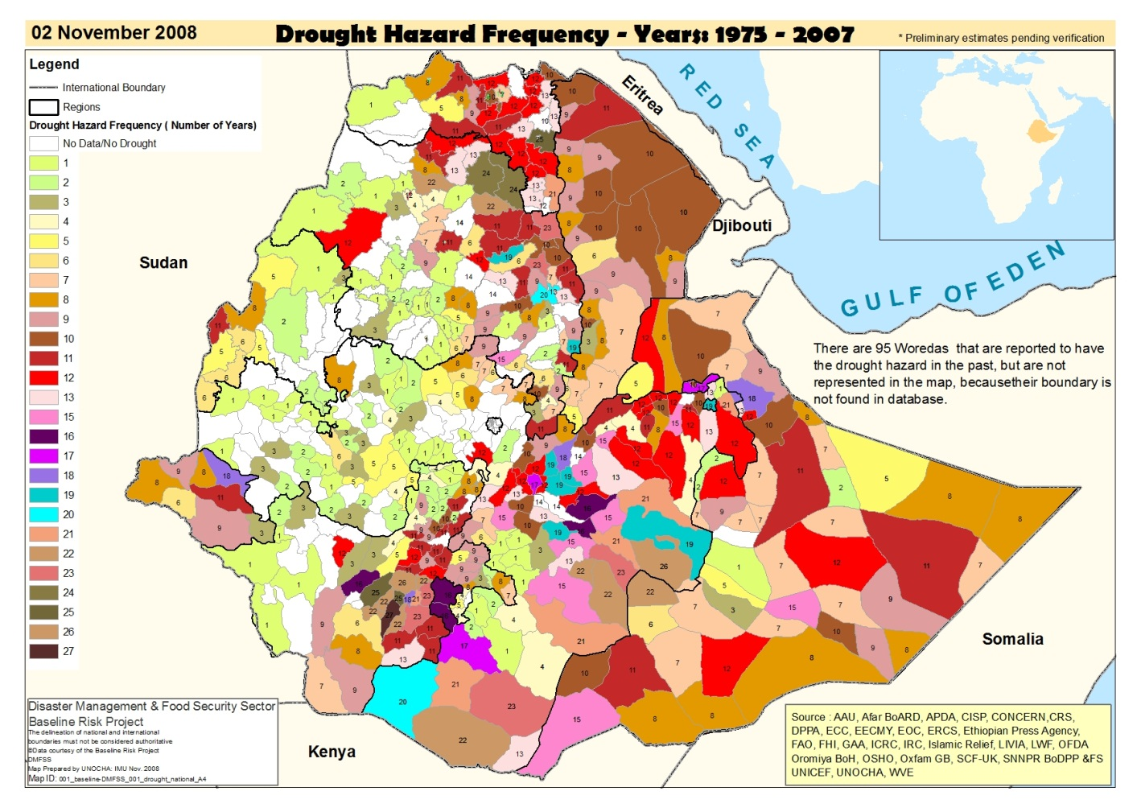
Figure 5: Drought distribution and frequency
This map has been produced by the Ministry of Agriculture, and the DRM/FSS. It presents data from various sources and shows the drought frequency between 1975 and 2007. This map could be overlaid with the hydro-met infrastructure to identify where current infrastructure is inadequate and where it needs to be improved.

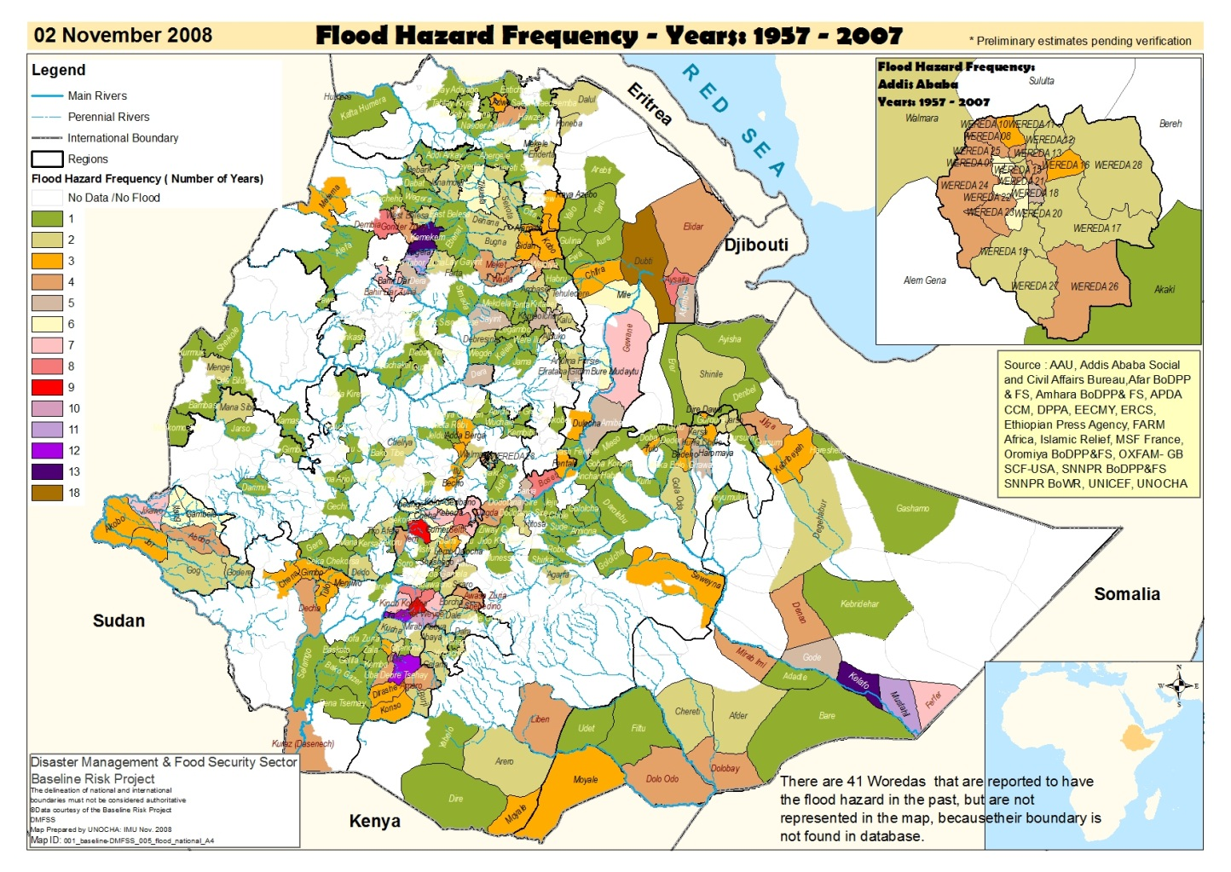
Figure 6: Flood distribution and frequency

Some important points:

- To ensure effective, realistic and meaningful project design further dialogue is required with the NMA, MOW and the MOA/DRMFSS to map the existing infrastructure and the needs that this project can address. This is particularly important for outcome 1 “Enhanced capacity of national hydro-meteorological (NHMS) and environmental institutions to monitor extreme weather and climate change” in order to ensure maximum impact and avoid any duplication with other projects. The allocated funds are at the moment set at 3,310,000 USD and may require modification to meet the requirements from the country technical assessment. The final figure will emerge from the discussions with all stakeholders and once the technical assessment is completed.

- Site selection and O&M plan is going to be of crucial importance for the installation of the weather infrastructure. Coordination between various Govt department (MOA, Early Warning and Response Directorate, DRM/FSS, NMA, MOWE) will be essential.
- There is a need to focus on rehabilitation of existing infrastructure and data rescue before investing too much of the funds in procuring new equipment. Ethiopia has 1200 weather station that are in different states of operation and can contribute extensively to the countries weather data gathering effort.
- Training and capacity building of NMA staff at the centre and at regional level to enhance data collection and analysis will be a very important part of this programme and a capacity building plan will be developed in partnership with NMA.
- Emphasis was made on the importance of supporting large awareness campaigns through the various media on meteorology and meteorology literacy. Many people in Ethiopia do not give any importance to meteorology, do not understand it and therefore cannot depend on and use the forecasts for planning their activities.
- Calibration instruments and training is central to using the existing weather stations network more effectively. This may involve the procurement of a mobile calibration unit.
- A technical assessment and strategic plan for what NMA needs already exist and needs to be updated to be used for this project.
- Potential partners for financial sustainability for climate information systems and EWS were identified and need to be consulted. As the project funds will be for establishing a nation-wide climate information and EWS in the country, possible ways in which such a system can leverage private sector finance were explored during the mission through discussions with Govt officials and with the UNDP CO. The public private partnerships were discussed as part of the financial sustainability aspect and are only at their “ideas” stage. Much more work and interaction with these sectors will have to take place in the coming months to correctly assess the willingness of private clients to pay and which climate variables, at what lead time would these partners be interested in. They include engagements with:
- Ethiopian Airlines and civil aviation
- Insurance companies
- Farmers Unions/Associations
- Ethiopian Telecom
- Hydro power and tourism

Initial consultations

For Ethiopia please see the mission schedule in the annex 2. Bilateral consultations were held with Government departments and multilateral/bilateral donors described below:

- Friday 21st September. Director of the Meteorological Forecast and Early Warning Directorate, Mr Diriba Korecha: The project objectives were briefly explained. The NMA is probably going to be the IP based on its capacity and UNDP CO experience with the organization. Mr Korecha expressed great enthusiasm for the project. He explained that the project was addressing key and relevant issues for Ethiopia in terms of need for climate and weather information capacity building as well as the development of human resources expertise and training. Currently 1200 manual weather stations and 37 automated weather stations are distributed across the country, however not all are functional due to lack of spare parts, human resources and vehicles.

Figure 1: Met stations distribution as of 2008, not all are functioning.
An internal assessment document on the needs and gaps of NMA is available and needs updating. One of the biggest gaps in the system is the lack of continuous data availability, which is needed for accurate forecasting and modeling. The PPG phase activities will need to assess details of the existing weather information system to identify the needs and gaps. It will be important to get the list/map of these stations indicating which are functional, what variables they record and how they transmit data back to the NMA. A training and capacity building plan was suggested, to be designed in partnership with the NMA, the Ministry of Water and Energy and the Ministry of Agriculture (especially the Early Warning and Response Directorate, Disaster Risk Management & Food Security sector).

Discussions on successful and unsuccessful projects were initiated but will be held in more detail in the coming months to learn the lessons and best practices from these past activities. The issue of O&M and budgets was also brought up but will need further detailed discussions to define output 2.5 (which aims at designing a sustainability and O&M plan for the project). This plan will be designed during the project implementation phase but we need to present a broad outline of it in the project proposal.

- Monday 24th September: UNDP Climate Change and Vulnerabilites Team. Mrs. Sinkinesh Beyene (CCV team leader) and Takele Teshome, Programme Analyst and focal point Shimelis Fekadu (climate change and Environment programme specialist) were present. The PPG and PIF were presented and discussed, as well as the upcoming Inception Workshop. The importance of impact was emphasized, focusing on linkages with other ongoing projects and existing communication and SOPs for passing the critical information to the end user. The project results framework was discussed and it was agreed that it was accurate and relevant and would be used as a guide throughout the PPG phase.

- Monday 24th September: Visits to the Ministry of Agriculture as they are an important partner and to stress the importance of their participation in the IW and discuss the existing EWS for drought and floods. A senior representative of the ministry attended the IW. Initially the minister himself was to attend but was later unable to commit, and was represented by the director of the early warning and responses directorate. The visit was useful as it provided insights on how the EW system in Ethiopia functions (see diagrams below). It is under the supervision of the Early Warning and Response Directorate, and is called the Disaster Risk Management and Food Security Sector (DRM/FSS). The ministry confirmed the centrality and importance of NMA in the system as an accurate information and forecast provider.

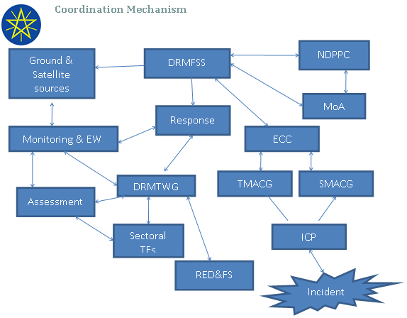
Figure 2: EWS Coordination and communication Mechanism

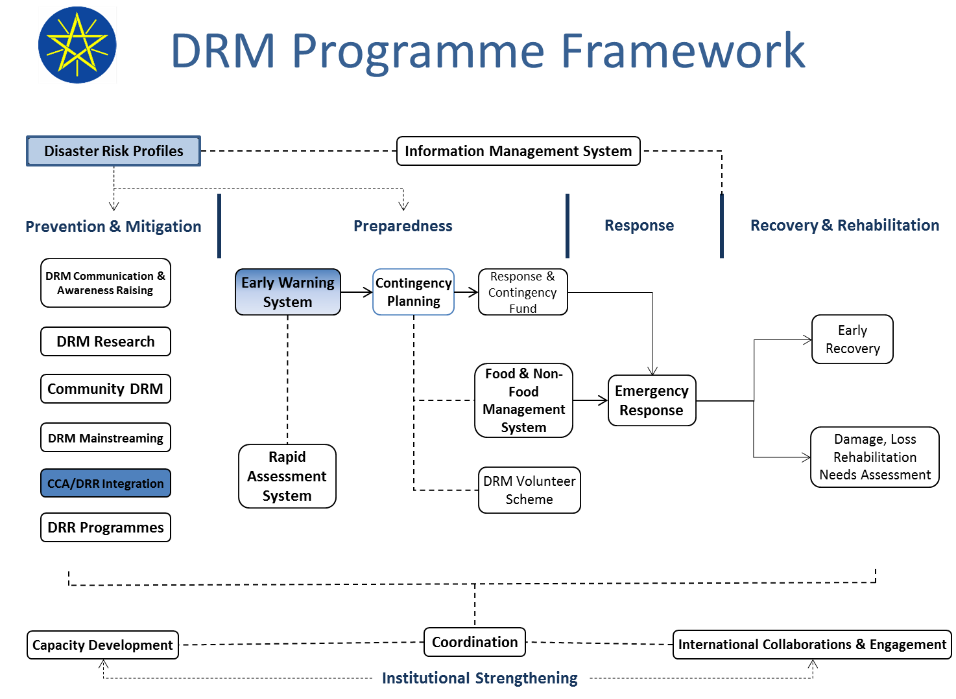
Figure 3: The DRM Framework
Figures 1 and 2 present the EWS and DRM frameworks in Ethiopia. Climate Change Adaptation is clearly identified as a factor for prevention and mitigation. Droughts and floods (climate related events as opposed to earthquakes and tsunamis for example) have been confirmed by the Director of DRM/FSS and the Director of Hydrology and Water Quality, to be the main natural disasters Ethiopia has to face. This highlights the importance of a robust weather information gathering system that can analyze the data and issue early warnings when necessary. An enhanced Meteorological department, with the ability to collect more observed data and assimilate useful forecast information, will be able to feed more useful information into this existing early warning and disaster risk management framework for dissemination to the local populations and long term planning.

- Monday 24th September: Director and deputy Director of NMA. The meeting was to present the project and get the feedback from this very important partner. They are extremely enthusiastic about the project and are ready to provide all support to the PPG phase. The needs of the agency and the direction the project should take were discussed. The PIF was presented and both outcomes were agreed to be accurate and reflect the needs of the agency and the country. Comprehensive technical assessments and capacity building plans should be developed to provide the detailed outputs. This will be done during October and November by the NC, with support from the technical specialist and the UNDP CO.

A brief overview of the state of the equipment and forecasting capacity already in place is presented below:

  - 1200 weather stations, most of them are conventional (manual)
  - 37 automated weather stations
  - Surface stations
  - Sparsely and unevenly distributed (see map, figure 1)
  - Concentrated along the main roads, urban regions
  - Equipped with outdated instruments
  - Only few meteorological elements are observed
  - Maintenance, routine station inspection
  - The question of landownership for setting up stations.
  - Some stations are below the standard of the World Meteorological Organization’s station distribution requirements.

Details for the above will be gathered during the PPG phase to understand how they operate, how often they are visited by staff, how is the data communicated back to NMA.

- Realization of meteorological factors on local and regional scales
  - Limited research documentations
  - Lack of interest from research institutions, universities
- Monitoring and modeling
  - Inaccessibility of model products (how and why these modeling products are not accessible will be assessed during the PPG)
  - Weak/limited computational facility and manpower
  - Poor representativeness of local climate parameters in General Circulation models
  - Monitoring and modeling is time consuming, requires huge storage facility, high speed computers, fast internet services – the question to ask would be, can we not provide access to offshore modeling resources rather than trying to build new ones in Ethiopia ?
=== Requires Investment
  - trained manpower with advanced degrees

- Forecast products, dissemination and their use
  - Forecast products are more of general, qualitative and probabilistic
  - Follow the level of scientific development, not fully take into account the users interest
  - Various sources of weather information but low analytical skills
  - Avoidable climatic hazards--- by investing on the climate science and infrastructure. Eg. Life and economic loss due to slowly emerging droughts or rapid-onset flash flooding
  - Inappropriate use or misinterpretation of climate information
  - Communication systems (language, information flow, media)
  - Cultural barriers or beliefs: Mother Nature! Keeping living cattle as asset, societal practices

NMA has already produced a report that presents the gaps and needs of the Agency, and although it needs to be updated, it will be used to guide the design of the project document along with other actors and user requirements.

- The state Minister of Water attended the opening ceremony of the IW. The distribution of hydrology stations and their condition was discussed (see figure 4).

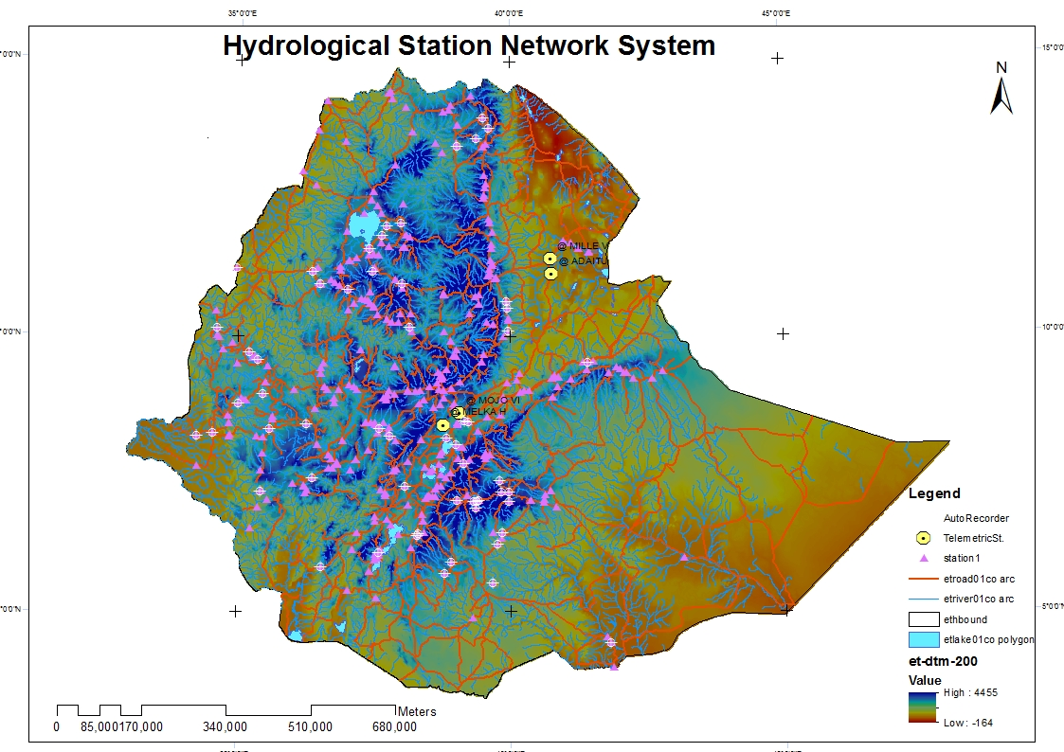
Figure 4: Distribution of Hydrology stations

Below is a summary of the state, distribution and condition of the hydrology network:

Abbay Basin: -
  - The network in number as well as distribution does not fully sample the basin
  - Especially in the high lands the stations are located near the sources whereas in the downstream no monitoring stations exist due to lack of access because of bad or no roads
  - In addition some stations need reallocation to the downstream
Awash Basin:-
  - The station network distribution needs much attention
  - Since this basin is exposed to severe flash floods as well as river flooding special attention is required for monitoring through telemetry system
Rift Valley:-
  - In this basin chains of lakes are found
  - The network distribution in the basin still needs additional stations
Wabi_Shebelle: -
  - The Hydrological Stations are located in the high lands which do not represent the basin resources adequately
  - The basin is affected by flooding, Monitoring is required through Telemetry system
Genale Dawa: -
  - The station network is limited in number and distribution especially on the downstream part.
Tekeze Basin:-
  - The Hydrological stations are located along the road or where ever there is access
  - The stations network is so limited therefore it needs reallocation and additional stations
Omo_Ghibe Basin: -
  - The stations network is so limited therefore it needs reallocation and additional stations

- Wednesday 26th September: The UNDP CD was unavailable for health reasons, a meeting was held with the acting deputy country director - programme, to present the initiative and discuss strategic directions.
- Attempts to meet with DFID and World Bank representatives were unsuccessful as they were not available and did not respond to email and phone calls. However the NC will follow up on these meetings with support from UNDP CO.

The box below presents the main points that were identified as the way forward by the participants of the inception workshop for the strengthening of the national EWS and long term planning for CCA.

The Way Forward

- Upgrading meteorological stations /number of weather elements and time of observations
- Rehabilitation of existing weather stations and data rescue
- Enhance the use of ICT
- Expansion of automatic weather stations
- Representativeness of stations /surface and upper air; lowlands and mountainous; urban and rural)
- Expansion of remote-sensed facilities (satellite)
- Global data exchange
- Coordination with other departments like Water and DRMFSS
- Strong collaboration between information producers, research society, user community
- Accuracy, timeliness, availability, usefulness, compatibility -- high priority
- Research
- Manpower development and computation skills -- capacity building
- Knowledge transfer

Project development

Although all activities have not yet been identified and will be done during the PPG phase, this project will build upon and converge with existing initiatives in the country identified below:

- UNDP’s Africa Adaptation Programme (AAP) project “Supporting integrated and comprehensive approaches to climate change adaptation in Africa - Supporting climate resilient sustainable development in Ethiopia”.
- Climate resilient green economy programme of the UNDP.
- Strengthening National Capacities for Disaster Risk Reduction and Livelihoods Recovery (DRR/LR). This is a UNDP project that aims at building the institutional capacity for Disaster Risk Reduction and resilience and recovery capacity of communities prone to disaster.
- Promoting Autonomous Adaptation at the community level in Ethiopia, LDCF funded UNDP project. This project aims to be a catalyst for promoting national action in Ethiopia that builds the resilience of local communities and their capacity to innovate and manage climate change opportunities and risks.
- Government of Ethiopia and World Bank (GFDRR) – Ethiopia Disaster Risk Management Country Plan. This project seeks to reinforce risk and vulnerability assessments, early warning systems and contingency planning.

Identification of successful and unsuccessful interventions and the reasons why they did or did not work was not done during the inception mission and will be done by the NC during the month of October and November. This will be done by interacting with all stakeholders including the Govt, the NMA, the DRMFSS, the DHWQ, the World Bank, WFP, UNDP, and CSOs.

The activities proposed in the PIF have been well received and described as relevant and accurate for the needs of Ethiopia by all participants in the inception workshop and in bilateral discussions. However the assessment of the current capacity and the detailed needs in terms of the training and capacity building will be identified during the month of November in collaboration with the NMA, the ministry of Agriculture (DRMFSS) and ministry of Water and Energy (Hydrology), and with support from UNDP CO.

A broad functioning of the EWS in Ethiopia has been presented in section 2 of this report. The detailed existing technology assessment including the human capacity to operate and maintain the system will be assessed in the months of October and November by the NC with support from the IC and the UNDP CO. This will be done by interacting with the NMA, the DRMFSS and Directorate for Hydrology and Water Quality. Other stakeholders like the WFP, the WB, DFID, FEWSNET, USAID and CSOs like Climate Change Forum Ethiopia will be consulted to understand the details of the EW communications system and how effective it is. It will be important to grasp the details of how information flows between different departments, using what media (cell phones, internet, fax, VHF…etc). Assessing the weaknesses and the operational aspects of the EWS will feed into the prodoc and provide useful facts to plan the intervention.

It is also important to keep in mind the need for using the improved weather information gathering capacity for long term planning. The PPG phase will assess the existence (or lack of) of institutional linkages that permit such planning to take place. For example linkages between NMA and the Ministry of Planning or Finance may not exist and may be necessary to improve long term planning for climate change adaptation. One of the obvious beneficiaries would be the Ministry of Agriculture, who could issue agricultural advisories to farmers based on more accurate weather forecasting and long term trends.
Consultations with the NMA, the Ministry of Agriculture (DRMFSS) and Ministry of Water and Energy (DHWQ) and their different departments will take place to determine the most pressing need in terms of EWS and the strategies and activities needed to improve forecasts and produce relevant climate hazards products and their dissemination. Other stakeholders like FEWSNET, DFID, WFP, and other UN Agencies, CSOs will be consulted to identify what are the existing gaps in the EWS and long term planning process for climate change adaptation. Details of how many weather and hydrology stations are functioning and how many are not, why? What are the O&M procedures, how often are these stations checked and how is the data returned to NMA for logging and analysis.
Institutional linkages and mapping will take places to assess weaknesses and identify gaps in the communication and dissemination system. Questions on how is information transmitted between institutions using what methods and whether they are effective will need to be answered. Emphasis on using the improved weather information for long term planning for climate change adaption will be presented and discussions with all stakeholders on how to enhance the planning capacity will also be addressed. It is important to note that the limited time and funds available for the PPG will not allow for a large scale users consultation.

The technology and skills that exist to make forecasts have been briefly presented in section 2 and are broadly inadequate and below the standards of WMO. Therefore the PPG phase will aim to identify the additional skills and technology required to improve the forecasting abilities of Ethiopia. This will be done during the months of October and November by the NC with support from the IC and the UNDP CO.

Although some of the gaps were identified, like for example the limited number of AWS (37 out 1200 weather stations in Ethiopia) and the recurrent breaking down of manual weather stations leading to discontinuous data during the inception workshop and mission, the detailed assessment of the gaps in the current EWS will be identified during the months of October and November by interacting with the NMA, the ministry of Agriculture and ministry of Water and Energy (Hydrology department). Questions on how equipment is maintained, how often it is visited, where do the funds allocated for the O&M come from will be asked. A report on this assessment will be prepared and shared with Mark Tadross for his review at the end of November. This will allow enough time to review the assessment and decide whether more information and what kind is needed additionally.

It is important to note that the EWS presented in section 2 of this report is fairly robust in Ethiopia and is under the control of the ministry of Agriculture. Drought remains the countries’ major hazard along with floods and these mainly affect farming activities, with the exception of river side flash floods which affect population living on the banks of rivers. The DRMFSS is the institution with the responsibility of intervening as soon as possible to warn and relieve affected populations. The DRMFSS receives weather forecasts from the NMA and hydrology data (river flows and levels) from the Directorate for Hydrology and Water Quality (DHWQ) and based on their severity issues a warning. The information is overlaid with vulnerability and environmental data. The system then moves into a relief and rescue mode if necessary or just prepares personnel and goods for a possible hazard. The central role of NMA and the DHWQ as a reliable provider of weather and hydrology information was emphasized and strengthening them will strengthen the entire resilience of the country.

Due to its history and repeated famines, droughts and floods, Ethiopia has developed a robust DRM system which was described in a presentation made by the Director of DRM/FSS at the inception workshop. Communications lines are in place and clear reactions to early warning (who needs to do what, and were do the funds come from) exist. The weakness is in the accuracy and timeliness of the weather forecast and early warning.
During the PPG phase information will be gathered to understand these weaknesses better. There are many levels at which timeliness and accuracy can be a weakness and this will be researched to find out whether it is a the monitoring of the data that is late, is it the actual forecast or is it the converting of the information into a warning.
There will be an evaluation of the information flows and the DRM system, as well data sharing and SOPs between govt departments. This will be done in the month of November by the NC and the IC in collaboration with the NMA, the ministry of Agriculture and ministry of Water and Energy and with support from the UNDP CO.

The site selection and location for AWS, hydrological gauging stations, weather and coastal radars, and upper air stations will be done during the months of October and November by the NC and the IC with the NMA, the ministry of Agriculture and ministry of Water and Energy and with support from the UNDP CO. Some information already exist in the form of internal assessments and plans made by the NMA and other govt departments, however these reports need to be updated and reviewed.

Potential partners for financial sustainability for climate information systems and EWS were identified and need follow up. As the project funds will be for establishing a nation-wide climate information and EWS, possible ways in which such a system can leverage private sector finance were explored during the mission through discussions with Govt officials and with the UNDP CO. The public private partnerships were discussed as part of the financial sustainability aspect and are only at their “ideas” stage. Much more work and interaction with these sectors will have to take place in the coming months to correctly assess the willingness of private clients to pay. They include engagements with:
a) Ethiopian Airlines and civil aviation
b) Insurance companies
c) Farmers Unions/Associations
d) Ethiopian Telecom
e) Hydro power and tourism

The implications for the defined outcomes and outputs in the PIF are that they are broadly relevant to the current needs of the country. The changes that will need to be made will emerge from the technical assessment but are not anticipated to be substantial. There is undoubtedly a need for contextualizing and adapting some of the outputs to the actual needs that emerge from the country assessment, but these changes will not be major and the outcomes have been approved and accepted by the stakeholders at the inception workshop, and will not be changed.

Output 1.1: Rehabilitation and procurement of hydrology stations. This output remains relevant and the country technical assessment will refine the exact numbers that need rehabilitation and how many new stations need to be procured.
Output 1.2: Rehabilitation and procurement of meteorology stations. This output remains relevant and the country technical assessment will refine the exact numbers that need rehabilitation and how many new stations need to be procured.
Output 1.3: Procurement and/or rehabilitation of radar: The procurement of new radar has been ruled out due to the cost, but there is an interest to assess the cost of rehabilitating and existing but nonfunctioning radar.
Output 1.4: Procurement and installation or rehabilitation of upper air monitoring stations: Interest has been shown in procuring another upper air monitoring station, but the impact and use of this station will have to be assessed and understood before including this activity.
Output 1.5: Procurement and installation or rehabilitation of satellite monitoring equipment to receive real time climate and environmental information. There is a clear sense that this is an important output for Ethiopia and details of what equipment and what training is required will be assessed during the PPG phase.
Output 1.6: Training for O&M is a very important output and will remain in the prodoc, with details emerging from the training and capacity building plan being developed.
Output 2.1: Strengthening of NMA by training forecasters is very relevant and will remain as an output.
Output 2.2: Tailored sector-specific early warning products that link climate, environmental and socio-economic information on a range of timescales are developed, based on identified user needs. This output will have to be contextualized and adapted to the current needs of Ethiopia.
Output 2.3: National Capacity to assimilate forecast and feed them into development plans and PRSPs is strengthened. This is a very relevant output and will be retained in the project results framework. Activities to achieve this output will be detailed in the prodoc.
Output 2.4: Improved communication channels and SOPs. This output is very appropriate for the country and will remain in the project results framework with details and contextualizing defined in the prodoc.
Output 2.5: Plan for sustainable financing for the operation and maintenance of the installed EWS developed and implemented, including public and private financing options. This is crucial output and will remain a central effort for the project during implementation.

Implications for the project budget and co-financing

The current budget allocations cover outcome 1 and 2 and will not change at the outcome level. Rather some adjustments may be required at the output level, but this cannot be precisely identified before the detailed country assessment is completed by mid-December.

No precise information on current budgets and their ability to sustain equipment, operations, maintenance and human resources are available at the moment although these will be probed during the country assessment phase. Generally resources for O&M are chronically limited and insufficient in the LDCs.

An assessment of the financial needs and gaps of the NHMS and other ministries/departments to budget and plan for the human and technical costs of operationally maintaining current and additional observation networks and systems will be done in the month of November by the NC and the IC in collaboration with the NMA, the ministry of Agriculture and ministry of Water and Energy and with support from the UNDP CO. The initial sense from the inception mission is that they are insufficient.

No new co financing sources have been identified yet. They will be explored during the PPG phase, in the months of January and February by the IC, the NC and support from the UNDP CO and HQ. The confirmation of the originally identified co-financing sources have not been confirmed of changed yet. This is planned in the months of January and February.

Institutional coordination and implementation

The IP has been tentatively identified as the National Meteorology Agency (NMA) for the reasons below:
- This project is primarily oriented towards strengthening weather information gathering capacity for EW and long term planning.
- The NMA is the agency in charge of gathering weather information and issuing early warnings
- The NMA is responsible for the forecasting and analysis of weather information
- The UNDP CO feels that it would be the ideal IP
- The Govt would like to see the NMA in charge of spearheading the project which does not exclude other govt department like the DRM/FSS and the Directorate for Hydrology and Water Quality to be partners and responsible parties.

The issuing of the early warning will be done by the NMA as they have the information and the capacity to analyze it, but the reaction to that warning and the measures that will follow are the prerogative of the DRMFSS, which is in charge of DRM in the country.
As mentioned earlier the EWS and the DRM units in the Ethiopia are fairly robust and have existing SOPs and reaction plans. It was emphasized by the govt and other stakeholders at the inception workshop that these links should be used and not duplicated. No new institutional links need to be forged.

Identified risks

Risks have been identified in the PIF and no new ones have been found during the inception mission.

Follow up activities – Timeline and Workplan

The work plan and timeline below aims at providing a detailed roadmap for the PPG phase. The objective is to deliver a draft full size compliant UNDP GEF pro doc by the middle of January 2013 as planned at the Cape Town meeting.
In order to achieve this several activities and tasks have been identified for the technical specialist, the NC and the UNDP CO. The NC has been issued a contract on the 5th of October and will be able to complete the technical assessment of the weather infrastructure, the capacity and training plan, and coordinate with the UNDP CO, the MOA, the NMA and other stakeholders to prepare a draft results framework by the end of November.

The technical specialist (IC) responsibilities are broadly the following:
- Contribute to the design and conduct of at least 3 national consultations in each country, at the inception, mid-term and conclusion of the project preparatory phase;
- Coordinate closely and support the NCs activities and information gathering efforts.
- Completion of an inception report and plan for the roll out of activities during the project development phase (scheduled to take no longer than 12 months);
- A stakeholder consultation plan with measures for documenting and including community inputs during the project preparation period;
- Provision of advice and technical guidance to other members of the project design team on key outputs of the project preparatory phase, which feed into the comprehensive project proposal;
- Prepare the drafting of UNDP-GEF/LDCF compliant, full-sized Project Documents and associated CEO Endorsement Templates for submission to the GEF CEO for endorsement (the CEO endorsement will primarily draw on information in the Project Document, with some additional details on budgets and work plans that need to be defined);
- Assess and finalize a report on important lessons following completion of the preparatory phase;
- Prepare a powerpoint presentation on the final project design including UNDP-fact sheets (3-4 pages) that summarize the expected results of the project.

A second mission and national consultation is tentatively planned for the middle of December to finalize the results framework, including contextualized outcomes, and outputs, ensuring the sum of outputs and activities deliver the expected outcome and a fair idea of costs and budget is arrived at.
Close collaboration (daily interaction) will take place between the technical specialist and the NC as well as with the UNDP CO focal point.

Date/Month | Activity | Remarks
September 2012 | Contract issued; preparation for the first mission to Ethiopia and the Inception Workshop. The mission was held between the 20th and the 26th of September and the IW took place on the 25th September. | Completed
October 2012 | Submission of the Inception Report, recruitment of the national consultant (NC). Begin the technical assessments of weather infrastructure, other similar initiatives and capacity and training needs. Meetings with various directorates at NMA, the Ministry of Agriculture, the Ministry of Water and Energy, WFP, the World Bank, UNDP and civil society like the Climate Change Forum – Ethiopia (NGO). The IC will support and coordinate these efforts and begin the drafting of the prodoc. | As soon as the NC is contracted he needs to start on the country level weather infrastructure assessment, identify and engage with other stakeholders implementing similar initiatives, and prepare a training and capacity building plan. This will be done with support from the technical specialist and UNDP CO and will require engagement and interaction with all stakeholders.
November 2012 | Prepare draft results frameworks with detailed outputs and costs based on the country needs assessment and the interactions with all stakeholders.  Prepare report on country background, existing EWS, DRM systems and coordination mechanism for the project. Existing budgetary constraints for implementation of new and existing technologies will be assessed.  Start organizing second workshop for finalization and approval of the results framework. | The outputs of results framework are starting to emerge from the results of the country needs assessment. All gaps need to be filled and intense interaction with all stakeholders is required to ensure any duplication is avoided and coordination mechanisms are identified. This will be done by the NC with support from the UNDP CO and technical specialist and debriefing with Mark.
December 2012 | Organize the second national consultation workshop to approve the results framework and agree on the draft project document if necessary. Alternatively meetings with stakeholders could be sufficient. This will be decided based on the consultation with stakeholders.  Prepare the draft project document and share with Mark Tadross for review and technical compliance.  SMART Indicators need to be developed for tracking and M&E. | The final results framework with all detailed outputs needs to be approved by the various stakeholders and the country authorities and UNDP CO. This should be done during the second mission and national consultation workshop. A draft pro doc is ready for Mark’s review and comments. This will be led by the technical specialist and the NC with close collaboration with the UNDP CO.
January 2013 | Complete the draft pro doc based on the second national consultation including the results framework, situational analysis, contextualized outcomes and outputs, institutional arrangements including personnel and budgets.  The pro doc is submitted to Pradeep and Mark for review. | This will mainly be done by the technical specialist with support from the NC and the UNDP CO. A tentative deadline for the submission is the 20th of January 2013.
February 2013 | Start collecting co-finance letters and any information gaps in the pro doc.  Finalize budgets and cost of equipment  Coordinate with peer reviewers and Mark | This will be done by the technical specialist and the NC with support from the UNDP CO.
March 2013 | Second draft of pro doc prepared  Validation meeting organized and facilitated  Obtain approval and sign of from Government and UNDP CO  Award set up in ATLAS | This will be done by the technical specialist and the NC with support from the UNDP CO.
April 2013 | Second draft is submitted to Pradeep and Mark for final review.  Prepare GEF CEO endorsement  Obtain OFP endorsement and cofinance letters | This will be done by the technical specialist and the NC with support from the UNDP CO.
Mai 2013 | Final GEF CEO endorsement is submitted  Co finance letters are submitted  Available for revision  Further information gathering to provide GEF with any additional information required.  Rewriting and comments incorporation | This will be done by the technical specialist and the NC with support from the UNDP CO.
June 2013 | Available for revision  Further information gathering to provide GEF with any additional information required.  Rewriting and comments incorporation | This will be done by the technical specialist and the NC with support from the UNDP CO.
July 2013 | Available for revision  Further information gathering to provide GEF with any additional information required.  Rewriting and comments incorporation | This will be done by the technical specialist and the NC with support from the UNDP CO.

NC detailed workplan

Please see Annex 4.

Budget for PPG:

In total three missions and stakeholder consultations are planned during the PPG. One has already been completed in September at an approximate cost of 4000 USD (travel, DSA and workshop).
The two next missions will take place in December 2012 and in February or March 2013 and will cost similar amounts i.e 5000 USD (travel, DSA and workshop).

The consultancy fees for the IC and NC would have to be added to give a complete picture.

Annex 1: Initial mission schedule

Mission Schedule for Benjamin Larroquette, Technical Specialist, UNDP-GEF Inception Workshop for the preparation of the LDCF project in Ethiopia.
(20 – 26 September 2012)

Day/Date | Time | Meetings/Activities
Thu 20 Sept 2012 |  | Arrival in Adis Ababa, meeting with UNDP Focal point, Mr Shimelis Fekadu
Fri 21 Sept 2012 | 8:30–11:00 | Meeting with UNDP focal point Shimelis Fekadu, Programme Specialist CCV, and other colleagues
 | 11:00-13:00 | Meeting with Director of Meteorological Forecast and Early warning Directorate, National Meteorological Agency (NMA)
 | 14:30-18:00 | Work at UNDP office with Shimelis on preparation of documents and planning for the IW
Sat 22 Sept 2012 | 08:30-12:30 | Discussion with UNDP Focal Point, Mr Shimelis Fekadu, and preparation of background documents for the IW.
 | 13:30-18:00 | Planning of NC work and timeline for the project PPG phase, review of UNDP documents, UNDAF, other ongoing projects on Climate Change Adaptation
Sun 23 Sept 2012 | 09:30-13:00 | Final preparation and arrangements for Inception Meeting,
 | 13:00-17:30 | Prepare speech and talking points for the UNDP CD, finalize presentations and project brief.
Mon 24 Sept 2012 | 09:30-11:00 | Meeting with UNDP CCV team leader and colleagues.
 | 11:00-12:30 | Meeting with Ministry of Agriculture
 | 14:30-16:00 | Meeting with Ministry of Water and Energy
 | 16:00-17:00 | Meeting with NMA Director and deputy director
Tue 25 Sept 2012 | 09:00-17:30 | Inception Workshop
Wed 26 Sept 2012 | 8:30 – 13:00 | Internal meeting at UNDP
 | 14:00 | Departure

Annex 2: Inception Workshop Agenda

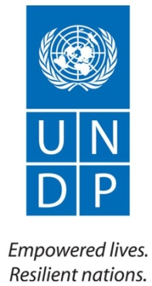
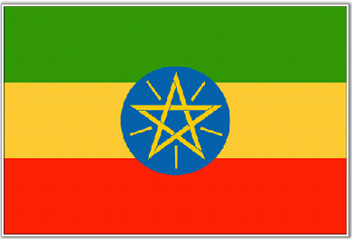

Inception Workshop Strengthening Climate Information and Early Warning Systems for Climate Resilient Development and

Adaptation to Climate Change

Venue: Hilton Hotel

Date: 25/09/2012

Agenda

Time | Agenda | Facilitators
09.00 9:30 | Registration
 | Opening remarks
09:30 – 09:45 | Director General NMA
09:45 – 10:00 | UNDP Ethiopia
10:00 – 10:15 | His Excellence, State Minister of Water and Energy
10:15 – 10:30 | Ministry of Agriculture
10:30 – 10:35 | Introduction of the workshop agenda | (UNDP/NMA)
10:35 – 10:50 | Project components and timeline - outline the regional approach and potential benefits | (International consultant)
10:50 – 11:10 | Coffee break
Session 1 – Project background and ongoing activities
11:10 – 11:30 | Presentation by Meteorological services on current state of observational infrastructure, forecasting floods and droughts and EWS. | NMA
11:30 – 11:50 | Presentation by Department of Water/hydrology on current state of hydrological monitoring, water resources and flood forecasting | MOWE/NMA
11:50 – 12:10 | Presentation by Department of Agriculture on extension services and responses to climate hazards | MOA/
12:10 – 12:30 | Presentation by Disaster management on response and communication of warnings etc. | MOA/DRMFSS
12:30 -13:30 | Lunch
Session 2 – Review of project design and planning key activities

13:30 - 14:00 | Introduction to EWS in the African context, gaps, needs and outline of the project aims and outcomes Discussion | International Consultant
14:00 - 15:00 | Working Groups on two components: Hydro-met technical requirements and EWS for disaster management and long term planning (Component review - develop key activities to achieve outcomes, and determine milestones, discuss stakeholders and implementation partners) | Working Group
15:00 - 16:00 | Presentations by working groups and discussions | Working Group
16:00-16:15 | Tea/coffee break
Session 3 – Identify key stakeholders and partners
16:15 | Working session to identify key vulnerable populations, areas at risk, private sector interests, innovative communication channels etc.  Plenary discussions, clarifications | Organizers
17:30 | Workshop close | NMA

Annex 3: List of stakeholders and contact details

1. Jessica Troni, Regional Technical Advisor, UNDP, South Africa
2. Nicholas Haan, previously Chief Technical Advisor for FAO. Food security
3. Shimelis Fekadu, climate change and Environment programme specialist.
4. Mrs. Sinkinesh Beyene, CCV team leader.
5. Takele Teshome, Programme Analyst.
6. Mr Diriba Korecha, Director of the Meteorological Forecast and Early Warning Directorate.
7. Director of Early Warning Directorate and DRM/FSS
8. Director of Hydrology and Water Quality Directorate
9. Mr. Fetene Teshome, Director General and Mr. Dula Shanko, Deputy Director General, National Meteorological Agency.
10. Acting Deputy Country Director programme, UNDP Ethiopia.

Annex 4: NC detailed workplan

 | EWS Africa
 | NC time allocation and workplan by months
Month | Task as per TOR | Days | Activities
Sep-12 | Attend the IW, meeting with IC and UNDP CO Focal point | 1
Oct-12 | *Develop a stakeholder consultation plan with measures for documenting and including community inputs during the project preparation period;  * Review and gather information on past, current and planned projects related to the EWS, including disaster management and risk reduction activities. Help identify both successful and unsuccessful interventions;  * Engage with government ministries and departments to determine the current state of the EWS, including equipment, telecommunications, databases, forecasting and monitoring products, advisories and communication of EWS messages; | 12 | Week 2: (3 days)  1) Initiate contact with stakeholders  2)Design a stakeholder consultation plan with list of stakeholders and agenda to meet  Week 3: (4 days)  1) Desk review of past and current projects related to EWS  2) Short report presenting the initiatives including analysis of successful and unsuccessful interventions  3) Meet with UNDP CO to coordinate and agree on PPG and project objectives.  Week 4: (5 days)  1) Meeting with NMA to assess current state of weather information gathering infrstructure  2) Meet with MOA to understand the linkages and ways to transfer the weather inforamtion effectively  3) Meet with any other relevant stakeholders
Nov-12 | * Liaise with UNDP CO focal point, IC and Govt officials to design an conduct the second workshop for the PPG  * Engage with government ministries and departments to determine the current state of the EWS, including equipment, telecommunications, databases, forecasting and monitoring products, advisories and communication of EWS messages;  * Engage with government ministries and departments to determine the current state of the human resource capacity, and design a training and capacity building plan for the project.  * Prepare reports | 15 | Week 1: (4 days)  1) Meet with UNDP CO to update on progress and get feedback and guidance  2) Complete report on existing weather infrastructure and identify needs (number of stations to be rehabilitated, procured, site selection…etc)  Week 2: (4 days)  1) Meet with MOWE to assess Hydro infrastructure needs and locations  2)Meet with NMA to finalise the report on weather infrastrucure assessment, get approval  3) Submit report to IC  Week 3: (4 days)  1) Meet with NMA, MOA, MOWE to assess training and capacity needs at various levels.  2) Meet with UNDP CO to debrief and agree on training and capacity building strategy.  3) Prepare training and Capacity building plan and report  Week 4: (3 days)  1)Reach out and meet with other relevant stakeholders like NGOs, women associations, farmers associations...etc  2) Document meetings, gather and analyse relevant information, prepare and submit report.  3) Ensure gender issues and comments from PAC taken on board
Dec-12 | * Contribute to the writing, design and review of the project document, taking care to ensure that it is in agreement with National priorities and existing initiatives;  * Review and gather information on past, current and planned projects related to the EWS, including disaster management and risk reduction activities. Help identify both successful and unsuccessful interventions;  * Determine the costs associated with the climate and hydrological observing network, including equipment purchases, operations and maintenance, and human resources; | 11 | Week 1: (3 days)  1) Plan second nationnal stakeholders consultation workshop  2) Coordinate with UNDP CO to send invitations  3) O&M plan emerging  Week 2: (3 days)  1) Prepare second National stakeholders consultation workshop, background documents, presentations, hall bookings.  2) Initiate cost assessment and prepare a draft project budget (not detailed, just main outputs)  Week 3: (3 Days)  1) Facilitate with IC and UNDP CO the second national stakeholders consultation workshop  2) Prepare a draft project results framework with IC and UNDP CO  Week 4: (1 day)  Prepare and submit report including O&M plan
Jan-13 | * Determine the costs associated with the climate and hydrological observing network, including equipment purchases, operations and maintenance, and human resources;  * Help the IC design the project’s Knowledge Management and M&E component (including learning mechanisms and SMART, results-based indicators), aligned to the GEF Results-Based Management Framework for Adaptation to Climate Change;  * Start securing co financing letters by liaising with agnecies and institutions | 8 | 1) Finalise cost estimates and project results framework with IC and UNDP CO  2) Help IC design and write the draft prodoc including country background and infrastructure assessments, M&E, and capacity building plan.  3) Fill in any information gaps for completion of draft prodoc  4) Begin approaching partners for securing co finance letters
Feb-13 | * Liaise with UNDP CO focal point, IC and Govt officials to design an conduct the final peer review and validation workshop for the PPG  * Contribute to the writing, design and review of the project document, taking care to ensure that it is in agreement with National priorities and existing initiatives;  * Final budget and cost worked out | 10 | 1) Support and initiate the organisation of the PPG validation workshop planned for March  2) Finalise project budget and any missing information with IC and UNDP CO  3) Review comments from submitted draft prodoc and incorporate changes and comments with the help of IC  4) All costs and budget idenitfied and finalised  5) Help identify list of stakeholders for validation workshop
Mar-13 | * Conduct final validation workshop  * Contribute to the writing, design and review of the project document, taking care to ensure that it is in agreement with National priorities and existing initiatives;  * help obtain sign off from Govt and UNDP CO | 12 | 1) Prepare and organise validation workshop logistics  2) Facilitate validation workshop with IC and UNDP CO  3) Contribute and help review draft prodoc to incorporate comments and additonal request to obtain a UNDP GEF standards prodoc  4) Held obtain sign of from NMA, MOWE, MOA and UNDP CO  5)Prepare validatio workshop report and help finalise the prodoc for April submission
Apr-13 | * Obtain co fiance letters  * Contribute to the writing, design and review of the project document, taking care to ensure that it is in agreement with National priorities and existing initiatives; | 7 | 1) Obtain co finance letters from partners with the help of IC and UNDP CO  2) Help finalise prodoc for submission  3) Help gather any missing data, meet with Govt to inform of the status
May-13 | Contribute to the writing, design and review of the project document, taking care to ensure that it is in agreement with National priorities and existing initiatives; | 7 | 1) Obtain co finance letters from partners with the help of IC and UNDP CO  2) Help finalise prodoc for submission  3) Help gather any missing data, meet with Govt to inform of the status
Jun-13 | * Contribute to the writing, design and review of the project document, taking care to ensure that it is in agreement with National priorities and existing initiatives;  * Help with final data gathering and confirmation for incorporatingreview comments from HQ | 7 | 1) Obtain co finance letters from partners with the help of IC and UNDP CO  2) Help finalise prodoc for submission  3) Help gather any missing data, meet with Govt to inform of the status
Jul-13 | Provide additional information as required by GEF up until final clearance of the project document by the GEF. | 5 | 1) Help with the reviews and comments from GEF to finalise the prodoc
Aug-13 | Provide additional information as required by GEF up until final clearance of the project document by the GEF. | 5 | 1) Help with the reviews and comments from GEF to finalise the prodoc
 | Total days | 100

