Using Weather and Climate Information for Agricultural Insurance in Africa

UNDP Programme on Climate Information for Resilient Development in Africa

Explore the new opportunities improved weather and climate information could bring to lower risk and foster resiliency for Africa’s most vulnerable populations. This extended examination on agricultural insurance provides deeper exploration on a topic explored in an upcoming UNDP publication ‘A New Vision for Weather and Climate Services in Africa.’

January 19, 2016 | Prepared CIRDA

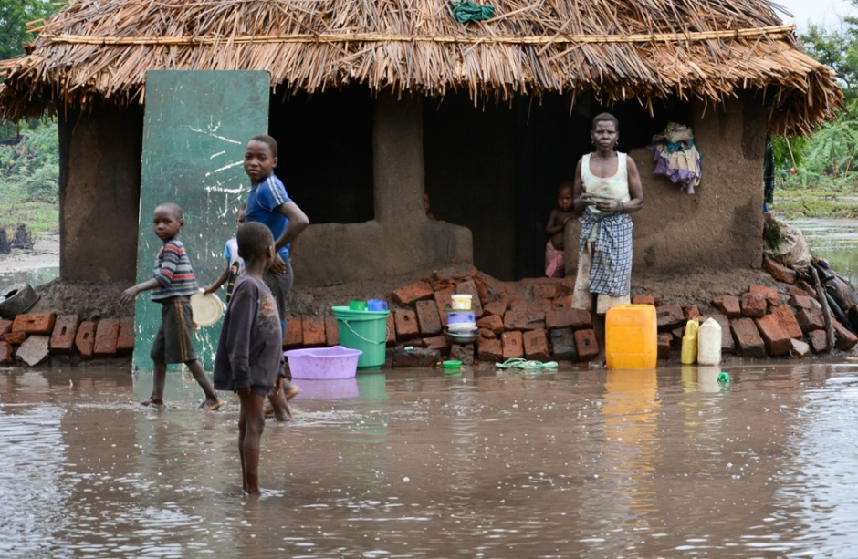
To receive a copy of the report, send an email to gregory.benchwick@undp.org
www.adaptation-undp.org/projects/cirda

Overview
Lowering risk and building resiliency is an essential component of sustainable development. It constitutes a huge win for both the public and private sectors, with increased productivity and market stealth, improved risk thresholds for smallholder farmers, and the potential for greater market stability.
Many of the least developed countries in the world are rural and the majority of the population rely on agriculture as a form of livelihood. Farmers face a slew of risks, from market and financials to weather, disease and pest issues. Most of the risk and impact faced by farmers is weather related. Fluctuations in temperature, severity and frequency of storms, or rainfall can impact the crop yield dramatically, which threatens the household welfare and ultimately threatens local food security and political stability on the national level.
Statistics from the International Disaster Database over the last 30 years indicate that an estimated 1,000 natural disasters took place in Africa affecting 328 million people with damages estimated at $24 trillion. Although floods have accounted for most of the total disasters, droughts are the hazard that has affected the most people and caused the most damage, accounting for 80% of people affected and 40% of total economic damages. These weather shocks can have serious consequences for smallholder livelihoods, particularly when they are uninsured.
The traditional financial tools available to small-scale rural farmers are often non-existent or unaffordable, or if provided by the state, these instruments will be focused on recovery. As a result of this uncertainty, farmers tend to fall back to traditional methods of risk management, which includes saving money and planting lower-quality crops. Because weather shocks are so consequential, the mere possibility of low rainfall can make farmers reluctant to invest in risky-but-profitable activities and technologies, further lowering their future earnings. Lack of insurance deters smallholder farmers from seeking loans for fear of being unable to pay back the loans and losing productive assets, which were secured as collateral. This paradigm of risk aversion continues to agricultural inputs such as fertilizer, better quality seed and agricultural technology. In some extremes, domestic households are known to keep children from school in order to utilize their services in the field. Inadequate or unaffordable risk management facilities or instruments amplify the impacts of weather-related shocks, which result in far reaching implications on national and regional stability.
A New Vision for Weather and Climate Services in Africa
Upcoming UNDP Publication Examines Building Resilience to Climate Change Through Public Private Partnerships and Advanced Weather Systems
The collection, analysis and distribution of reliable climate and weather information has the potential to greatly benefit efforts by African nations to reduce poverty, build resilience and adapt to a changing climate. For over 30 years, the international development community has made substantial investments in climate information systems for Africa, nevertheless, today, according to the World Bank, “most hydromet services in sub-Saharan Africa are unable to meet current needs for weather and climate information, and offer only limited areas of trans-boundary cooperation.” In this report a new vision to address sub-Saharan Africa’s climate and weather monitoring and forecasting needs is explored. This vision first looks at challenges of the current approach, and how this has affected the ability to achieve development goals, reduce risks and empower Africa’s least-developed countries to support their citizenry with climate information and early warning systems that can save lives, boost productivity and protect the environment in a changing climate. This new vision includes the implementation of advanced new hydrometeorological technologies and services, as well as the formulation of new partnerships between the public and private sectors. Creating a sustainable model for the delivery of effective climate services in sub-Saharan Africa will require policy makers to critically examine the status quo and establish a new vision for the implementation of this essential public service. There is no silver bullet, but with effectively structured public-private partnerships, new technology and services, strengthened institutions, increased regional cooperation and continued capacity building, sustainable climate and weather information solutions are a realistic and attainable goal. Reaching this target could have a significant impact on the achievement of the Sustainable Development Goals, protecting lives and building powerful resilience for Africa and beyond.

Crop and Index Insurance
In traditional crop insurance, indemnity payments are linked to individual farmer yield or cover multiple perils (i.e. hail, pests, diseases, etc.). In order to determine the payout, a loss assessment is performed through costly and time-consuming individual farm visits that evaluate the impact of an event on the farmer’s yield. These insurance instruments tend to be expensive, time consuming and in the case of developing countries, not subsidized. Farmers that have traditional insurance have less incentive to work hard if their harvest is insured, and farmers who take more risks might be more likely to purchase insurance, raising the costs of insurance facilities. Providing these financial services in LDCs is expensive as it requires high premiums from the purchasers and high costs and skills of resources from the assessing insurance company.
Index insurance links payments to an independently observable outcome, such as local rainfall, which is assumed (based on modelling results) to be highly correlated with yields. Such an approach could solve many of the cost and informational problems associated with traditional crop insurance. In particular, the insurer no longer must monitor thousands of individual farms, only the local rain-gauge. This also reduces the need for skilled assessors and quantifiers that could reduce the time required to evaluate the loss, which in turn reduces the premiums and substantially reduces the payout time.
Establishing index-based insurance is, however, not as simple as installing a rain-gauge. A weather index can be constructed using any combination of measurable weather variables, over any period of time. The parameters must be chosen that best represent the risk to the agricultural end user. This implies that good quality meteorological data must be used to correlate its influence on agricultural yield over time.
In LDCs, some of the main limitations for the implementation of index-based weather insurance include:
- the limitation on good quality historical and current weather information that is spatially representative (or sufficiently dense to cover the national landmass)
- lack of historical agricultural yield data
- cost effective and reliable data communications (reaching both insurers and end users with reliable and easy-to-understand data)
- cultural impediments to the adoption of new technologies, products and services
Without these parameters in place, commercial insurance providers might not be able to provide a cost-effective insurance solution. There are a fair number of successful Index Insurance projects throughout the world, most notably in India and in Kenya that are fully commercialised, but government subsidized. The key to the success of these projects, however, is the participation between the public and private sectors to fund the installation and maintenance of real-time weather observation stations and the participation of the National Meteorological and Hydrological Services in data quality control.
Good weather insurance instruments are those that balance simplicity with complex dynamics that characterize weather stress impacts on crop yields. They must be adapted to reflect the local conditions, and they must be simple to understand and be easy to communicate to the farmers and stakeholders. In order to guarantee continued purchase of the insurance product, farmers must be educated to understand under what conditions payouts will be triggered. In Brazil, innovative ways to communicate information to farmers have been prepared in the form of graphic “comic” booklets. This ease of communication coupled with a quality and affordable service has resulted in a participant retention rate of over 90 percent year on year.
The CIRDA Programme
This multi-country programme supports Climate Information and Early-Warning Systems Projects in 11 of Africa’s Least Developed Countries in their missions to save lives and improve livelihoods. By building capacity to issue extreme weather warnings, sharing new technological advances in weather monitoring and forecasting, and facilitating innovative partnerships with the private sector, the programme works to foster regional cooperation, support strong institutions and build resiliency to climate change.

Countries
- Benin
- Burkina Faso
- Ethiopia
- The Gambia
- Liberia
- Malawi
- Sao Tome and Principe
- Sierra Leone
- Tanzania
- Uganda
- Zambia

Sovereign Risk Insurance
The concept of index-based insurance is to use an independently measured variable and correlate its impact to the yield of the insured farm. In practice this works well to insure farms against isolated high frequency incidents. In the case of widespread catastrophic events, the value of the index insurance is limited. Typical responses to these catastrophic events by governments are either to seek international aid, or begin the long and arduous task of disbursing relief aid. By the time these safety payments have been received, irreparable damage has been done to infrastructure and livelihoods.
An appropriate sovereign risk financing strategy is therefore required to limit the financial exposure resulting from the public financial support to agricultural insurance. This strategy could include lines of credit or other risk transfer options designed to limit the fiscal exposure of the government to excessive losses. In order to lower the costs of such a broad risk contingency scheme, a regional risk management effort could be encouraged.
African Risk Capacity is a continental sovereign risk pool and early response mechanism designed to provide cost-effective contingency funding to African governments to execute pre-approved contingency plans in the event of severe natural disasters. It was jointly developed by the African Union Commission and UN World Food Programme. The ARC’s mission is to help African Union Member States improve their capacities to better plan, prepare and respond to extreme weather events and natural disasters and to assist its Member States to protect the food security of their vulnerable populations.
The ARC achieves its mandate through:

- Early warning systems
- Index-based insurance and risk pooling
- Contingency planning

Index-based insurance trigger payouts based on the observable index falling below a set level in a geographically limited area in real time. The sovereign insurance risk insurance essentially triggers on the observable index falling below a certain level on a much larger geographical area based on forecasted information. The impact of this weather shock is then mapped against a national household vulnerability profile to determine the total cost of emergency response. ARC’s aim is to ensure that sufficient planning is done upfront to ensure that when an event is triggered, it is validated on the ground and benefits are paid out with minimal delay to the end user. Currently, it is estimated that ARC evaluation and payouts to governments will be on average of three months. This halves the national response times of most LDCs and will serve to protect the livelihoods of the agricultural sector.

ARC Payouts
ARC provides insurance for several countries in Africa, using both global satellite data and human development indices to assess risk and provide payouts. Insurance payouts from ARC in 2014-15 can be used as an indicator of crop losses in Africa today. To give some more perspective from a global lens, weather-related crop losses reported in the US in 2012, a banner year for crop losses with draughts across the US West, added up to US$17.3 billion.

2014-2015
US$43 million in payouts.
- Kenya: US$9 million
- Mauritania: US$1.4 million
- Senegal US$3.6 million
- Niger US$3 million
- Senegal US$16.5 million (payouts triggered in late due to drought)
- Mauritania US$6.3 million (payouts triggered in late due to drought)
- Niger US$3.5 million (payouts triggered in late due to drought)
2015/16
US$25 million for the eight countries (Kenya, Mauritania, Niger, Senegal, Burkina Faso, The Gambia, Malawi, Mali)

Conclusion on Insurance
Agriculture is associated with many types of risk that expose farmers, agribusinesses and governments to significant potential losses. Many approaches can be employed to manage the agriculture-related risks. Often, several instruments may need to be applied within an overall risk-management framework. This framework must take into consideration at the very least:

- Complete national risk profile
- Risk management strategies i.e. risk mitigation, risk transfer, risk layering, etc.
- Proactive strategies at all levels to cope with the weather related shocks
- Formal and informal methods of managing weather-related catastrophes
- Potential Government investment programmes to improve the local agricultural “supply chain” including:
  - Investment in state financial lending / subsidy schemes
  - Infrastructure investment i.e. roads, electricity, irrigation, communication, meteorological equipment
  - Research and development in agricultural sciences, meteorology, hydrology

