UNDP-GEF-UNV CBA Stock-taking Workshop
June 29-July 3, 2009, Kingston, Jamaica

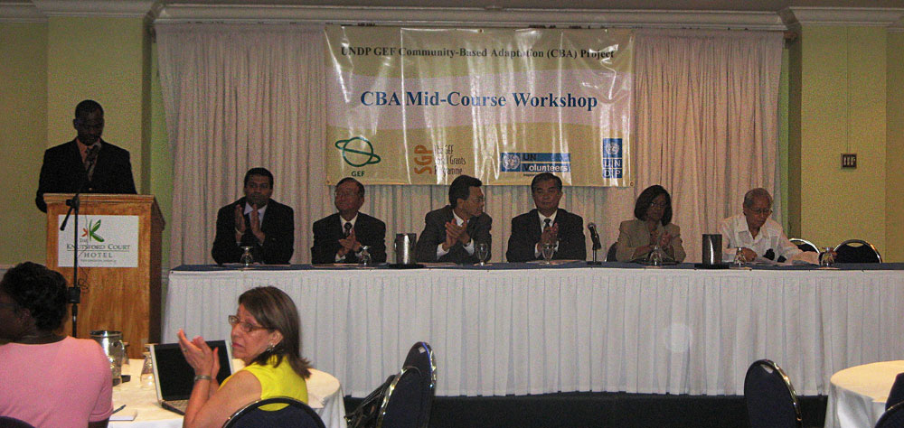
Workshop Opening Ceremony

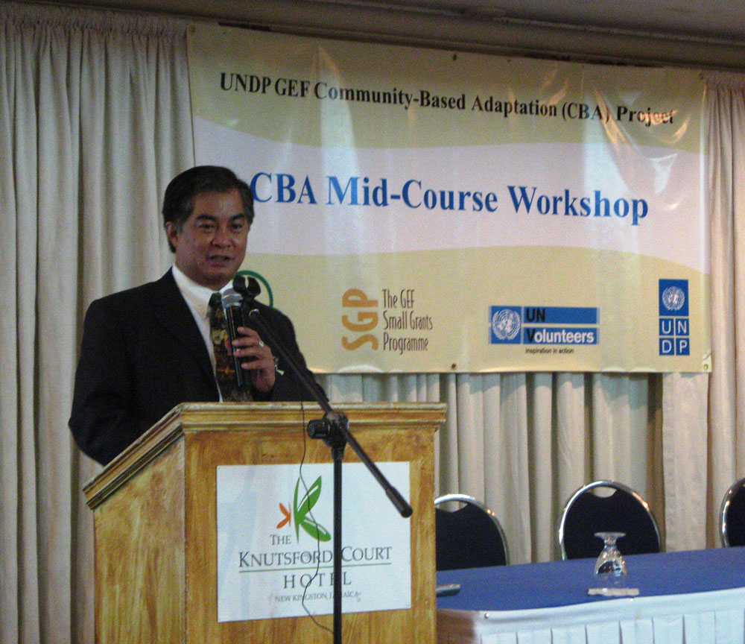
Delfin Ganapin, Global Manager, UNDP/GEF SGP

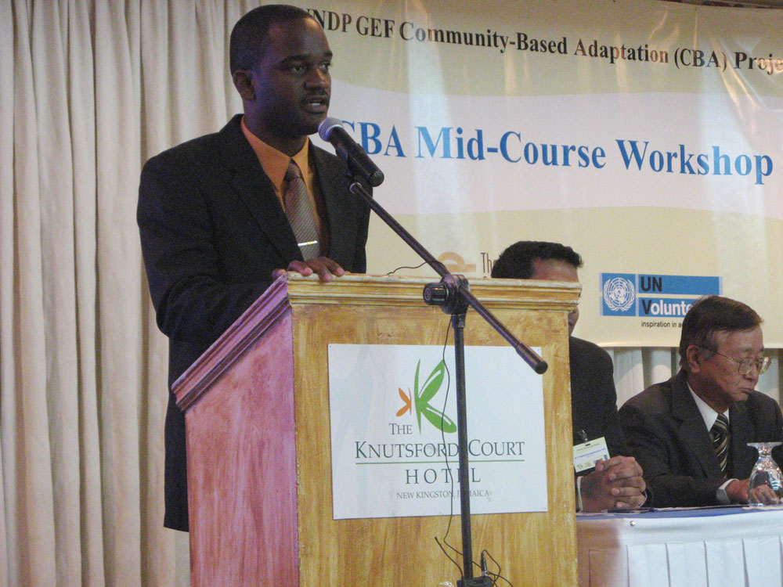
Dale Rankine, CBA/SGP National Coordinator for Jamaica welcoming participants.

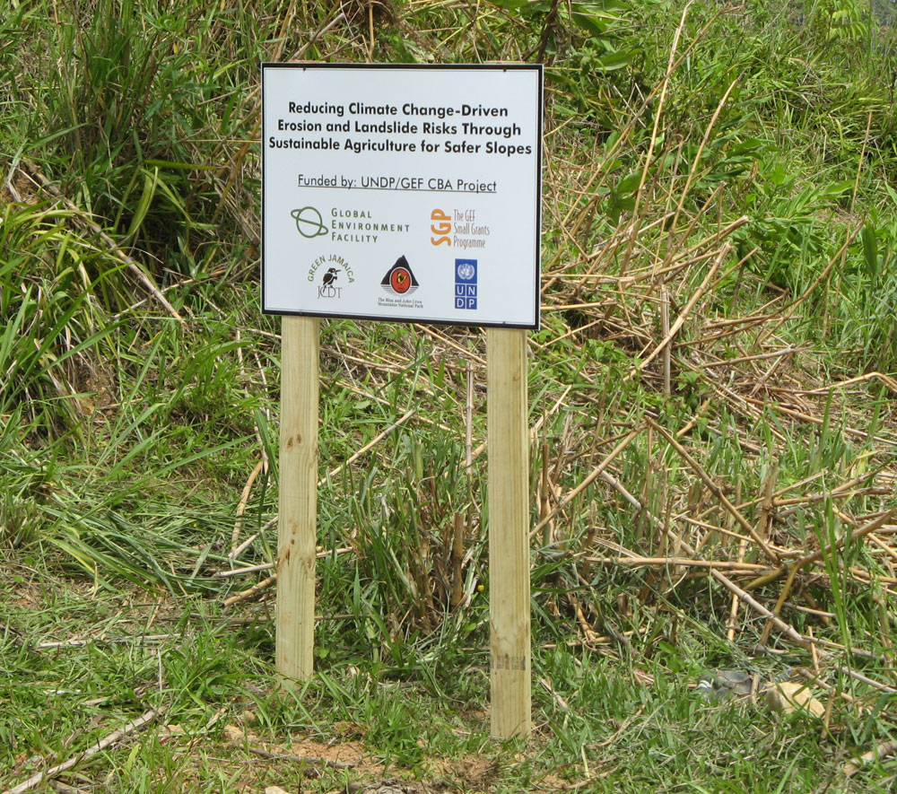
Field visit to CBA project site near Kingston.
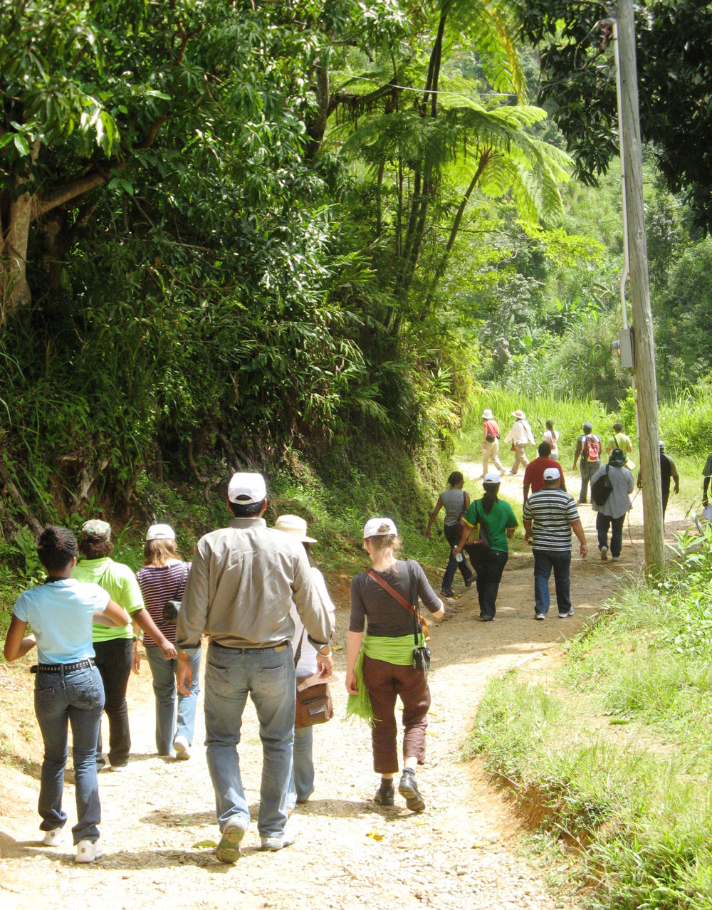
Field visit to CBA project site near Kingston.

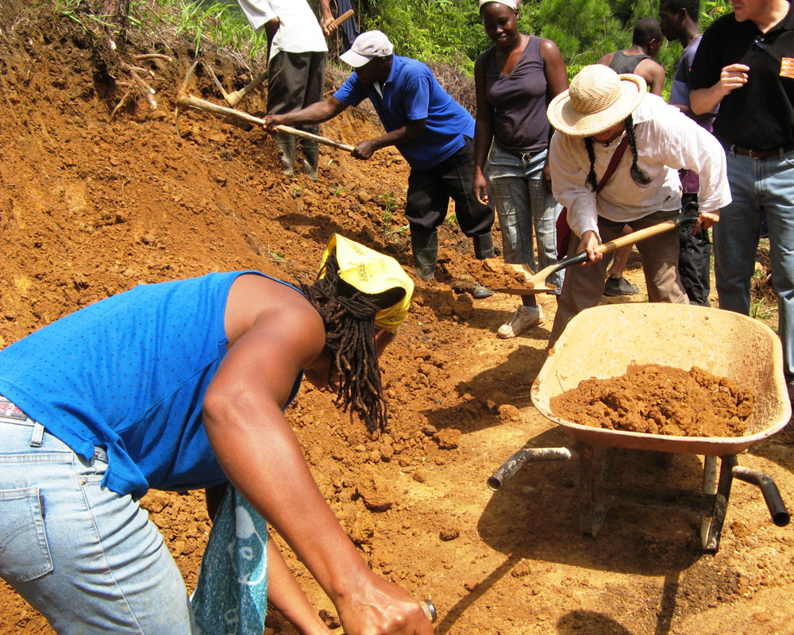
Community members clearing ground to construct a greenhouse.

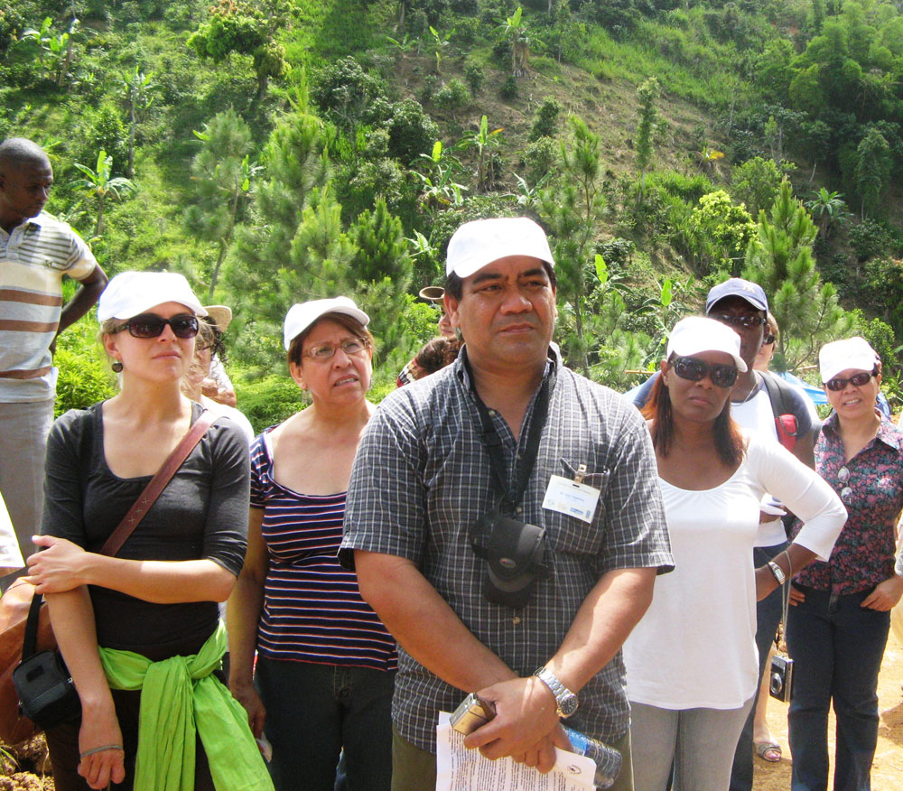
Field visit to CBA project site near Kingston.
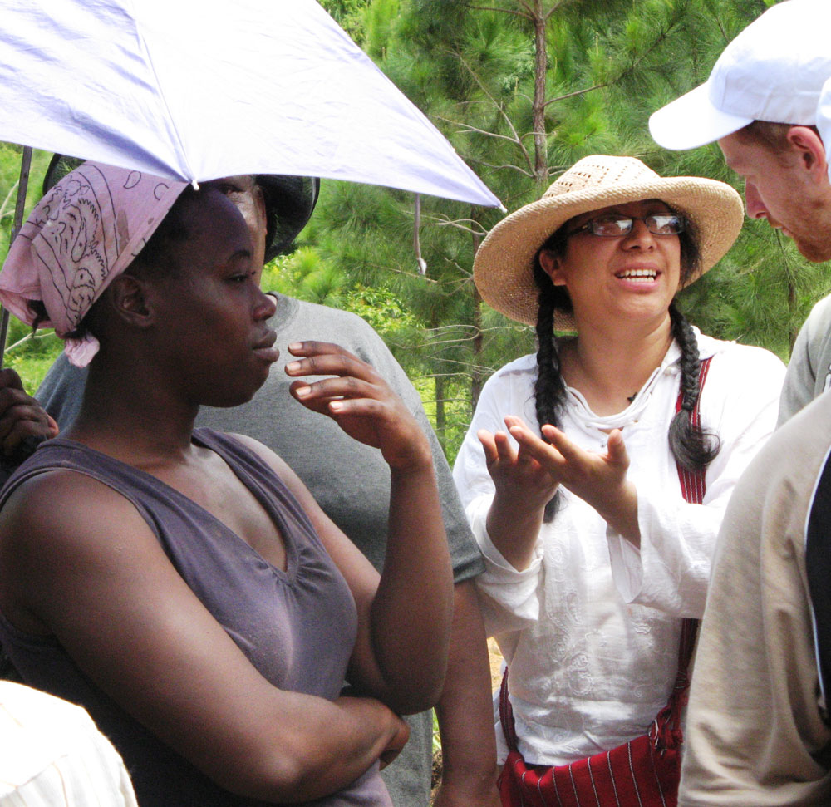
CBA staff discuss project with local residents.

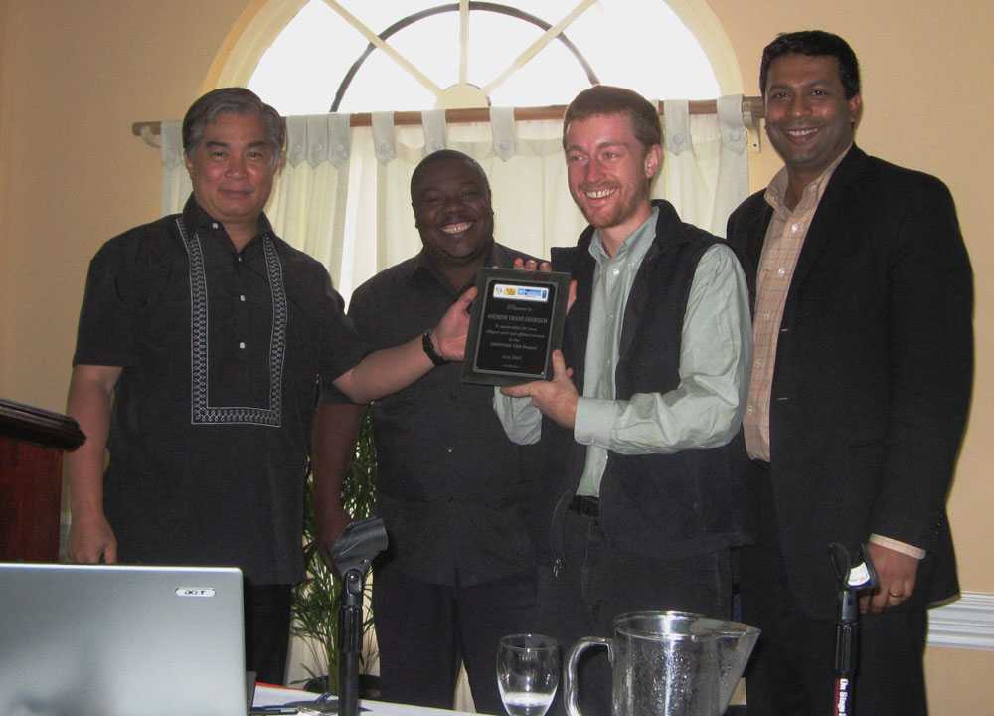
Delfin Ganapin (SGP), Nickey //Gaseb (CBA Namibia), Pradeep Kurukulasuriya (UNDP-GEF) present an award to outgoing CBA Project Coordinator Andrew Crane-Droesch.

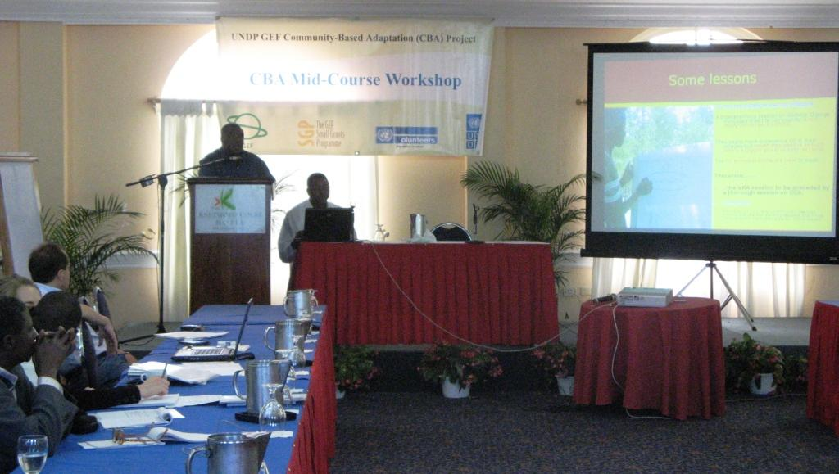
Nickey //Gaseb (CBA Namibia) and Katiella Mai Moussa (CBA Niger) give a presentation on lessons learned from implementing the Vulnerability Reduction Assessment.

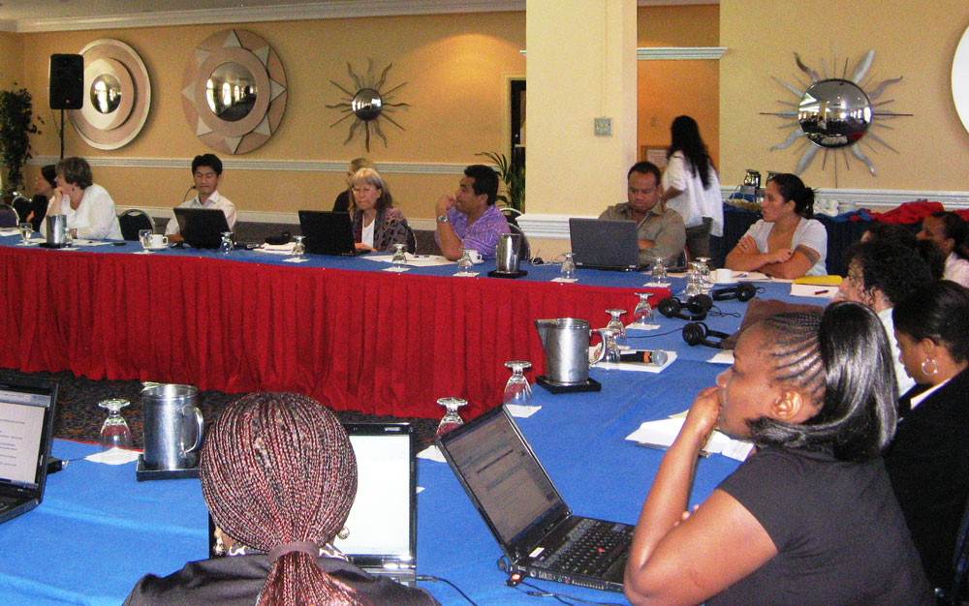

Workshop participants listening to a presentation.

