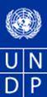
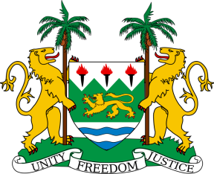
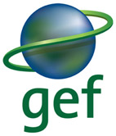

United Nations Development Programme
Country: Sierra Leone
PROJECT DOCUMENT

Project Title: Building Adaptive Capacity to Catalyze Active Public and Private Sector Participation to manage the Exposure and Sensitivity of Water Supply Services to Climate Change

UNDAF Outcome(s): 3. Natural resources are sustainably and equitably managed and threats and impacts from natural and man-made disasters are reduced

Expected CP Outcome(s): Policy framework and institutional arrangements for managing natural resources and addressing climate change, disaster, and environmental management strengthened

Expected CPAP Output (s):
(i) Policies, legal and institutional framework for managing land tenure reform improved;
(ii) Increased resilience and enhanced national and local capacities for disaster risk management, environmental governance, climate change adaptation and mitigation for effective early warning system
(iii) Improved Waste Management in Bo and Makeni cities and relevant lessons learned shared with other Local Councils

Executing Entity/Implementing Partner: Ministry of Water Resources

Responsible Party: UNDP

Programme Period: 2011 - 2015

Atlas Award ID: 00074076
Project ID: 00086632
PIMS # 4613

Start date: October 2013
End Date October 2017

Management Arrangements NIM
PAC Meeting Date TBD
Total resources required $ 13,090,000
Total allocated resources: $ 13,090,000

- GEF $ 2,940,000
- UNDP $ 150,000
- Other:
  - Government (Grant & In-kind) $ 9,000,000
  - UNDP (Grant & In-kind) $ 1,000,000

Brief Description
The water sector in Sierra Leone is undergoing revisions and sustainable water supply, which remains a major challenge to national development, is one of the major national priorities. There are several climate related challenges that place significant constraints to sustainable water supply, both to Freetown as well as rural districts. The most significant is that during prolonged dry spells provision of dirking water is problematic. Although sufficient water is available in the rainy season, during the dry season water shortage are pertinent. Other climate related risks include that (i) water sources are tapped unsustainably, and water is mined beyond long-term capacities, and (ii) water infrastructure developments are planned without taking climate resilience into account.

The proposed project has several entry points and overall focuses on capacity building for climate resilient decision-making in the water sector. Outcome 1 Critical public policies governing the management of water resources revised to incentivize climate smart investment by the private sector, will be achieved through specific technical capacity development activities and igniting informed public and private sector dialogues. Based on focused capacity needs assessments a suite of professional updating activities will be designed especially for staff of the newly formed Ministry of Water Resources, the Guma Valley Corporation and other specified key target groups. Outcome 2 Water supply infrastructure in Freetown and Puhejun, Kambia and Kono districts made resilient against climate change induced risks focuses on pioneering innovations that particularly address the dry season water supply problems, which are likely worsened by anticipated climate change impacts. On request of the MWR rain water-harvesting (RWH) innovations will be established as learning experiments, capturing and storing drinking water quality rainwater during the rainy season and saving it for use in the dry season. In Freetown existing springs that are already being developed by Guma as supplementary sources will be protected from degradation and rainwater for supplementation of the sources will be attempted through construction of stand-along RWH infrastructure. Innovative designs of collective “rooftops” for water capture in high density living areas will be tested. In Puhejun, Kono and Kambia districts – the focal areas for planned AfDB water supply investments – this project will build capacities of district level water professionals for climate resilient planning and decision-making. Additionally, low-cost and simple water supply and storage techniques promoted by the Welthungerhilfe and two associated community-training centres will be further developed to incorporate RWH innovations in their designs to help overcome dry season water supply shortages.

National institutions especially the MWR, who is the executing agency for this project, will directly absorb the adaptation learning emerging from the demonstrations. 2.94 Mio US$ will be required from GEF funds, with cash and in-kind co-financing through UNDP and the Government of Sierra Leone.

Agreed by (Government):
NAME SIGNATURE Date/Month/Year

Agreed by (Executing Entity/Implementing Partner):
NAME SIGNATURE Date/Month/Year

Agreed by (UNDP):
NAME SIGNATURE Date/Month/Year

Table of Contents
I. Situation analysis 6
1.1 Context 6
1.1.1. Environment 7
1.1.2. Policy 9
1.1.3. Institutional Context 11
1.1.4. Decentralization, Local Government, and Forms of Social Capital 12
1.2 Threats and root causes 13
1.2.1. Climate change context 13
1.2.2. Future climate projections 14
1.3 Long-term solutions and barriers 16
1.3.1. Key barriers 16
1.4 Stakeholder and baseline analysis 19
1.4.1 Stakeholder overview 19
1.4.2 An introduction to project sites 23

II. Strategy 32
2.1 Project rationale and policy conformity 32
2.2 Country ownership: country eligibility and country drivenness 33
2.3 Design principles and strategic considerations 33
2.4 Project objective, outcomes and outputs/activities 34

III. Project Results Framework 49

IV. Total budget and workplan 51

V. Management Arrangements 56

VI. Monitoring Framework and Evaluation 58

VII. Legal Context 62

Annexes 63

List of acronyms
ACF  AfDB  AMAT  ARR  AWP  BTOR  CC | Action Contre la Faim (Action Aid Sierra Leone)  African Development Bank  Adaptation Monitoring and Assessment Tool  Annual Performance Report  Annual Work Plan  Back To Office Report  Climate Change
CCA  CCM  CCRM  CBO | Climate Change Adaptation  Climate Change Management  Climate Change Risk Management  Community Based Organisation
CDA  CHO | County Development Agendas  Community Health Officer
CO | Country Office
CP  CPAP | Country Program  Country Programme Action Plan
CRM | Climate Risk Management
DFID  DEX  EC  EDF | Department for International Development  Direct Execution  European Commission  European Development Fund
ENSO  EPA  ERC  EWS  FACE | El Nino Southern Oscillation  Sierra Leone Environmental Protection Agency  Evaluation Resource Center  Early Warning System  Fund Authorization and Certificate of Expenditures
FAO | Food Agriculture Organization
FAOSTAT  GB  GDP | Food Agriculture Organization – Statistics  Great Britain  Gross Domestic Product
GEF  GCM  GoSL  GIZ  GVWC  ICRC  IDPs  IRC | Global Environmental facility  General Circulation Models  Government of Sierra Leone  German International Cooperation  Guma Valley Water Company  International Committee of the Red Cross  Internally Displaced Persons  International Rescue Committee
IPCC | Intergovernmental Panel on Climate Change
ITCZ  JICA  LVIPs | Inter- Tropical Conversion Zone  Japan International Cooperation Agency  Kumasi Ventilated Improved Pit Latrines
LDC | Least Developed Country
LDCF | Least Developed Countries Fund
M&E  MEAs | Monitoring and Evaluation  Multilateral Environmental Agreements
MDGs  MOA  MoWR  MoFED  MoHS  MLGRD  MSF  NCCS | Millennium Development Goals  Ministry of Agriculture  Ministry of Water Resources  Ministry of Finance and Economic Development  Ministry of Health and Sanitation  Ministry of Local Government and Rural Development  Medicine San Frontiers  National Climate Change Secretariat
NAPA  NEWPPCU  NDSAP  NGO  NWSP | National Adaptation Program of Action  National Energy, Water Policy Planning and Coordinating Unit  National Sustainable Agriculture Development Plan  Non-Governmental Organisation  National Water Supply Policy
NPRS | National Poverty Reduction Strategy
PAC  PC  PHU  PIF  PIU  PIR | Project Appraisal Committee  Project Coordinator  Peripheral Health Unit  Project Identification Form  Project Implementation Unit  Project Implementation Review
PPG  PPPs  PROWACO | Project Preparation Grants  Public-Private Partnerships  Provincial Water Company (formerly called SALWACO)
PRS  PRSP  PWJ  RBM  RUF  SALWACO | Poverty Reduction Strategy  Poverty Reduction Strategy Papers  Peace Winds Japan  Result Based Management  Revolutionary United Front  Sierra Leone Water Company (now PROWACO)
SBAA | Standard Basic Assistance Agreement
SCCF  SLBF  TAR  TBD  ToRs  UN  UNHRC  UNICEF | Special Climate Change Fund  Sierra Leone Business Forum  Third Assessment Report  To Be Done  Terms of Reference  United Nations  United Nations High Commissioner for Refugees  United Nations Children’s Fund
UNDAF | United Nations Development Assistance Framework
UNDP  UNDP CO  UNDP EEG  UNDP RCU  UNDP RTA | United Nations Development Program  United Nations Development Program Country Office  United Nations Development Program Environment and Energy Group  United Nations Development Program Regional Coordination Unit  United Nations Development Program Regional Technical Advisor
UNFCCC  USAID  USD  WASH  WD  WPPCU | United Nations Framework Convention on Climate Change  United States Agency for International Development  United States Dollars  Water, Sanitation and Hygiene Policy  Water Department  Water Policy Planning and Coordination Unit

Situation analysis

1.1 Context
- Sierra Leone is an Anglophone West African country, bordering the North Atlantic Ocean, between Liberia and Guinea. The country is richly endowed in natural resources, especially minerals such as diamonds, titanium bauxite, gold and rutile, on which the economy is largely based. However, despite this natural wealth, 70% of the total population, of 6 million people (FAO, 2012), live in poverty. Sierra Leone’s 11-year civil war (1991-2002) was a large influencing factor in the deterioration of livelihoods, infrastructure, production capacity, and economy. In 2010, the country’s GDP stood at approximately 2.2 billion USD (World Bank, 2010). Resilience and economic growth are priorities to the country.

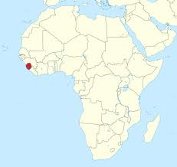
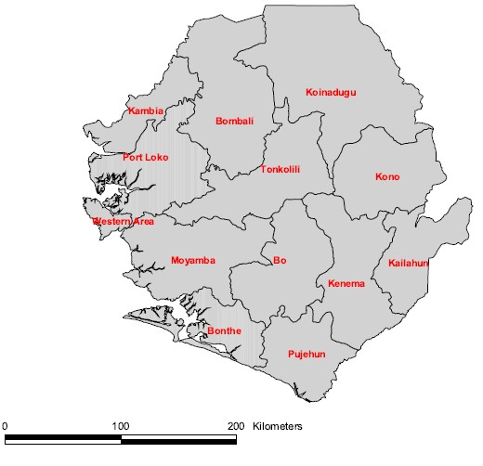
Figure 1. Map of Sierra Leone, and location in Africa

- During the civil war, which took place between 1991 and 2002, more than 50 000 people were killed, much of the country’s infrastructure was destroyed, and more than two million people were displaced to neighbouring countries. The presence of diamonds had a large influencing factor on the war, and was used to fund the acquisition of weapons and ammunition.

- The end of the war was a result of Guinean cross-border bombing raids against villages believed to be bases used by RUF (Revolutionary United Front), as well as a UN resolution that demanded the Government of Liberia expel all RUF members and halt the illicit diamond trade, among others. Efforts by the Lome Accord, trust and reconciliation and the 2002 presidential and legislative democratic elections served well in establishing a context for increasing humanitarian interventions. The country is slowly emerging and showing signs of a successful transition. However, many challenges remain, among them one of the biggest has been the access to safe drinking water.

- The civil war had devastating impacts on all facets of the economy, destroying Government’s ability to adequately meet the needs of the nation. The water sector is probably the sector which has had most challenges in improvement. Despite efforts by Government and numerous NGOs, access to water has not improved much since the end of the civil war, stagnating at about 50% and even declining in rural areas. The percentage access of the population to safe drinking water is 34%.

- One of the main challenges has been the lack of capacity in the water sector – and with the projections of climate change set to exacerbate the water issue – this is the main area which needs to be addressed for resilience and adaptation.

1.1.1. Environment

- Geography: Sierra Leone is located in the southern in the south-western part of the bulge of West Africa, between 7 and 10°N and 10 and 13°E. The country covers a total area of 71,325 km² and is divided into four geographical regions: the Northern Province, Eastern Province, Southern Province and the Western Area. These regions are further subdivided into fourteen districts. Freetown, located in the Western Area of the country, is the capital.

- Drainage and Watersheds: The country is well drained by numerous rivers and creeks. Of the main rivers, five of these have their sources from the neighbouring countries of the Republic of Guinea and Liberia (Figure 2). The Great Scarcies, Little Scarcies and Moa river basins have their sources from the Guinea whilst the Mano river basin has its source in the Republic of Liberia (Figure 2). The drainage system of Sierra Leone consists of a series of rivers from north to south, including the Great Scarcies, Little Scarcies, Rokel, Jong, Sewa, Moa, and Mano rivers (Figure 3). The country is considered to be endowed in abundant water resources, but water is known to be scarce in the dry season.

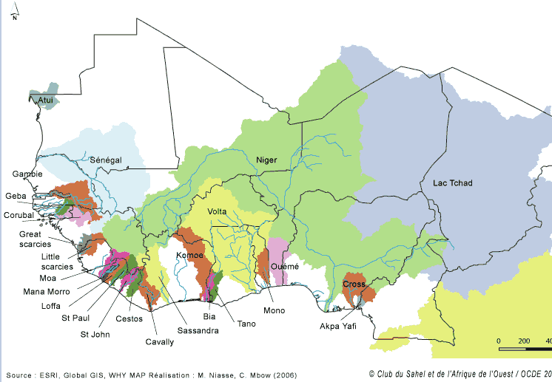
Figure 2 Transboundary Watersheds in West Africa
Figure 3 Main surface river basins of Sierra Leone
- Groundwater: Groundwater is the mainstay of water supply provision sources throughout the country in both the rural and urban areas as a result of the failed central public water service provision. The groundwater usual forms range from boreholes, to concrete line hand-dug wells to traditional dug wells and to various spring sources. Very little reliable information is known about the capacity of the various well in the absence of any systematic monitoring. Thus there is absence of much scientific knowledge and analysis about how much of it is available in the country and how it is distributed.
- Climate and vegetation cover: Sierra Leone has a tropical climate with two distinct seasons. The dry season generally runs from December to April, and the rainy season runs from May to November. The country has six major ecosystems: Forest, Montane, Savanna, Agricultural, Wetland, Freshwater, Coastal and Marine.
- Environmental degradation: Deforestation (for energy and construction) accounts, to a large extent, for the environmental degradation in the country. Mining activities have also left vast areas deforested and degraded. The uncontrolled exploitation of mineral resources, coupled with very few mitigating policies and conservation programmes over the years, and poor enforcement of those existing, has resulted in devastating environmental consequences. Sierra Leone also faces other environmental problems such as land degradation, loss of biodiversity, coastal area degradation and pollution of fresh water resources.

- Water supply and access: Despite Sierra Leone being endowed with abundant water resources in the form of seven major rivers, only 34% of the population has access to safe drinking water (up to 80% of the rural population has no access). Sierra Leone is unlikely to reach the Millennium Development Goal (MDG) targets on halving the number of people without access to improved water sources and sanitation by 2015 if it carries on its current trend, with or without climate change. Changes in the national water supply and sanitation (WSS) policy in Sierra Leone have resulted in frequent shifts in responsibilities and lack of capacity. Institutional changes have mostly followed political changes. The challenge going forward will be to fully implement the current policies while sorting out the (limited) inconsistencies with other pieces of legislation. It will be important that the sector has adequate time for implementation, to build capacity, and to align funding to responsibilities.

The devolution of water supply responsibilities as prescribed in the 2004 Local Government Act has not been implemented due to lack of capacity in the local council administrations, resistance of central ministries, and inconsistencies among various laws. With the ongoing decentralization process, further institutional reforms are foreseen in the framework of the new National Water and Sanitation Policy (NWSP) and the Local Government Act, with more responsibilities being devolved to local governments which should play an increasing role in water supply and sanitation service delivery.

The NAPA states that the water supply in Sierra Leone (Freetown and inland settlements) requires urgent attention. This sector is also depicted as one of the most vulnerable to climate change. Climate change has the potential to severely disrupt the water regimes, possibly leading to floods, droughts, changes in the amount of runoff as well as changes in ground water levels. One of the priority projects under the NAPA is the institutional strengthening of the water sector. The aim of the project is to strengthening existing institutions for effective management and control of water resources for sustainable development. The need to enhance human and institutional capacities is consistent with ensuring that realistic options aimed at minimizing the negative impacts of climate change are considered. The outcomes of the project would provide the impetus for government and other stakeholders to intensify efforts geared towards adapting successfully to climate change through monitoring and research. Another priority project of the NAPA includes improving the existing supply of water in Sierra Leone. The third priority project related to water includes the promotion of rainwater harvesting techniques to improve access to water at household and community level.

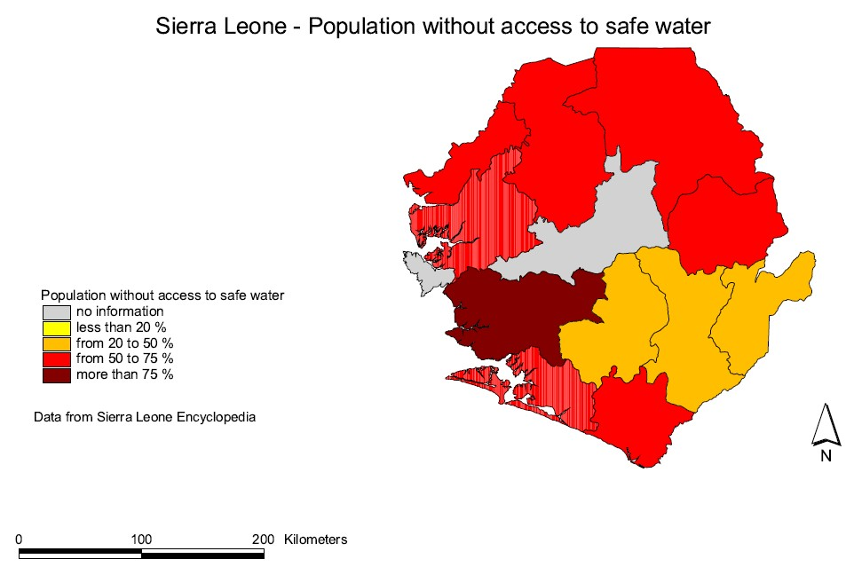

Figure 4 Map of population without access to safe water in the districts of Sierra Leone. Source Unicef 2003

1.1.2. Policy
An in-depth review of all policies relating to water and climate change was undertaken as part of the development of the project (Annex 4). The hierarchy of relevant policies is:

- Vision for Sierra Leone 2025: Launched in 2001, the “Sierra Leone Vision 2025: Sweet-Salone” is the country’s long-term development plan. At its core is the aim to create a prosperous society that cares about the people and the environment. Under its first scenario, “Sweet-Salone”, which it aspires to, it aims that by 2025, Sierra Leone has known years of peace, democratic and only moderately corrupt governance, sound economic growth, lower unemployment and poverty, and improved quality of life for all. Among the facets towards improved quality of life is the provision of adequate healthcare, water and sanitation for all. This project falls within the domain of the vision in terms of it upgrading infrastructure and capacity through donor funding and private investment toward clean water supply to all areas of the country equitably.

- The Poverty Reduction Strategies (PRS): Sierra Leone implemented the first Poverty Reduction Strategy, which focused on consolidating peace and security and economic growth. However, poverty is still wide-spread and the country has consistently ranked at the very bottom the UN Human Development Index. The country now has a second Poverty Reduction Strategy (‘Agenda for Change’). The second strategy’s fourth priority includes the increase of the population’s access to safe drinking water.

- County Development Plans: Two relevant development plans include the Financial Sector Development Plan, which eludes to the country’s inadequate water supplies as one major hindrance to the country’s progress; and the National Sustainable Agriculture Development Plan (2010-2030) which among its many actions, focuses on the development of a sustainable water management system and water conservation.

- United Nations Development Assistance Framework (UNDAF, 2008-2010) and the UNDP Country Programme of Action (2011-2012): The UNDAF (2008-2010) largely focused on increasing the population’s access to water. The UNDP Country Programme of Action (2011) has various relevant focuses, including climate change, capacity building in various sectors and the equitable delivery of public services (through capacity building), including water.

- The Transitional Joint Vision for Sierra Leone of the United Nations Family (2013-2014): The transitional plan focuses through its Cluster 3 to ensure that natural resources are sustainably and equitably managed and threats and impacts from natural and man-made disasters are reduced. UNDP is the cluster focal point for the UN family and climate change resilience can be considered a critical component for the various cluster objectives.

- National Adaptation Program of Action: Sierra Leone completed its NAPA in 2007 and the program sets out various priorities in terms of adaptation. The project sets out to address two of its priorities, namely (1) capacity building of the Meteorological Department through training of personnel at various levels in order to capacitate the department in its mandate to support the formulation of climate change policies necessary for information to decision makers for mainstreaming climate change; (2) institutional strengthening of the water resources sector with a view to ensuring effective delivery of hydrological services, predicated on the realization that workable options for adapting to climate change is consistent with collaborative research, monitoring, and efficient management of finite resources; and (3) promotion of rain water harvesting and development of an integrated management system for fresh water bodies with the aim of increasing water availability for domestic and commercial use through sensitization of communities about the possibility of capturing, storing and utilizing water.

- National Sustainable Agriculture Development Plan (2010-2030): The National Sustainable Agriculture Development Plan (NDSAP) provides the roadmap for moving agriculture, forestry and fisheries forward to address Sierra Leone’s growing needs due to population growth and to create additional income to the national economy. It elaborates on the potential for irrigation remaining largely unexploited and argues the need to utilize the annual rainfall for extending the growing season into the six-month dry season. In terms of climate change, it notes that farming practices are expected to change with a move towards practices that are better adjusted to erratic rainfall such as photo-sensitive rice varieties for more flexibility in planting times. It also argues that climate change is not expected to severely impact Sierra Leone’s favourable rainfall if forest cover is maintained.

- Forestry Policy: There is no formally adopted Forest Policy for Sierra Leone yet, but rather an evolution of practice in response to changing priorities, including decentralization, community roles, gender issues and the linkages to other sectors, such as water catchment. It makes links to water through the conservation and protection of water catchments areas in order to maintain a sustained water yield for inland valley swamp development and cultivation.

- Draft Rural Water Supply Strategy: The strategy document describes an approach for extending and sustaining rural water supply service delivery across Sierra Leone. The guide is intended primarily to support stakeholders working directly and indirectly in the water supply and sanitation sector. It makes no direct linkages to climate change, but does note that some communities will be susceptible to the risks of seasonal flooding and disease outbreaks, as well as other shocks.

- Water, Sanitation and Hygiene (WASH) Policy: The WASH Policy responds to the urgent need for integrated and cross-sectoral approaches to water management and development as well as the provision of safe and adequate drinking water facilities. It provides overall direction for addressing the challenges in the WASH sector, and covers five main thematic areas, namely water resources management, urban water supply and sewage, rural water supply, hygiene and sanitation, and the legal regulatory, and institutional framework.

1.1.3. Institutional Context
- In general, institutional capacity remains extremely weak. Most government institutions became dysfunctional during the war because of lack of qualified staff, lack of resources and lack of financing. The condition of these institutions was further exacerbated by high levels of corruption. In the post-war period, difficulty in attracting professionals, progressive reduction of donor funding, lack of clear mandates and, to some degree, a weakly shared national vision constrain performance. A very weak judicial system lacks the capacity to adjudicate matters in a timely manner.

- The WASH Policy defines the roles and mandates of each institution and Ministry, suggests various reforms so to allow for coordination and collaboration between stakeholders for the benefit of the national economy and population of Sierra Leone. The implementation of the Policy falls under the remit of four government ministries namely the MWR, the Ministry of Finance and Economic Development (MoFED), the Ministry of Health and Sanitation (MoHS) and the Ministry of Local Government and Rural Development (MLGRD); and the local councils. The MoEWR is the line Ministry with overall responsibility for energy (mainly electricity) and water policy formulation, regulation, and implementation supervision. The MoEWR hosts and provides leadership for the multi-donor funded Sierra Leone WASH Programme which aims to enhance the country’s capacity for achieving the MDG targets for water and sanitation. The Ministry of Finance and Economic Development (MoFED) is responsible for government finances and development planning, including providing strategic guidance to planning and financial management, and funding for WASH sector development activities. MoHS is now responsible for mainly policy formulation and providing oversight for delivery of health and environmental sanitation (solid waste) services. Primary health care services (including environmental health) is devolved to the local councils, which makes the actual delivery of solid waste management the responsibility of local councils. The situation with respect to other aspects of sanitation still needs clarification. MOHS has a crucial interest and role in the implementation of the NWSP given the close alignment of water, sanitation and hygiene, and health outcomes, standards and costs. The MLGRD among other things is charged with implementation of the National Decentralization Policy.
- The Ministry of Water Resources (MWR) was established as a stand-alone Ministry after the last elections in November 2012. It is the lead Government institution responsible for water and the decision to make it an own entity (before it was the joint Ministry of Energy and Water Resources) can be seen as a drive to elevate its operations. Its main functions focus on ensuring that all citizens have access to adequate water services.

- One of the biggest issues identified is that institutional capacity is weak and much effort is needed to strengthen central and local level authorities. Various recommendations towards institutional strengthening have been made and one of these is the priority that the Ministry needs to build experience and expertise for water resources management that will support the establishment of a National Water Resources Management Agency.

- The Ministry of Water Resources has a road-map of interventions, and one of them is the active roles for community-based institutions. The ministry aims to introduce the concept of community based water resources management and encourage the WASH sector to engage in water resources management issues.

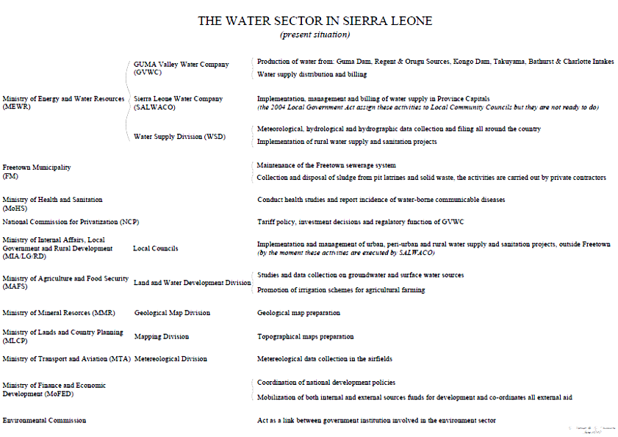
Figure 5 The Water Sector Structure in Sierra Leone

1.1.4. Decentralization, Local Government, and Forms of Social Capital
- Sierra Leone is going through a process of decentralization. Under the Local Government Act (2004) and in line with the Local Government Regulations (2004), responsibilities for sanitation provision were decentralized, with Local Councils assuming full responsibilities on sanitation aspects in 2005. However, Local Councils are still in the process of building capacity and are yet to determine what this role might mean in practice and how they will implement this demanding responsibility. There are therefore concerns regarding human resources as the sector adopts decentralized service provision. Local government bodies, with limited technical capacity and financial resources are likely to struggle to fulfil their roles.

- Decentralization was reintroduced in Sierra Leone in the immediate post-war years after three decades of suspension. The devolution of water supply services started taking place only during the second phase (post-2008) and is only now being devolved to the councils, and is still currently largely limited to rural water supply.

- Delays in devolution, experienced in the past years, have largely been due to weak local level capacities especially in the district councils against associated financial and other risks. The decentralization policy requires that the central government transfer both funds and personnel for devolved functions. However, the payroll and personnel management aspect of devolved functions continue to be centralized in Freetown. Therefore councils generally manage with the staff either recruited by them or assigned from the central government to carry on core support administrative and management functions rather than actual technical service delivery functions.

1.2 Threats and root causes

1.2.1. Climate change context
- Climate change represents a significant threat to all countries. This threat is tempered by capacity of each country to adapt to the changes. Adaptive capacity is the ‘ability to design and implement effective adaptation strategies or to react to evolving hazards and stresses so as to reduce the likelihood of the occurrence and/or the magnitude of harmful outcomes resulting from climate-related hazards’.

- The climate of Sierra Leone can be summarized as follows; monthly rainfall is approximately 1000 mm in coastal Sierra Leone but decreases to 300 mm in the west. Rainfall occurs during the wet season, between May and October, peaking between July and September. The rainfall season is largely controlled by the movement of the Inter-Tropical Conversion Zone (ITCZ) which oscillates between the northern and southern tropics over the course of the year. When the ITCZ, is in its northern position, the dominant wind direction in regions south of the ITCZ is south-westerly, blowing moist air from the Atlantic onto the continent. This pattern is referred to as the West African Monsoon, and causes exceptionally high rainfall on the coastline of West Africa during the wet season. During the winter, the dominant wind direction is reversed, the dry and dusty Harmattan winds blow from the Sahara desert.

- The seasonal rainfall in this region varies considerably on inter-annual and inter-decadal timescales, due in part to variations in the movements and intensity of the ITCZ, and also to variations in timing and intensity of the West African Monsoon. The most well documented cause of these variations is the El Niño Southern Oscillation (ENSO). El Niño events are associated with drier conditions in West Africa.

- Temperature
- Annually, projections indicate that ‘hot’ days have increased by 38 – and additional 10.3% of nights – between 1960 and 2003.
- Annually, projections indicate that ‘hot’ days will occur on 26-63% of days by the 2060s, and 37-84% of days by the 2090s.
- Hot` day or hot night is defined by the temperature exceeded on 10% of days or nights in the current climate of that region and season. Cold days or cold nights are defined as the temperature below which 10% of days or nights are recorded in the current climate of that region or season.
- Nights that are considered hot for the annual climate of 1970-99 are projected to occur on 41-79% of nights by the 2060s and 54-92% of nights by the 2090s.

- The temperatures in Sierra Leone are lowest in the wettest season (22-25°C) and higher during the rest of the year (25-27°C). Mean annual temperature has increased by 0.8°C since 1960, and average rate of 0.18°C per decade.

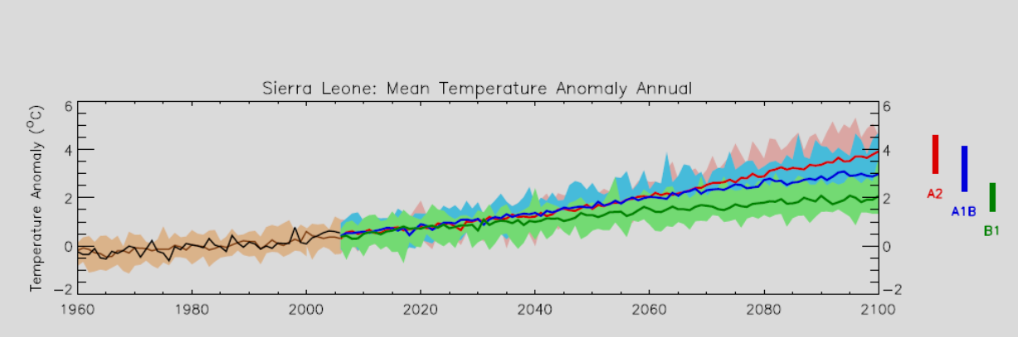
Figure 6 Past and projected mean temperatures for Sierra Leone up to 2011. Source: UNDP Climate Change Country Profiles (http://country_ profiles.geog.ox.ac.uk)
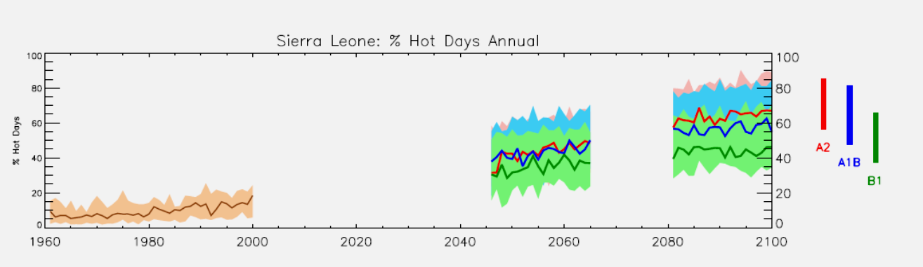
Figure 7 Past and projected percentage of hot days for Sierra Leone up to 2011. Source: UNDP Climate Change Country Profiles (http://country_ profiles.geog.ox.ac.uk)

- Precipitation
- Projections of mean annual rainfall averaged over the country from different models in the ensemble project show a wide range of changes in precipitation for Sierra Leone, but tend towards overall increases, particularly in JAS and OND. Rainfall in JAS is projected to change by -27 to +29% by the 2090s, and -19 to +33% in OND.
- The proportion of total annual rainfall that falls in heavy events is projected to increase. Seasonally, this varies between tendencies to decrease in JFM and to increases in JAS and OND.
- 1- and 5-day rainfall maxima in projections all tend towards increases, particularly in JAS. The range of changes in projection from the model ensemble covers both increases and decreases in all seasons.
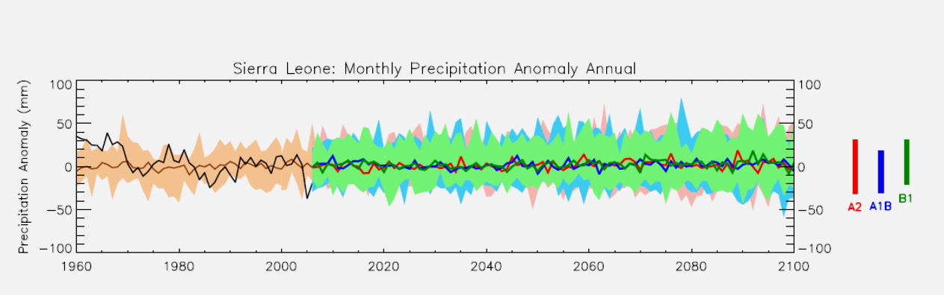
Figure 8 Past and projected monthly precipitation for Sierra Leone up to 2011. Source: UNDP Climate Change Country Profiles (http://country_ profiles.geog.ox.ac.uk)

- Regional Climate Change
- Model simulation of precipitation changes for the Sahelian and Guinea Coast regions of Africa are strongly divergent and most models fail to reproduce realistic inter-annual and inter-decadal rainfall variability in the Sahel in twentieth century simulations. There is insufficient understanding of the processes causing tropical rainfall to allow a prediction of the direction of change with any certainty. IPCC identifies this as an area requiring future research to understand the variety of model responses in this region (Christensen et al, 2007).
- Model simulation shows wide divergence in projected changes in the amplitude of future El Niño events as the West African climate can be strongly influenced by ENSO, thus contributing to uncertainty in climate projections for this region.

1.2.2. Future climate projections
- The mean annual temperature is projected to increase by 1.0–2.6°C by the 2060s and 1.5–4.6°C by the 2090s. The projected rate of warming is most rapid in the northern inland regions of western Africa than the coastal regions. According to the NAPA, the projected rainfall from 1961–1990 to 2100 under the General Circulation Models (GCM) outputs show an increase in rainfall by about 3% and 10% below current monthly and annual rainfall values respectively. The NAPA’s results indicate that because the maximum temperatures have increased (by about 0.67°C and 0.18°C respectively) with a corresponding interesting trend in the decrease in precipitation levels by 50.28mm, it is projected that Sierra Leone will continue to experience an increase in temperature as well as drought/dry spells.

- The climate models (HADCM2, UKTR, CSIRO, ECHAM and UKMOEQ) indicate a steady increase in temperature for Sierra Leone with little inter-model variance. With regards to rainfall an increase or decrease under climate change scenario is a critical factor in estimating how climate change will affect Sierra Leone, given the country’s extreme vulnerability to water related problems. Various General Circulation Models (GCMs) have been used in developing climate change scenarios for Sierra Leone. The models predict an increase in temperature of of about 5 °C by 2100. The increase in temperature will increase the amount and intensity of precipitation. An increase in rainfall could lead to an increase in surface runoff, resulting in flooding. On the other hand a decrease in the amount and intensity of rainfall may lead to drought. Climatic risks pose a serious challenge to Sierra Leone’s water sector, a sector which already faces several challenges.

1.2.3. The Vulnerability of Sierra Leone’s water sector

- By far the highest vulnerability is the current infrastructure, which still is lacking or very poor and is only now being rehabilitated and has been impacted as a result of the war. Most communities rely on surface water, which has implications in terms of water-borne diseases. Already, a large percentage of the population has no access to clean water. It is projected that this will be further exacerbated by climate change, especially during prolonged dry spells. Major water uses include domestic (drinking, cooking, hygiene), agriculture (irrigation), industrial (beer, spirits, soft drink, cooling and waste disposal), and energy production (hydroelectrical power production). Migration of the rural population to the capital, Freetown, during the civil conflict has put considerable pressure on the water demand.

- Shifting rainfall has created water supply problems resulting in the decrease to consumers, reduced stream flow of rivers and streams and also health related problems associated with the outbreak of water borne disease. For example, following the drop in rainfall since 1970s, the flows of major rivers has fallen significantly. The stream flow to the Manu River fell by 30% between 1971 and 1989.

- Pollution of surface water resources through uncontrolled mining activities is a major problem in West Africa and especially Sierra Leone.

- Increased flooding could cause serious problems, such as pollution of ground water and destruction of current water-related infrastructure. Long dry spells in north and western areas of the country have already disrupted water supply resulting in negative health impacts. As water resources become scarce and competition for water increases, polluted water may be used for drinking and bathing, and this spreads infectious diseases such as typhoid, cholera and gastroenteritis. These diseases particularly affect the urban poor. Moreover, decreased availability of water for irrigation food production heightens the risk of poor nutrition and increased susceptibility to disease.

- The water sector is also already limited in terms of capacity and investment opportunity (especially in the forms of tariffs). The institutional and individual capacity for climate change adaptation is extremely low, leaving this sector particularly vulnerable. Because virtually all other sectors depend on an effective supply of water, the high vulnerability of the water sector has a “domino” effect on the increasing vulnerability of other sectors, e.g. agriculture, mining, health. It also has major implications on other important aspects, like food security. As a whole it can seriously undermine the Millennium Development Goals, the improvement of livelihoods.

- In terms of ecosystem services, a sustained decrease in normal rainfall could alter the hydrographic bearing of the country’s streams and rivers. The IPCC’s Third Assessment Report (TAR) reveals that current trends in major river basins in Africa indicate a decrease in runoff of about 17% over the past decade. The expected decrease in rainfall compounding the low conversion factor of precipitation to runoff will exacerbate the water resource shortfall.

- The vulnerability of ecosystems and forest formation to protect watersheds will depend on rainfall variability modulated by vegetation dynamics in the various geographical regions in Sierra Leone. Less rainfall and a potential increase in evapo-transpiration could affect the distribution of plant and animal species, which already is under considerable pressure from deforestation for ladn clearing and energy supplies. Projected climate change is expected to alter frequency, intensity, and the extent of vegetation fires. Potential increases in the frequency and severity of drought are likely to exacerbate desertification. This of course will have a compounding affect on the water availability and further increase vulnerability of the water sector.

- The fact that 90% of Freetown’s population depends on one water source, the Guma Valley reservoir, puts immense pressure on the source. The Guma Valley Water Company, the company responsible for water provision, has a severely weak monitoring system in place and a virtually non-existing risk management or contingency plan i.e. related to climate risks. In 2006, the water level fell way below the intake level causing a major water shortage in the city. On the other hand, during intense rainy seasons, the reservoir is at full capacity – leaving it highly vulnerable to overflow. Either one of these situations causes immense vulnerability to the city’s inhabitants, and with no Early Warning System, or effective monitoring in place, elevates the vulnerability even more so.

1.3 Long-term solutions and barriers
- The ultimate long-term solution would be to have an enhanced capacity of decision-makers in the public and private sector involved in water provision to plan for and respond effectively to climate change risks on water resources. They would ensure that water sector investments made are climate resilient, with mainstreamed adaptation in water development frameworks at country level and targeted vulnerable areas. Adaptive mechanisms and innovations are being tested in target pilot sites, at the local community level, and lessons learned synthesised for systematic up-scaling. It is recognized that climate change is not the only threat to the water sector in Sierra Leone, however, the below analysis does specifically address this threat.

1.3.1. Key barriers

Difficulty to react to uncertainty of climate risk
- Climate change is a hard issue to address and manage: (1) effects may take a long time to be felt (2) it is still not clear what they will be, and (3) therefore the best way to manage them cannot be predicted with any precision. Above all there is a complex interrelationship with the impacts of environmental destruction because of human action that leaves many societies vulnerable to the slightest change in weather regimes that are so important for their access to clean and safe water.

- The increase in variability and unpredictability of global climate will have impacts across the world. In West Africa, rainfall patterns will be disrupted and temperatures will increase, but the detail of these effects cannot be accurately predicted and the effects of climate change at country level are similarly poorly understood. Sierra Leone needs to formulate and start to implement responses to the likely future global changes in climate.

Absence of reliable/up to date information on climate impacts on key sectors, including gender specificities
- The decade old civil war limited institutional capacity to systematically collect and analyze data to inform climate resilient policy formulation. Inadequate staff and poor facilities for weather forecasting and related activities have undermined the ability of the Meteorological Department to provide adequate support information to other sectors of the economy so that they can better adapt to the impacts of climate change. Whilst some targeted efforts are underway by institutions such as the UK Met Services through funding by UNDP and others, to systematically strengthen the Meteorological Department’s capacity, there are major gaps in technical skills for generation information on climate change (for example: downscaled or long-term forecasts are non-existent and/or not utilized). There is limited dissemination of available forecasts, and forecasts are not packaged in a format that is accessible to end-users such as sector specific technocrats, district planners or policy makers.

- No specific climate risk analysis for any sector have been undertaken in Sierra Leone so far. Although the First and Second National Communications to the UNFCCC do include initial assessment including on the water sector, it is clear that this has just the beginning of a process and further efforts have to be made to improve the information base. One key consideration in the water sector must be that gender sensitive analysis and planning must be undertaken to ensure that water supply and management will be effectively more climate resilient in the future.

- Currently there is limited access to reliable information for effective climate risk management. The lack of a climate information communication system enhances the country’s vulnerability. Without appropriate information and climate risk management tools, policies will lack the right navigation to govern climate risks in the water sector. In turn, no appropriate monitoring systems are in place to monitor the largest water reserve (Guma) on which Freetown depends, neither are climate risk assessments and contingency plans operational.

Weak national and local knowledge base on climate impacts, risks and opportunities and insufficient sharing and learning mechanisms on climate change
- As a result of the war, desegregation of communities due to migration has severely weakened the local knowledge-base with limited transfer of indigenous skills between and within communities. The use of available global and other external knowledge bases is also limited for a number of reasons that span from awareness that various tools exist and are available to knowing what to do with the information once it is secured.

- This knowledge gap is evident for innovations and actions in the water supply sector per se, and is even more pronounced in terms of public awareness of (a) climate change impacts, (b) possible adaptation measures, and (c) how human interaction can either diminish (through adaptation and preparedness) or exacerbate climate change impacts. During local level consultations some existing coping strategies were identified, but overall communities seem still overburdened to deal with the detrimental effects that the long war had on their daily livelihoods.

- It is evident in Sierra Leone that very limited consideration of gender specific vulnerabilities, needs and possible solutions are included in decision making. So far gender specific climate risk and opportunities have not been addressed systematically generally and specifically in the water sector.

- Climate risk information, adaptation options and knowledge are not shared and disseminated as widely as needed to enable communities to cope with the adverse climate impacts. There is no learning system in place to capture, codify and inform scaling up methods. In addition, there is no regular flow of information and dialogue on climate change between parliamentarians, local council members, traditional authorities, NGOs/CBOs, and the private sector.

Current policies, strategies and regulatory mechanism have limited or no consideration of climate change issues
- Key institutions such as the Water Policy Planning and Coordination Unit (WPPCU) and the Sierra Leone Environmental Protection Agency (EPA) are severely constrained by human resources with the appropriate scientific and technical capacities necessary to internalize climate change issues into policies, strategies and regulatory mechanisms. Although Sierra Leone recently successfully established its National Climate Change Secretariat (NCCS), it is clear that without dynamic and sustainable systems, including local competencies to generate and use relevant information on climate change risks (and associated economic impacts), integrated climate resilient policy formulation is severely constrained, if at all possible.

- The newly established Water Act of 2012 is considered a major achievement and was strongly supported by the targeted donor support to the Water, Sanitation and Hygiene (WASH) cluster. Currently the Act is not yet underpinned with relevant regulations, and it only contains basic climate change risk considerations at present.

Public financing shortfalls lead to overall infrastructure challenges and insufficient coverage of climate resilient water supply
- Since the war only just some basic water infrastructure has been rehabilitated or newly established. Investments into the development of new or old water infrastructure are being made by several donors both for urban water supply in Freetown and in the various districts. This specific project is designed to assist some such donor supported investments in building climate resilience in their project work. But it is recognized that the overall infrastructure challenges are still a major concern and barrier to achieving the overall solution.

- Since 2008, local councils have been required to manage all urban water supply activities (except Freetown) and peri-urban water supply schemes. Unfortunately, these decentralized public bodies are frequently not prepared for the task, lacking finances, capacity and institutional authority to respond effectively to the demands of the population, specifically on climate resilient water supply systems. Scarce public finance needs to be used to catalyse and leverage additional resources for the necessary investments for the operation, maintenance, and management of vulnerable infrastructure.

- Outreach to the community-level is particularly weak. Although the Water Act makes specific provisions for rural water supply and establishment of WASH committees, no significant roll-out has commenced. The so-called WASH consortium of NGOs has pioneered some innovative and locally applicable approaches to rural capacity support, but especially recurring financial and human resource bottlenecks at district level hamper a more speedy service provision to the rural areas.

Limited technical capacities and limited innovations, especially to react to impeding climate risks
- Similarly, it is recognized that in Sierra Leone the technical capacities are very limited, mostly as an entire generation of (young) professionals is missing due to the war. One key barrier is the lack of technocrats and practitioners in the water sector including water engineers and others, another is that those professionals who are employed often lack the opportunity for professional updating on emerging issues such as climate risks and adaptation options and solutions in the water sector.

- There is a serious underrepresentation of female professionals in all water related jobs, and special gender support policies must be implemented as a matter of urgency to address this development short coming.

- At this point there are limited innovation technologies that are being developed locally. Whilst some international organisations and NGOs have invested into the development of low cost community water supply (e.g. Welthungerhilfe), mechanisms for community water management (e.g. WASH Consortium), rehabilitation of water infrastructure (e.g. Jica, DFID), most of these are focused on immediate water provision. Innovations in terms of determining long-term sustainable water supplies, including a consideration of climate risks, development of larger scale rain water harvesting techniques etc. are still only peripheral. Gender sensitive and tailored technology innovations are needed to reduce specific vulnerabilities of women.

- Where such innovations are being pioneered they often do not find their way into a larger public domain or are readily picked up by public services for further dissemination at this point. This can, to a large extent, be attributed to the various capacities bottlenecks in the country.

1.3.2. Solution:
A comprehensive solution to the identified key barriers would include the following:

Improved knowledge and information

- Enhanced capacity and understanding of climate risk management in the technical staff pool as well as within the decision-makers base will improve planning for resilience and climate risk management.

- Effective climate risk assessment and contingency planning for Guma Reservoir, based on an improved monitoring systems. This will will secure pre-planning for water access and also help towards building an Early Warning System.

Capacity support and human resources development

- Enhanced capacity of key staff, coupled with an integrated and sustainable climate information and communication system will greatly enhance the information necessary for planning, including information necessary for climate smart investments and development.

- With capacity building programmes at institutional and local level, a sample of working force will have a much better understanding of the risks and impacts of climate change, as well as the potential of supporting existing coping mechanisms and pioneering adaptation solutions.

- Targeted capacity building approaches through both components of this project will focus on climate risk analysis and management, especially within the pool of engineers, community water supply practitioners, government officials, and the like.

Gender

- Gender focuses and considerations in capacity building approaches with regard contextual gender differentiation of roles and responsibilities at community level will go a long way in efficient project implementation.

- Gender inclusions as part of modules in capacity building approaches will support the integration of gender equality in the sustainability aspects of the project.

Gender sensitive and tailored technology innovations will be implemented to reduce vulnerability of women.

Support to policy processes and climate resilient decision-making
- Capacity building initiatives of both technical staff and decision-makers will enhance understanding of climate resilience and risk management for effective integration of climate risk into planning and policy development.

- The envisaged bottom-up approach in which dialogues are formed between all decision-makers will also create a platform in which planning can be conducted based on vulnerabilities within the water sector to climate change.

- Effective monitoring, as well as a central climate communication and information system, will also aid planning and policy development in an integrated and climate smart manner.

Demonstrations and innovations

- Putting in place climate smart infrastructure which is resilient as a pro-active approach will enhance overall access to water within a climate insecure future.

- With support to various existing developments for climate smart infrastructure, specific to site, such as innovative and futuristic rainwater harvesting mechanisms to gain access to water in the dry season, could greatly enhance the water infrastructure in Sierra Leone.

- Private Public Partnership building will support cooperative responsibilities in climate smart water supply infrastructure investments, create a platform for innovative entrepreneurships for effective water supply and harvesting mechanisms.

Lessons learning mechanism and upscaling

- A sharing of information on existing coping mechanisms, adaptation alternative, what works, and what doesn’t will help shape up country knowledge, at community level, the opportunities that exist within the adaptation arena to create and maintain resilient water supply infrastructure.

1.4 Stakeholder and baseline analysis

1.4.1 Stakeholder overview
Sierra Leone Government level
- As elaborated in the institutional section of this document, the Ministry of Water Resources (MWR) is the main institution dealing with water in Sierra Leone. The implementation of to this project important policy falls under the remit of four government ministries, namely MWR, the Ministry of Finance and Economic Development (MFED), the Ministry of Health and Sanitation (MHS) and the Ministry of Local Government and Rural Development (MLGRD), and the local councils.

- The MWR is the line Ministry with overall responsibility for water policy formulation, regulation, and implementation supervision. The MWR hosts and provides leadership for the multi-donor funded Sierra Leone WASH Programme which aims to enhance the country’s capacity for achieving the MDG targets for water and sanitation.

- The EPA will be the Steering Committee Chair of the project. Generally, the EPA is mandated to harmonize legislative, policy and institutional framework with regards natural resource management in Sierra Leone. With European Union support, under the 10 EDF, substantial funding is given to EPA to improve environmental governance. Under this project, EPA already established coordination mechanisms between key Ministries and technical support is in place to define modalities for the mainstreaming of the environment and Multilateral Environmental Agreements (MEAs) into key policy development. A strategic partnership with this EU project on environmental governance will be executed by EPA for policy development activities.

- In the same context, Sierra Leone recently established its National Climate Change Committee (NCCS) housed at EPA. The NCCS is envisaged to be an integral partner in this project with regards guiding and informing the process in terms of demand-led increased knowledge and information on climate risks integrated effectively into climate resilient policy formation and other relevant decision-making.

- The MoFED is responsible for government finances and development planning, including providing strategic guidance to planning and financial management, and funding for WASH sector development activities.

- MoHS is now responsible for mainly policy formulation and providing oversight for delivery of health and environmental sanitation (solid waste) services. Primary health care services (including environmental health) is devolved to the local councils, which makes the actual delivery of solid waste management the responsibility of local councils.

- The MLGRD is responsible for the decentralisation drive in Sierra Leone and the local councils are governed through this Ministry. The three project districts outside of Freetown are Puhejun, Kambia and Kono (see more details below). Each District Council has its own development plans, and these are in many ways directly linked to the activities in this project. In accordance with these development plans, as all of them have a strong focus on working towards ensuring a clean water supply to the people, the district councils will form an active part of the project site implementation. Many activities of this project are in harmony with the activities of the development plans (e.g. construction of water infrastructure and training of water supply staff). District councils are envisaged to form an integral partner and implementer (as well as project beneficiary) with regards the local level piloting in terms of the protection of existing streams, rainwater harvesting innovations and maintenance trainings.

International Agencies and donor community in Sierra Leone
- United Nations agencies and multilateral donors including the World Bank, EC, JICA, USAID, DFID and others maintain an active presence in Sierra Leone and play influential roles in determining national priorities and mechanisms for their implementation in Sierra Leone’s post war reconstruction.

- The issue of climate change is now high on the international agenda. There is intense pressure on western governments to tackle climate change, largely within the conditions set by peripheral bodies, especially those with funding that needs to be channelled into these activities. But weak institutional capacity faced by Sierra Leone is making funding for the implementation of the NAPA difficult. In addition, programs funded by the World Bank, EC, USAID, DFID and United Nations agencies have emphasized environmental impact assessments, but many are not holding their implementing agencies accountable for integrating climate change adaptation into the design and implementation of these programs.

- The AfDB is currently developing a project in the water and sanitation sector which will focus on water supply and sanitation infrastructure, rural water supply and sanitation programme development, and capacity building. It will include, amongst other, water monitoring and research and adaptation mechanisms at rural level. The design of the AfDB project is being coordinated with this project. AfDB has also developed a project request to GEF for a climate resilience intervention, incorporating the good practices and expanding the geographical range by implementing five additional districts not covered by this project.

Non-Government Organizations
- Several international NGOs, who formed part of the WASH consortium, will form a strong part of the stakeholder process, especially with regards the work done on community water harvesting conducted in and around Freetown, these include Action Aid Sierra Leone, Action Contre la Faim (ACF), Concern International, GOAL Ireland, Oxfam GB, and Save the Children UK. A breakdown of various NGO activities is given in Table 1 below.

- There are several local NGOs that work in the WASH sector in Sierra Leone, including on the district level. Overall the local NGOs capacity are considered to me still relatively weak, but worthy of specific support.

- The Environmental Foundation for Africa (EFA) is an exceptional local NGO with a long-standing track record of environmental advocacy, project implementation and capacity building experience in Sierra Leone, Liberia and the region. EFA is currently developing an innovative “Environmental and Sustainability Learning Centre” in the outskirts of Freetown. The centre offers a modern and inspiring location for learning, policy dialogue and other and demonstrates resource use efficiency and innovation on site. They have an established track record in learning and capacity material and approach development and implementation, including through strong regional and glob al linkages.

Table 1 NGOs active in the water sector in Sierra Leone (Source: WaterAid 2008)
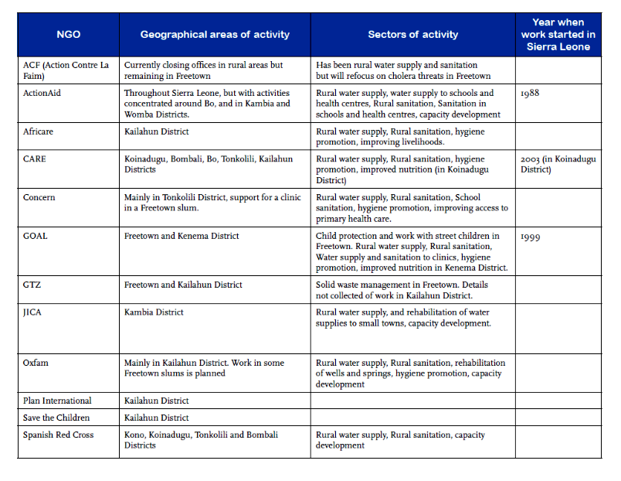

Private Sector
- The private sector has already been involved in the project development phase, and will play a large role towards the project’s success. This, in terms of water infrastructure investment, but also in terms of improving water society capacity as a result of the implementation of various capacity building initiatives of the project. The Guma Valley Water Company (GVWC), a parastatal entity, is responsible for Freetown’s water supply. Guma is governed by its key shareholder, the MWR. The Provincial Water Company (PROWACO), formerly known as SALWACO, is legally mandated to perform various responsibilities, including the provision of water supply to all urban centres (except Freetown) and rural areas – thus their participation at local level will be vital.

- Numerous water consumers from the private sector are important target groups and stakeholders of this project. There is an established industry that uses water from various sources for treatment and bottling of drinking water, as well as there are industries i.e. mining and food production that are considered water intense.

Table 2 Stakeholder groups and potential role during the project stage.
Stakeholder groups | Potential role during the project
Water Department, Ministry of Water Resources | Overall Project Implementation. A Project Implementation Unit (PIU), attached to WD will be set up to coordinate and direct project execution in Freetown. District WASH coordination officers and support staff will be the key executers of the district and local level activities with relevant NGOs and individuals.
Sierra Leone Environment Protection Agency | Parts Component 1 coordination in partnership with Ministry of Water Resources Resources GEF and UNFCCC Focal Point. Steering Committee Chair of Project Implementation.
National Climate Change Committee | Partnerships with EPA on various components, project beneficiaries in terms of knowledge and information portals created.
Ministry of Economy, Planning and Cooperation | Aims to assist mainstreaming, climate considerations into relevant policies and other country key planning documents and also strengthen competency in resources mobilisation
Ministry of Finance | Responsible for coordination of cooperation initiatives.
Meteorological Department | Partner for EWS and information /knowledge generation activities under component 1.
Local Government in Freetown, District Councils in Kambia, Kono and Puhejun | Contribution to the implementation of project activities at least at two villages per district;; overall strategic guidance.  Beneficiaries from capacity support activities, building district level capacities in dealing with climate change.
Environmental Foundation for Africa (EFA) | EFA has recently set up a environmental and sustainability learning centre near Lakka in Freetown. Modern and inspiring infrastructure is available for hosting trainings, demonstrations of technologies and political dialogues. Capacities for developing cutting edge learning approaches for a suite of stakeholders through a strategic partnership with the IUCN Commission on Education and Communication exists, which can support content development for modules.
Sierra Leone Business Forum (SBLF) | Platform for policy dialogues especially with the private sector under component 1
Innovation training centres at Grafting and Kenema | Demonstrations of water supply and management innovations; pioneering for adaptation additions; training of replicators from the local communities in the three project districts
Local NGOs and consulting services esp. At the district level | Support to project implementation in all districts
Pilot sites: Pujehun: Bandajuma Sowa,Gbondapi, Kono: Koeyor community Jaima Sewafe Chiefdom, Kambia: Mambolo Chiefdom, Malambay | Primary beneficiaries and partners in local level testing and implementation of climate change resilient rainwater harvesting technologies, storage and management.
Communities, Women and Youth Associations, CBOs | Beneficiaries of adaptation measures and contribution to the design and managing of small scale water supply systems. Form part of policy formulation.
Private sector (the Guma Valley Water Company, Provincial Water Company (PROWACO), Small Water providers) | Support the establishment of framework for policies and supports in promoting investment and entrepreneurship development on adaptation, designing of climate resilient design, build climate resilient water harvesting schemes), Guma Valley Company to benefit from improved monitoring system

Consultations during PPG phase
- Detailed consultations were conducted during the PPG phase of this project. A summary report of the field consultations and the stakeholders interviewed is included in the Annex. The inception meeting took place in July 2012, and subsequently national level, community and district level consultations took place up to January 2013. A project verification workshop was held in Freetown on 15 January 2013.

1.4.2 An introduction to project sites
- This project aims to support infrastructure and capacity building in the urban setting (Freetown and Guma Valley Reservoir) and in the rural setting (Southern, Northern and Eastern regions). During the PPG phase explicit community level consultations were conducted to establish local climate related risks, vulnerabilities and capacities, with a focus on the water sector.

- The intervention districts were identified in a participatory manner during the inception phase, and are particularly aligned with the planned AfDB interventions in Puhejun, Kambia and Kono.

- Specific pilot sites and communities have been identified during the PPG phase based on existing climate vulnerabilities and water sector risks. In consultation with the district councils and the WASH coordination officers of MWR, two pilot communities per district were selected and profiled during the PPG phase consultations.

Figure 9. Map of intervention areas/districts (green arrows)

Freetown and the Guma Valley Reservoir
- Freetown is the capital and largest city in Sierra Leone, with a population at roughly 1.2 million. Like the rest of Sierra Leone, Freetown has a tropical climate with a rainy season from May through to October; the balance of the year represents the dry season. The beginning and end of the rainy season is marked by strong thunderstorms. Under the Köppen climate classification, Freetown has a tropical monsoon climate primarily due to the heavy amount of precipitation it receives during the rainy season. Freetown's high humidity is somewhat relieved November through to February by the famous Harmattan, a gentle wind flowing down from the Sahara Desert affording Freetown its coolest period of the year. Temperature extremes in Freetown are from 21 degrees Celsius (70 degrees Fahrenheit) to 31 degrees Celsius (88 degrees Fahrenheit) all year. Temperatures around 28 degrees Celsius are normal, with very little day/night variation.

- Freetown experiences abundant rainfall with heavy precipitation events and rising sea levels along the coastal plains. However, the city also faces serious challenges in terms of access to water. Water supply to Freetown and its environs is by the Guma Valley Water Company, which was established in 1961 to serve the then population of 800,000 people. Due to Urban migration as a consequence of the civil conflict, water demand in the city of Freetown now far exceeds the supply. This is responsible for water shortage affecting many parts of the city. In addition, frequent power shortages have exacerbated the situation, as water cannot be lifted to the high well areas where power is needed to pump the water. To cope with the current water demand and achieve wider equity in water supply, the Guma Valley Water Company has introduced nighttime rationing in many areas including settlements of the Peninsula Road. From Juba westwards and parts of Kissy and Wellington.

- The Guma Reservoir supplies approximately 1.1 million people with water, and is overcapacitated. In 2006 an extended dry season caused severe water shortages in the city. An ineffective monitoring system hinders appropriate planning for climate resilience.

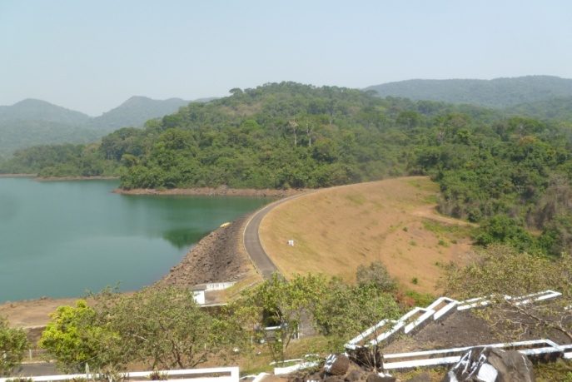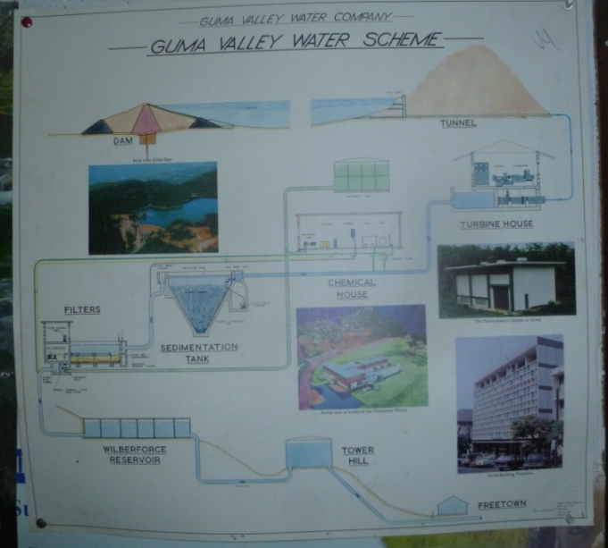
Figure 10 Guma Reservoir - the major water supply for Freetown comes from the more than 50 years old reservoir that taps springs and rivers from six catchments already under current climate conditions the reservoir cannot supply sufficient water to the city

- Water harvesting practices, especially rainwater harvesting, is prevalent in and around Freetown, especially in the rainy season. Since the water supply from the Guma Reservoir already cannot provide sufficient fresh water for demands in the city, several alternative and supplementary water sources are being explored and partially developed. An additional dam is being constructed near Freetown.
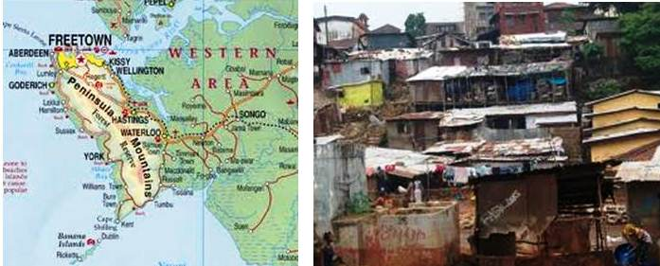
Figure 11 : Map and mage of Freetown
- Community water harvesting is taking place in three communities, namely Mamba Ridge, Thunder Hill, and Cemetery Blue. These water harvesting sources are streams or rivers that are captured for use by the immediate community. They were all considered as minor sources by the GVWC and as a result have not been sources of water for the Guma Reservoir, mainly because of problems associated with water quality. These minor community sources have had improvements from NGOs and Guma and have been interconnected with the Guma water at some points. The Mamba Ridge source harvesting started as purely a community initiative and in recent years has received intervention through the Urban Wash Consortium through ACF. The Guma Valley Water Company, through funding from the Indian Government, has also improved the other two community sources at Thunder Hill and e Cemetery Blue.

- Most inhabitants use rainwater harvesting to provide water for domestic purposes, such as flushing toilets, cleaning, etc. household water harvesting is mainly captured by the roof of a building and sometimes diverted to a gutter from where it is channelled into a storage facility. However, these are often not taken up too positively because the community perception is that rainwater harvesting occurs during rainy season when there is already sufficient supply of water; this could be improved though in areas where households are not connected to the pipeline. Water storage capacities but also quality is a key concern. The usage of plastic reservoirs implies that water collected is not suitable for drinking, as the plastics are inferior quality and contaminate the water.

Rural areas
Southern Province (Pujehun District: Bandajuma Sowa & Gbondapi)
- Pujehun District is a district in the Southern Province of Sierra Leone, with an estimated population of 238,919. Its capital is the town of Pujehun. The district of Pujehun borders the Atlantic Ocean in the southwest, the Republic of Liberia to the southeast, Kenema District to the northeast, Bo District to the north and Bonthe District to the west. It occupies a total space of 4,105 km² and comprises twelve chiefdoms, namely Barri, Gallinas Perri, Kpaka, Malen, Mano Sakrim, Makpele, Panga Kabonde, Panga Krim, Pejeh, Soro Gbema, Sowa and Yakemoh Kpukumu Krim. Its main ethnic groups are Mende, Vai, Temne, and Sherbro. The Chiefdoms are further sub divided into twenty-two (22) political wards for purpose of Council elections and administration.

- Diamond mining is a major economic activity in the district. The district is also rich in timber in its Gola Forest. The Atlantic Ocean, Moa and Wanje Rivers provide ample fisheries resources. The district has extensive rubber plantations, and large areas of Riverine grasslands have been deemed suitable for rice farming by the Development Plan for the district.

- During the war, Pujehun District suffered from concentrations of destruction and high levels of degeneration. Unlike Kono and Kailahun, also sharing International boundaries with Liberia, Pujehun did not experience high levels of displacement but in recent years it hosted some of the highest numbers of displaced, returnees and refugees from Liberia. The Government of Sierra Leone, in a bid to alleviate this situation, took the bold step to resuscitate the District Councils. Initially, District Management Committees were set up in 2000 to pave the way for the elected Councils. Their mandate was to identify Council property and to recommend strategies for the new role of the elected Councils.

- Water and sanitation facilities prove one of the biggest challenges, especially for towns like Bandajuma Sowa which serve as common points for business activities. Some of the key water-related issues in the district include lack of maintenance of existing Degremount pipe borne water systems, inadequate hand pump wells, poor toilet facilities, increase in water borne diseases, difficulty in access to safe drinking water, inadequate pump maintenance toolkits and lack of pump spare parts shops.

- Climate change risks in the water sector are increased flooding or drought and increased frequency of extreme events. The effects at community level are increased risk of disease and damage to property and livelihood. Pujehun, especially, Gbondapi, has suffered from floods and seasonal droughts which have destroyed crops and hampered food production capabilities. Strong winds have also destroyed houses, damaged water infrastructure and obstructed communications to remote areas. Recent storms have severely affected livelihoods of people in the Pujehun District, especially in term of destroying houses; poor building materials and sandy soils are contributing factors to the high level of vulnerability to storm disasters.

- Most towns are ill equipped to handle risks like disease. For instance, Bandajuma Sowa only has three community health centres and eight PHUs. The people are vulnerable to many illnesses such as malaria, pneumonia, kwashiorkor, diarrhea, typhoid and cholera. Water infrastructure is severly lacking, with only about three hand pumps per town with several unprotected water wells. Most of these water wells are found in swamp lands close to garbage disposal sites. Notably, the towns are also very prone to flooding due to low sea level and thus the water wells are often contaminated. This is especially true for the coastal, low-lying areas. The District Council has made plans, according to its development plan, to construct more hand pumps and delve into the rehabilitation and maintenance of hand pumps. It also aimed to rehabilitate existing Degremount pipe borne water system. It also aimed to train more hand pump mechanics in the district.

- Bandajuma Sowa is one of the rural towns in the district and a headquarter of Sowa Chiefdom. It has a population of over 2000. It is situated along the main river called Wanjama. It has a big market centre. The town has a well known health facility called Bummed Health Centre, formerly assisted by Medicins Sans Frontiers (MSF), now managed by the GoSL and headed by the Community Health Officer (CHO). It has a police post and a functioning local administration. Water and sanitation in Bandajuma Sowa remains one of the biggest challenges as it serves as a common business point for the business activities in the area. Several pumps were constructed int he town but a number of them are no longer functioning. As a result, rehabilitation of the well is one of the prioritised needs to address the water issue.

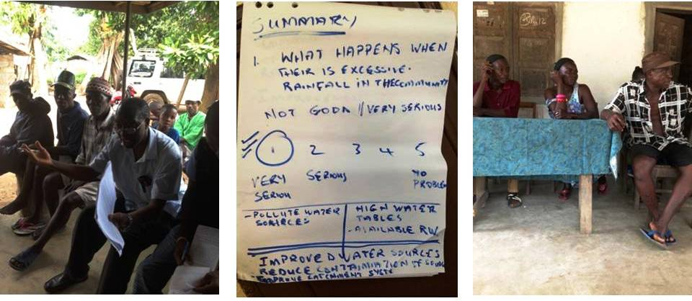
- Gbondapi is another market town located in the Kpanga Cheifdom of the district. This community faces similar challenges as Bandajuma Sowa. It is placed in a strategic location and is an important trading centre for those people living in the riverine areas. The economic activity of people are fishing, trading and farming.
Figure 12 Community consultations during the PPG phase with the Gbondapi community, to assess vulnerabilities, needs and existing coping mechanisms.
- Both communities/towns face similar climate change challenges – increases in severe events, such as heavy rains and flooding, but on the other hand, also face droughts and sporadic drying up of wells, etc. Issues identified by the communities themselves include wells drying out, river pollution increase due to pollution from upstream being increased in the watershed by heavy rains, polluted hand dug wells and the lack of sufficient facilities.

- Both communities have existing coping mechanisms which include roof top rainwater harvesting during the rainy season, but also drinking directly from hand dug wells which would enhance the risk of water born diseases. Currently, there is no provision of water service development infrastructure in Pujehun. There is also no investment plan. Despite the District Council Development Plans, the district depends heavily on the Ministry of Water Resources to help develop the water supply – implying that the ministry has yet to completely decentralise its operations. There is currently only one technical staff, the District Supervisor, who helps to supervise all environmental and water service provisions. There are serious limiting factors to facilitate the mobility of the monitoring and evaluation of the provision of water services. There is also not training of water pump attendants. Very limited informations is available on climate change risks from their own records.

Northern Province (Kambia District: Mambolo Chiefdom, Malambay)
- Kambia is a district in the Northern Province of Sierra Leone, with a population of 313, 765. Its capital and largest city is the town of Kambia. Kambia District borders the Republic of Guinea to the north, Port Loko District to the south and Bombali District to the east. The district provides an important trade route from Freetown to Conakry. The district occupies a total area of 3,108 km² (1,200 sq mi) and is divided into 7 Chiefdoms namely, Bramaia, Gbinleh- Dixing, Magbema, Mambolo, Masungbola, Samu and Tonko-Limba. is largely muslim. The district is largely muslim and its population is ethnically diverse. The Sierra Leonean Susu people are mainly based in Kambia District and they form one of the largest ethnic groups in the district.
- All the chiefdoms had medical centres or posts with the only referral hospital located in Kambia town, the district headquarter town. There are less transport facilities in almost all these places to the headquarter town. This made it possible for the highest number of death rate especially infant and maternal mortality in Kambia than all other districts in the country. There are 13 secondary schools in the district, located in Kambia town, Rokupr, Kasirie, Kychom, Mambolo, Tombowala, Madina, Kamassassa and Kukuna; three of the 13 of the secondary schools together with the hospital were all burnt down in February 1999 during the intensive fighting in the district, while the remaining 10 were systematically vandalised to an extent of completely ruining them.
- As the district was hit later by the war than most other areas of Sierra Leone, it hosted a huge number of Internally Displaced Persons (IDPs) until September 1998 when it sustained a heavy civil attack by the RUF civil fighters. Much of the population, together with over 40,000 IDPs who had sought refuge in the district fled to neighbouring Guinea. The inhabitants of this district constitute the majority of the refugees in the Forecariah prefecture (District).
- The district is considered as the main rice district of Sierra Leone. It has a large agricultural zone with extensive swamp areas found in every chiefdom, but more in the south-west, dominated by mangroves and large river estuaries. The rest of the vegetation consists of a mix between forest to the south and grassland or savannah to the north east. With annual rainfall above 2,500mm, the district has an impressive potential for upland, inland valley swamp and mangrove swamp farming. The population is mainly made up of farmers, practising off-season activities such as gardening and hunting. The major food crops grown by the people are, rice (the staple food), cassava, millet, sweet potatoes and sorghum, while groundnuts and maize constitute the major cash crops.
- In addition to farming, fishing along the many river estuaries and streams is practised by a large proportion of the population of the district. Fishing is an important source of income for the district, as traders come from other areas on both sides of the border to the fishing Islands and enclaves. This sector more than any other, demonstrates the division of labour between men and women in the community. While the men are the fishers, the fish trade is completely dominated by the women.
- Access to water facilities requires urgent attention in the district, only about one third of current water facilities is functional. Rainwater has not been harnessed in catchments, drills or other appreciable technologies in a systematic way to give people regular access to portable water through rainfall. Most of the communities rely on highly contaminated water sources, resulting in the prevalence of water borne diseases like typhoid, dysentery, cholera and parasitic diseases. This has a high correlation with the district’s infant mortality.
- Rehabilitating the existing systems (pipe-borne water and hand pump wells) in the district will reduce fatalities resulting from water borne diseases, and is set as a priority in the district’s development plan. The Kambia district’s main water issues, according to its development plan (2011-2013), is the inadequate supply of potable drinking water, unhygienic sources of drinking water, poor refuse disposal and no pipe-borne water, as well as poor management and maintenance of existing water infrastructure. Two thirds of the existing water facilities are damaged and in urgent need of repair, existing water wells are unprotected and have caused serious outbreaks of waterborne diseases such as cholera. Some NGOs have constructed water wells with spill effects negatively affecting the existing water wells. Most of the local contractors to whom contracts are awarded often do not have the modern equipment to manage or maintain these wells.
- Some additional aspects found during the community consultations and PPG phase interviews, was the perceptions, due to past experiences of interventions by the Ministry of Water Resources, that the MWR do not include, or ask for assistance from, the District Council during these planned interventions. There is also currently now tariffs paid by mining companies for water use, which exacerbates the over-use and consumption of water.
- Wells and streams, the main sources of water to the communities, dry up during the dry season and flooding occurs during the rainy season, two distinct issues set to be exacerbated by climate change.
- The development plan aimed to construct pipe-borne water systems in various towns in Kambia, including Kambia town and Mambolo. It also aimed to address the lack of trained pump attendants for the hand pump wells.
- The Northern Province is generally drier than other provinces, and the Kambia district is vulnerable to drought implications exacerbated by climate change. However, the district also faces flooding and sea level rise issues. Kambia’s wetlands are deemed as highly vulnerable to climate change, and are predicted to have significant losses in their mangrove forests due to shoreline retreats.
- There is a water services management structure particularly for the bigger communities called Kambia town and Rokupur both in the Kambia district. There is a water management board that reports to the Kambia District Council. For the smaller communities, there are relatively less effective management structures. The Kambia Distric has contacted Adam Smith International in petnership with ActionAid International to manage the water points in the district. The Kambia District Council has an Environmental and Social Development Officer in the district – who’s mandate includes climate change.
Table 3 Status of water and sanitation facilities as of 2010 in the district (Source: Rural Water Service Division Kambia 2010)
Chiefdom | NO. improved wells with hand pump | Borehole | No. of hand pumps functioning | No. of hand pumps not functioning | No. of traditional wells in use | No of surface water points | No. chlorinated water wells | No. VIP Latrines | No. of traditional latrines
Magbema | 94 | 5 | 36 | 63 | 156 | 14 | 200 | 91 | 1198
Masungbala | 35 | 0 | 9 | 26 | 50 | 69 | 50 | 6 | 219
Braimaia | 36 | 1 | 26 | 11 | 10 | 96 | 50 | 12 | 144
Gbinleh Dixing | 45 | 7 | 33 | 19 | 14 | 34 | 25 | 8 | 531
Samu | 23 | 0 | 7 | 16 | 96 | 41 | 59 | 15 | 1144
Mambolo | 30 | 0 | 10 | 20 | 100 | 36 | 100 | 10 | 257
Tonko Limba | 97 | 5 | 45 | 57 | 25 | 48 | 50 | 162 | 3948
TOTAL | 360 | 18 | 166 | 212 | 451 | 338 | 534 | 304 | 7441

- The Mambolo chiefdom is one of the largest chiefdoms in Kambia district. It has an estimated population of 55,545 inhabitants, of which 93% are engaged in subsistence farming. Rice and palm oil production is the main source of produce in terms of agriculture. The chiefdom has 8 sections with 73 villages along the Little Scarcies and mainland. Temne is the primary language/dialect of the people. Mambolo chiefdom has three (3) community health centres, eight (8) PHU’s. The people are vulnerable to many illnesses such as malaria, pneumonia, kwashiorkor, diarrhoea, typhoid etc not forgetting the fact this area is one of the hotspots for cholera disease in the district. Some of these PHUY’s are unmanned, due to poor incentives for volunteers or workers and the non/limited availability of drugs. The sick and aged have to travel by boat to Mambolo town for effective medical care and support. A total number of ten (10) people died and (407) sustained injuries as a result of the windstorm disaster in the chiefdom. Mambolo town, which is the chiefdom headquarter has only three (3) hand – pumps with several unprotected water wells. Most of these water wells are found in swamp lands close to their garbage disposal sites. Notably, the towns are very prone to flooding due to the low sea level, and getting the water wells contaminated by heavy down pour of rain. The situation is further compounded by the absence of many latrines/toilets in these communities; especially for the riverine area and some parts of the inland where open defecation is common even before the disaster. The problem of a crisis is inevitable as this pose a serious health hazard in the township and villages.

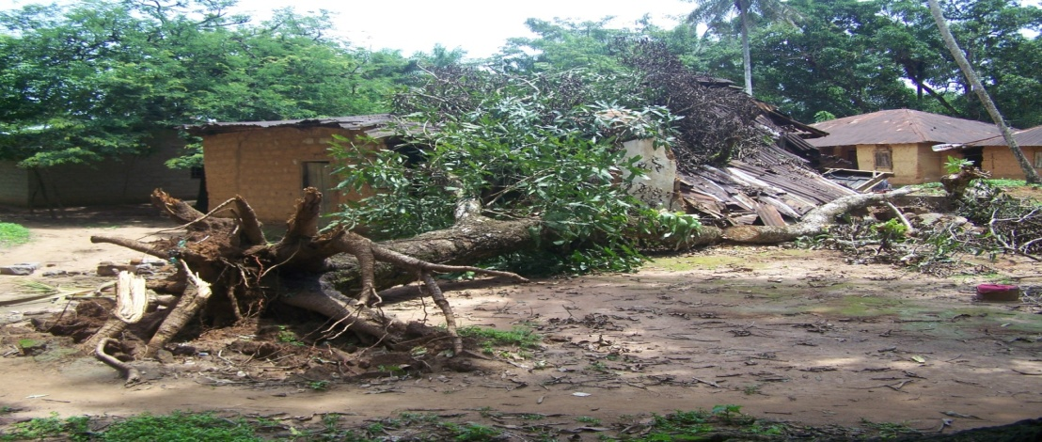
Figure 13 Result of flooding and strong winds in the Mambolo Chiefdom, Kambia District

- The town of Malambay has four unfinished, unmaintained wells. Communities here use the local wells and swamp water. The wells dry out during the dry season, and the community struggles excessively to access clean water – with outbreaks of cholera prevalent. In addition, the surrounding communities depend on Malambay for their water sources too.

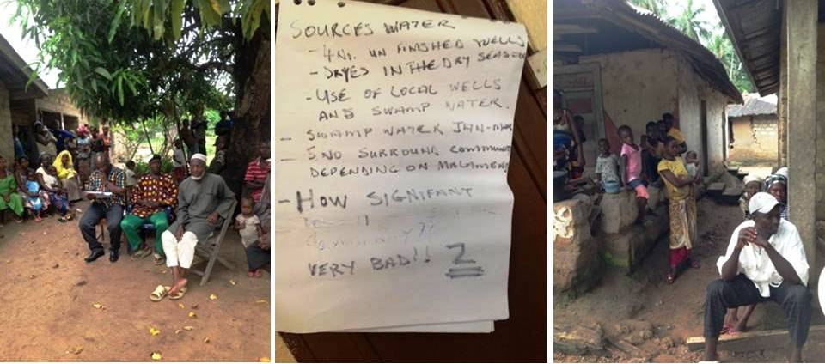
Figure 14 Community consultations during the PPG phase in Malambay, Kambia District, to assess vulnerabilities, needs and existing coping mechanisms.

- The major interventions needed at community level include a pipe-borne water supply, technical expertise needed to set up management boards to address existing capacity gaps, training of pump caretakers/pump mechanics, health units should be provided with a decent supply of water, as well as renewable energy mechanisms (for e.g. wells, boreholes, water quality laboratory).

Eastern Province (Kono District: Koeyor Chiefdom & Jaima Sewafe Chiefdom)
- Kono District is located in the North Eastern part of Sierra Leone. It has a large land size of about 5,641 sq. km and is populated by 255,376 people. The district’s capital is Koidu New Sembehun City. It shares borders with the Republic of Guinea in the East and with Koinadugu, Tonkolili, Kenema and Kailahun Districts in the North, West, and South respectively. The district comprises 14 (fourteen) Chiefdoms. The main ethnic groups are Konos, Kissis and Korankos. The district is topographically found on the Northeastern plateau Region of the Country, normally referred to as the Kono basin. The district is largely undulating with ranges of highlands along the Guinea border Region in the Lei, Mafindor, Sandor and Soa Chiefdoms to ridges and highlands stretching south of the district. The district in most parts is 600 – 1,000 ft. above sea level.
- In terms of drainage, all rivers & streams run from the North to South of the district. Tributaries like Bagbe and Bafi drain it, that confluence in lower Sandor Chiefdom to form the river Sewa running south. Other major rivers and streams include the Meli River which serves as a boundary between the district and the Republic of Guinea, the Moinde Stream the former source of water supply to the district headquarters, Koidu. The major highlands include the Tingi hills, an extension of the Buntimani Mountains, the Nimni hills and the Gori hills.
- Before the civil war, Kono District had a population well over 600,000; however, it experienced devastation during the Sierra Leone Civil War, which forced many of the residents out of the district. The district was heavily looted and constantly fought over due to the rich diamond reserves in the area.
- The main vegetation types are forestlands, Guinea savanna, secondary farm bush, grassland and inland valley swamp. The activities of the people e.g. farming methods (indiscriminate felling of trees, continuous cultivation and the creation of new settlements), have severely interfered with the vegetation of the district. However, all vegetation types are cultivable and useful for agricultural purposes.
- Other than diamond mining, economic activities include small-scale mining, small business activities (e.g. trading, fruits, vegetables) and transportation. All of these economic activities are only on a small-scale to augment daily survival of the community members. About 80% of household income is generated by women form their small-scale business activities.
- A large part of the district population depend on biodiversity products for consumption, fuel (fuel wood and charcoal), construction materials, thatching and roofing materials, ropes, crafts, medicinal plants, fodder, recreational materials (raffia, ornaments), spices, perfumes, poisons, composts, herbicides and insecticides. With the intensification of the war, the local population increased the wildlife cropping, targeting animals such as mammals, birds, reptiles, frogs and insects. The activities constituting major threats to biodiversity and unhealthy environmental activities include agriculture, livestock farming, forest exploitation, energy exploitation, mining, transportation, urbanization (infrastructure development) and waste disposal. Mining activities have led to the degradation of the environment, causing air and water pollution as well as food contamination, accidents and vibrations leading to cracking of buildings. Sand and clay mining are carried out along streams sides and swamps, which has led to the degradation of soil fertility.
- The sources of water supply in the district are the pipe borne, dug-out wells, boreholes, ponds and rivers. Pipe borne water is connected in only five out of the 24 Wards, with an unfair distribution of only 397 standpipes. The growing population of the few wards having pipe-borne water supply render these services inadequate and unable to meet the demands.
- The distribution of bore holes and operating open wells hand- pumps tend to favour only the more accessible areas/wards. Wards in farther Chiefdoms such as Lei, Mafindor, Toli, Soa and Gbane-Kandor are marginalized due to bad roads. Majority of the remote communities have no proper source of water supply, and therefore are compelled to depend on streams and ponds, which are often contaminated. Mining activity adversely affect the supply of water in the district.. General Sanitation and level of awareness on such is a major concern in the district.
- As per the district’s development plan, the link between water and sanitation clearly shows why malaria and diarrhoea are amongst the top ten diseases in the district. With the growth of population and settlement, refuse disposal is becoming more of a greater problem and efforts must be made to address it. The lack of proper garbage collection sites in the district also makes refuse disposal a problem. This is even the more compounded by the general lack of a culture of self hygiene as evidenced by the persistent habit of indiscriminate dumping of refuse in bushes and backyards. The intervention of NGOs like ICRC, IRC, PWJ and UNHCR and UNICEF, most communities in the Chiefdoms now have constructed wells and KVIPs.
Table 4. Water situation in Kono district (Source: Kono District Development Plan 2010-2012)
% without safe drinking water | Major source of water supply | No. of bore holes | No. of protected wells | % of household using protected wells | % of households using tap water | No. of V.I.P. latrines | % of households using V.I.P. latrines | % of households using pit latrines | Main method of waste disposal
49.2 | Rivers | 40 | 698 | 22. 6 | 21% | 2, 205 | 1.9% | 55.9% | B/Dumped

- Less than 50% of the population still lacks access to safe drinking water. Sources of water used in the district are about hand-dug wells fitted with pump; open hand-dug wells, river/streams, and rainwater and spring water. Majority of the people use bushes for dumping refuse.
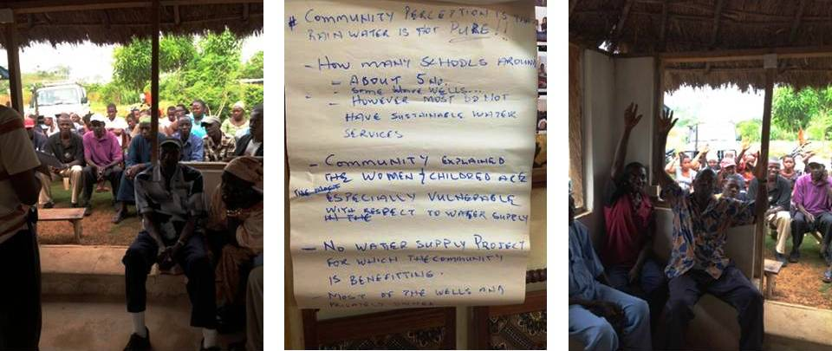
- Financing of portable drinking water is a new phenomenon in the district. The communities did not usually pay any money towards the provision of portable drinking water. Wells usually provided by the donors are handed over to the communities to operate, manage and maintain them. That is, the communities’ bear 100% cost for operation and maintenance. To ensure sustainability of these faculties, beneficiary communities form management committees called the WASH Committee. PWJ/WV trained these communities. The committees should undertake activities such as mobilization and management, facilitating community meetings and communal labour, embarking on routine and preventive maintenance. This is to promote cost-sharing approach to portable water acquisition by communities. The beneficiary community pays 10% cash contribution towards the capital cost, while the District Council provides the remaining 90%. The community however bears 100% cost towards the operation and maintenance of the acquired facility.

Figure 15 Community consultations during the PPG phase in Kono District, to assess vulnerabilities, needs and existing coping mechanisms.

- According to the district’s development plan (2010-2012), Water and Sanitation Committee (WATSAN Committees) were aimed to be formed in all beneficiary communities who would then be directly responsible for the operation and maintenance of the facility in their respective communities. Monies collected at the end of the month and those from the pay-as-you fetch system would be used to maintain these facilities. Trained Pump attendants would undertake minor repairs on the facility and assist the technicians in repairing the facility when it breaks down.
- Some of the main challenges outlined in the district’s development plan include: inadequate potable drinking water facilities in all communities, irregular supply of water (wells dry up in dry season), open wells are exposed to health hazards, frequent breakdown of facilities and lack of trained personnel, long duration due to deplorable road condition before broken pipe is repaired, long distances between houses to water facilities (boreholes), poor water quality, overcrowding at water wells since facilities are inadequate and communities are not able to properly maintain the facilities. The development plan aimed to strengthen existing water committees, rehabilitate existing infrastructure (wells, boreholes) and train personnel. It also aimed to construct/rehabilitate gravity fed systems.
- Climate change risks in the water sector relevant to Kono are the risks of flood and sporadic events of drought, and the increasing frequency of disasters. Most communities don’t have electricity supply, or pipe borne water supply. Only a few dotted water wells (boreholes) are found in the communities for drinking and other domestic purposes. Community members scramble daily for the limited water supply provided by the few boreholes available. These boreholes are not chemically treated, hence the frequent out-break of typhoid fever and other water-borne diseases. As a result of the erratic rainfall patterns, these boreholes often go dry due to the reduction of the water table. Family members are forced to travel long distances in search of water from streams and rivers in the forest.

- Especially in Jaima Seware Chiefdom, climate change will exacerbate the current situation of wells drying up in the dry season, causing severe water shortages, and flooding during the rainy season. Other issues identified by the community include water quality degradation as a result of mining activities.

- Major needs coming from the Koeyor chiefdom included an improved and resilient water supply both for consumption and business use. The daily scramble for the limited water supply sometimes leads to conflicts among community members. This is a serious socio-economic problem that could bring disunity to the community, and hence affects community development strides that require community cooperation.

- Existing coping mechanisms include rainwater harvesting mechanisms, but on a small scale. Efforts have been made to ensure that risk reduction approaches are developed with the view of reducing the vulnerability of the people. It has been noted that ignorance and lack of education have increased vulnerabilities. However, local communities have for generations developed coping strategies within their environment – this knowledge needs to be tapped and identified for effective articulation of adaptation options.

Strategy

2.1 Project rationale and policy conformity

LDCF conformity
- Sierra Leone is a party to the UNFCCC and is classified among the non-Annex 1 parties. It also is a signatory to the Kyoto Protocol, thus pledging political and practical commitment in the direction of sustainable development, while creating conditions to benefit from opportunities in this framework. Thus, following the example of Least Developed Country (LDC) Parties to this Convention, Sierra Leone has developed and submitted its NAPA and is entitled to benefit from the LDC Fund for the implementation of priority measures identified in its NAPA. Furthermore, Sierra Leone’s NAPA top priorities comply with the LDCF eligibility criteria.

- The Sierra Leone NAPA identified six high priority sectors, of which a ranking exercise identified the water sector as one of the three top priority sectors, with three associated priority projects. This proposed LDCF project directly responds to each of the three priority projects under water.

- The proposed project has been prepared fully in line with guidance provided by GEF and the LDCF Trust Fund. The project follows the guidance from ‘Programming Paper for Funding the Implementation of NAPAs under the LDC Trust Fund (GEF/LDCF 2006).

- Firstly, in line with GEF/LDCF (2006), this project was identified and conceived through the participatory NAPA process in Sierra Leone. Moreover, it was designed to be consistent with, and supportive of, national development strategies, as expressed in the Vision for Sierra Leone 2025, PRSP and related documents.

- Secondly, the project addresses the urgent and immediate activities identified in the NAPA, and is in line with the priority sectors identified in GEF/LDFC (2006) on a global basis. Notably, this project focuses on urgently needed adaptive capacities in the water sector. It builds local community adaptation capacities and strengthens county and national government services to be able to address adaptation in a well informed and knowledgeable way.

Overall GEF Conformity
- The Project has been designed to meet overall GEF requirements in terms of design and implementation. For example:

- Sustainability: the project has been designed to have a sustainable impact, at village and at national level. See section on sustainability below for more details;
- Monitoring and evaluation: the project is accompanied by an effective and resourced M&E framework, that will enable ongoing adaptive management of the project, ensuring that lessons are learnt, management decisions are taken based on relevant and up-to-date information, and regular progress reports are available for concerned parties;
- Replicability: great attention has been paid in the project design to ensure that lessons are replicable, and that the necessary replication mechanisms are in place. See section below on replicability for more details;
- Stakeholder involvement: following on from the NAPA process, the design of this project was effectively participatory. Moreover, the design of the project ensures the appropriate involvement of stakeholders in project implementation and monitoring.

2.2 Country ownership: country eligibility and country drivenness
- This project fully reflects the priority measures identified by Sierra Leone’s NAPA, and will contribute to the country’s development and achievement of critical MDGs. Access to water is a leading priority for the government.

- The access to water is a major priority to the country and is reflected strongly in the government development plans, strategies and policies. Sierra Leone’s Development Plan for 2025 “Sweet Salone” highlights the improved quality of life through the provision of water and sanitation for all envisaging the achievement to take place with support and in partnership with the private sector and donors. The second Poverty Reduction Strategy “Agenda for Change” reiterates the agenda for improving the access to safe drinking water. The Financial Sector Development Plan and the National Sustainable Agricluture Development Plan both highlight and prioritise this project’s activities. The project is strongly in line with the priorities of the WASH Policy as well as the Draft Rural Water Supply Strategy. Council Development Plans prioritise the project activities in the region. All of these also highlight aspects of climate resilience.

- The United Nations Family in Sierra Leone have also prioritised water access, through the UNDAF as well as the Transitional Joint Vision for Sierra Leone and the United Nations Family (2013-2014) and highlight the importance climate resilience.

- Major buy-in and ownership was taken up through active participatory processes during the PPG phase. Community consultations which took place during the PPG phase towards the socio-economic and vulnerability assessment reflected the urgency, need and strong demand for action with regards improved water supply infrastructure and training. Meetings with the Guma Valley Water Company, PROWACO and various government and education institutions exposed the massive demand and duy-in toward the project activities.

2.3 Design principles and strategic considerations

- Design principles and strategic considerations include:
- A strong existing baseline especially at demonstration sites as key criterion for intervention planning through a strategic partnership with AFDB. Specific site selection (districts) undertaken with MWR and AfDB. Although it seems that the AfDB support will be delayed, the project has been designed to create learning and technical capacities of water sector professionals at district level that can be applied directly the AfDB interventions, once they commence. Due to the project delivery delays of AfDB their contribution is not indicated as co-financing at this time.
- Strategic partnership with the EU Project on environmental governance executed by EPA for policy level component activities;
- Tangible local level demonstrations to develop visible and practical adaptation learning, which can be directly used and applied by district level water engineers and other district level partners i.e. but not only in Government as well as by other communities;
- A strategic partnership with the GUMA Valley Water Company, as well as the UNDP implemented EWS project that is aiming to establish a EWS monitoring system for the Guma Reservoir and an UNDP support to the WASH programme mostly financed through DFID. The UNDP component provides technical support to the Met Service to provide better weather and climate information to WASH operations.
- Up-scaling adaptation learning through integration into future policy making and into capacity building initiatives.
- UNDP’s comparative advantage on capacity building and gender especially relating to climate change. A suite of strategic capacity development activities are being planned to create critical sustainability impacts on building climate change resilience in the water sector in Sierra Leone.
- Consultations with IFAD and their specific GEF intervention in the agriculture and food security sector were undertaken, however, no specific interface points were identified.
- UNDP’s comparative advantage in designing and supporting this LDCF project is particularly strong because of the capacity building focus that the project has. UNDP has strong mandates and capacities to develop national capacities for integrating climate change risks/opportunities into social equity, economic growth and environmental protection issues at all levels of development decision making. Integrating climate change risks into sustainable management of environment and natural resources and into Poverty Reduction Strategies, key national development frameworks and sector strategies is the key business of UNDP in Sierra Leone as set out in the Transitional Joint Vision for Sierra Leone of the United Nations Family.

2.4 Project objective, outcomes and outputs/activities
- The project objective is to enhance the adaptive capacity of decision-makers in the public and private sector involved in water provision to plan for and respond to climate change risks on water resources.

COMPONENT 1: Integrating climate change considerations into water policies
OUTCOME 1: Critical public policies governing the management of water resources revised to incentivize climate smart investment by the private sector
Baseline:
- As part of the project development, a review of the water related policies on water resources management and related to climate change was undertaken (cf. PPG Report 2). The objective of the review was to assess whether water related policies are sufficient to deal with impacts of climate change, and suggest how to best align climate change issues into policies. A detailed baseline, following the strategic programming principles outlined in the afore section, has been established.
- GEF project builds on a set of baseline initiatives that aim to improve the governance and monitoring of water and sustainable development of the country. These development baseline initiatives are focused on (i) current efforts developed by the Ministry of Water Resources to establish relevant policies and planning tools on the water sector at national and subnational levels, and improve the monitoring system of the Guma Valley, (ii) the European Union initiative to support the Environmental Protection Agency for the development of coherent environmental policies, regulations and standards on environment and climate change; and on the Private sector initiative to establish the Sierra Leone Business Forum (SBLF) where the government and private sector are engaged in constructive dialogue.
- Government of Sierra Leone (GoSL)- water policy: The GoSL launched in January 2011 the National Water and Sanitation Policy (NWSP) and the implementation of its provisions is currently underway. The policy document focuses mainly on the urgent need for integrated and cross-sectoral approaches to water management and development as well as the provision of safe and adequate drinking water facilities. The assessment and analysis of water resources availability and the impact of climate change and catchments degradation on water resources are routinely carried out satisfactorily. However, key decision-makers who are supposed to lead the implementtaion of the policy have limited knowledge of climate change impacts or adaptation responses. Information, including inventory and mapping, is inadequate and staffs from MWR have limited expertise to internalize climate changes into existing local deve plan. However the UNDP EWS Project plan to establish partnership with The Center for International Earth Science Information Networks (CIESIN) based at the Sierra Leone Environmental Protection Agency (EPA) to support production of climate risk/vulnerability assessments to support decision making in sector planning and development activities of the government of Sierra Leone;
- The GoSL is also finalizing the Rural Water Supply Strategy that describes an approach for extending and sustaining rural water supply service delivery across Sierra Leone. The document does not mention climate change directly but highlight that some communities will be more susceptible to risks of seasonal flooding and disease outbreaks, as well as other shocks. External shocks will directly affect the ability of communities to pay water tariffs. These communities need to be identified and visually mapped so that robust contingency plans can be established. Meetings need to be held with these communities periodically to ensure communities know what to do in the event of external shocks and all the multiple sources of support are clearly defined.
- Subnational policies targeting the water sector: Water and sanitation is the top priority for most of District’s Local Development Plan in target areas (Kambia, Pujehun and Kono).
- Kono district Development Plan 2011-2012 is guiding the development of District in providing basic services to communities. The Plan highlighted the need to address concerns about mining and its associated activities that are impacting on the environment, polluting water courses, water wells, degrading the environment, etc.;
- Pujehun District Council Development Plan 2012 – 2014 noted the district’s potential in mining and consequences in the water sector such as pollution of the environment due to lack of inadequate environmental practices associated with lack of proper water and sanitation services.
- Kambia District Council Development Plan 2011 – 2013 addresses critical challenges and backlogs of addressing poverty and all its complications within District. The priority identified is to ensure clean and water supply and keeping safe environment.
However, climate change is not specifically mentioned and so addressed addressed. Local decision-makers have limited knowledge of climate change impacts or adaptation responses; Information, including inventory and mapping, is inadequate and staffs from local councils have limited expertise to internalize climate changes into existing local development plan
- Water Sector Planning Tool-Water point mapping: The Ministry of Water Resources established a nation wide Waterpoint Mapping exercise that has been completed on April 2012 to suport planning process and investment decision-making on the water supply and sanitaion for planning. It provides a true picture of the number of facilities available to the people as well as their functionality. It has identified 28,000 water points, of which 63% (18,086) are functional, 32% (9,290) are impaired and 5% (1,479) are under construction. On the average 40% are seasonal water points (are functional during rainy season only). The planned AfDB support to the MWR foresees the development of a ground water map for Sierra Leone, based on an extensive survey design. However, none of water points technologies were assessed according to their climate change resilience, taking account of both vulnerability to climate changes (determined by engineering and environment) and adaptive capacity (ability to be adjusted or managed so as to cope in response to different climate conditions). No specific climate risk assessment of future ground water availability is currently planned as part of AfDB intervention.
- Guma Valley reservoir Monitoring system: Water supply to Freetown and its environs is done by the Guma Valley reservoir, which supplies 90% of Freetown’s water by gravity feed around the peninsular from the west (where it is situated) to the east of the city. Freetown is wholly dependent on the Guma Dam and with no appreciable alternative sources should the dam fail. Guma Valley Company (GVWC), managed under MWR as a parastatal, lacks significant technical information i.e. on climate risks on their main water supply reservoir for Freetown. Guma climate station presently has an Automatic Daily Chart for rainfall recording. It also has an evaporation measuring means through three pans. These equipment are all not only very old but there is no back-up for them. In case of a breakdown of these equipment or in the worst case vandalized or stole, gaps would immediately happen the recordings. The availability of records from many of the stations used to develop the isohyetals are no longer in palce. Through the UNDP EWS project, which currenlty under preparation, a monitoring system for Guma Reservoir will be established. However, interpretation of such EWS information is currently not integrated into risk management contigency plans nor is the overall risk that climate change may pose on the sustainability of water supply to the capital known and debated by policy makers.
- The European Commission (EU) 'Environmental Governance and Mainstreaming Project' (4,000,000 euros- 4 years): In March 2012, Environmental Protection Agency Sierra Leone (EPA) and the European Commission (EU) launched the 'Environmental Governance and Mainstreaming Project' (4,000,000 euros- 4 years) in the form of a grant from the Tenth European Development Fund to ensure the effective implementation of the project. EPA will leading the development of coherent environmental policies, regulations and standards on environment and climate change. Under this project, EPA already established coordination mechanisms between key Ministries and technical support is in place to define modalities for the mainstreaming of the environment and Multilateral Environmental Agreements (MEAs) into key policy development. However, EPA has limited capacity and tools to guide key ministers through the steps of mainstreaming climate adaptation. National stakeholders could benefits from training programme and material on IWRM as a Tool for Adaptation to Climate Change developed by UNDP Cap Net.
- Donor investments including in the water sector currently are mostly driven by business-as-usual climatic models, and few such investments are mindful of newly emerging climate risks and opportunities. This specific output will analyse lessons learnt from project component 2, which adds climate additionality to ongoing water sector infrastructure and management interventions supported e.g. by the WASH consortium. It is clear that investments by other cooperation partners e.g. Jica, DFID, EU, at this point focus on delivery of infrastructure and with limited cognisance of climate related issues impacting on such developments.
- There are major private sector water users including water provision related industries such as fresh water bottling, but also water intense industries such as mining and agriculture/food production through irrigation. Climate change will have a range of impacts on businesses, e.g.
- Physical risks – Extreme weather events increase physical risks to business operations; Resource extraction could be limited by water availability
- Supply chain and raw material risks – Water scarcity affects production
- The establishment of the Sierra Leone Business Forum (SBLF) is an opportunity to engage Private sector in adaptation. The SBLF provide a platform for the government and private sector together to engage in constructive dialogue aimed at identifying, prioritizing and resolving key constraints of private sector development. The Forum has various working groups, including e.g. trade and industry, tax reform. Given the risks and vulnerabilities across all industry sectors and the significance of expected climate change impacts on businesses, dialogues need to be engaged in the water sector to provide a better understanding of the interplay between public and private sector adaptation strategies/investment, and of possible synergies or conflicts between them.
- Finally, at this point reliable and local level information on the climatic risks, vulnerabilities, but also on already existing coping strategies and adaptation action is absent in Sierra Leone and/or not well documented at all, including for the water sector. Limited or no research is supported that would further strengthen the development of locally effective and acceptable techniques and technologies that would help build climate resilience water supply at household, community and even settlement and urban levels.
Adaptation alternative:
- An important prerequisite for informed decision-making on adaptation is that it should be based upon the best available information on the implications of both the current and the future climate in the country. Improved information and tools on climate change risks and vulnerabilities is generated in Sierra Leone to enable evidence-based and informed policy decisions. This is will mainly support three strategic areas, (1) increased human resource capacities to lead the implementation of water policy, taking account of both vulnerability to climate changes (determined by engineering and environment) and adaptive capacity (ability to be adjusted or managed so as to cope in response to different climate conditions); (2) improved management of Guma reservoir to mitigate the overall risk that climate change may pose on the sustainability of water supply to the capital; and increased understading of climate risks by key water supply stakholders (parlementarians, traditional authorities, local communitites, Donors and Private sector, etc.) to cognise the climate related issues impacting on the water sypply and identify adaptation coping mechanisms based on lessons learned and best practicies demonstrated by the the project.

- The EU Project on environmental governance is used as a vehicle to mainstream climate change considerations into the WASH policy as a prerequisite for enabling more climate smart investment. As part of advancing this key result, LDCF resources are dedicated in part to finance the provision of relevant climate information and train government agencies to scale-up efforts to address climate change in water policies. The Meteorological Department plays an important role as data providers, and LDCF resources put in place the software (skills, competencies, mandates, process mechanisms) and hardware (tools) that are necessary to support policy formulation that is informed by relevant climate change information.

- Policy roundtables and other relevant information sharing platforms will be put into place to support a national and regional debate on climate change and to generate better understanding of the climate risks as well as adaptation options for the water sector. Technocrats, policy makers, donor organisations, national and international NGOs will be targeted to be part of such knowledge exchanges. Lessons learnt from component 2 of this project will ideally also be integrated into such debates, ensuring that best practices can be replicated and further up-scaled in the future.

Costs component 1
Co-financing: US$ 3,200,000
LDCF grant: US$ 700,000

Output 1.a: More than 50 officers from the Ministry of Water Resources, esp. the Water Policy Planning Coordinating Unit (WPPCU), the Sierra Leone Environmental Protection Agency (EPA) and Districts leaders provided with relevant climate risks management guidelines/tools and trained on how the results of the climate risk/vulnerability assessments should be used to adjust regulations and policies governing the water sector at national (NWSP, RWSS) and local level (Districts development plans)
- Technocrats from MWR and EPA in Freetown, but particularly regional technical staffs have extremely limited opportunity for professional updating, and usually find it difficult to address newly emerging technical issues and practices into their ongoing work. One of the major limitations is the lack of capacity to deal with climate risks and understandings of managing these risks in the water sector.

- Relevant professional updating and training materials must be designed and developed, based on relevant local information. In developing climate risks tools, training and professional updating materials it is essential to identify the demand for such learning opportunities, and more importantly the content that should be developed. Following cutting edge learning principles and approaches, participatory methods should be applied as a principle from demand articulation to module execution to ensure that the offered trainings have the desired impact on the target groups and effectively lead to changes in decision-making in the long-term. Gender specific information elements ought to be integrated into such materials, as gender sensitive analysis and planning is an important aspect of effective climate risk planning and response

- Facilities at the EFA Environmental and Sustainability Learning Centre in Lakka (Freetown) could be used to support this and other training and learning outputs, contributing to the establishment and functioning of a Sierra Leonean state-of-the art environmental learning centre. Learning material on climate changes and Water from CAPNET will be adapted to meet the training needs at national and local level. Finally, UNDP TACC Facility will be used to support the development of relevant Tools on climate model projections for river basins/watersheds and the updating of water point, groundwater mappings.

- Indicative activities for Output 1.a:
- Undertake a Climate Change Risk Management (CCRM) capacity assessment of MWR-EPA and District staffs and profile their professional updating needs. This include the identification of gender-based capacities and resources for managing climate changes risk; and also the assessment of required tools climate risks management including vulnerability maps, climate scenarios, extreme event forecasts, indicators of vulnerability and monitoring systems.
- Based on the assessment, develop climate risks tools and learning programme (i.e. including modules on generating, analysing, and integrating climate risk information). Gender issues will be appropriately highlighted throughout the entire training material. The Center for International Earth Science Information Networks (CIESIN) based at the Sierra Leone Environmental Protection Agency (EPA) and Met Department will support the production of climate risk/vulnerability assessments for decision-making. The training package will be developing with CAPNET.
- Conduct at least four trainings at the Lakka Centre or other relevant learning centres. It will be ensured gender balance among participants and the use of participatory learning format allowing both men and women to interact, exchanges of experiences and develop common vision and understanding on climate risks management.
- Set up and test an on-the-job learning approach to ensure that learning objectives are directly applied to daily responsibilities. It will be ensured that gender concerns are fully integrated in formulation, implementation, monitoring and evaluation of such approach.
- Update the Water Point and Groundwater mapping tools to adapt them to new aspects of climate changes developments;
- Establish participatory roadmap to guide the adjustment of regulations and policies governing the water sector for the inclusion and the provision of climate smart finance;
- Monitor learning impacts and applications with the use of Gender-disaggregated monitoring and evaluation system to measures how trainings affected both women and men.
Output 1.b: Climate change resilience plan and emergency contingency plan for the Guma Reservoir
- The water supply in Sierra Leone (Freetown and the inland settlements) requires very urgent attention. Guma Valley Water Company is incapable of meeting the water supply requirement of the city, even under unchanged climatic conditions.

- The Guma Valley Water Company (GVWC) has relied primarily on use of measuring the water level of the dam rather than stream flow measurements because the flow installations had become unserviceable and as a result, rainfall/runoff relationships have been difficult to determine. The Guma Reservoir has almost always been full during rainy season and this has led to a water resource system that is vulnerable to two different types of water stress, extended dry seasons (more common), and ‘true’ drought events where the rainy season rainfall is extremely low and may not be sufficient to fill the reservoir.

- A regional GEF project also implemented through UNDP is focusing on building EWS in priority sectors in various countries throughout Africa. The Sierra Leone project is foreseen to work jointly with this specific project intervention in the Guma area. A joint site visit was undertaken during the project preparation and complementary but stand-along project activities will focus on strengthening this important water supply to the capital. Whilst the EWS project will focus on establishing and improving the GVWC monitoring system, this project will address vulnerabilities to climate related disasters which may occur. A climate resilience and emergency contingency plan for the Guma reservoir will be developed through this specific output, and relevant upstream policy dialogues on the relevant support actions that will have to be put into place will conducted. This include following measures: (i) Mitigation measures taken in advance to reduce adverse effects, which were anticipated but not certain at the planning stage; (ii) Hedging measures taken in advance to reduce the risk of possible adverse effects that have newly been identified; (iii) Defensive measures taken after a risk has materialised, but the damages are such that the plan does not need to be modified; (iv) Corrective measures taken after a risk has materialised, but the damages are such that part of the plan has to be modified; and (v) Reassessment if the plan is clearly not working and needs to be reassessed.

- Indicative activities for Output 1.b:
- Undertake a Climate Change Risk Management (CCRM) capacity assessment of Guma reservoir and prepare TOR for the selection of consultant;
- Commission a climate change resilience plan and emergency contingency plan for the Guma Reservoir based on large consultation process engaging GVWC, Met Department and communities surrounding the reservoir;
- Train GVWC staff to run the climate resilience and emergency contingency plan;
- Establish processes for review, reassessment and evaluation of the climate resilience and emergency contingency plan.

Output 1.c: Regular dialogues established between parliamentarians, local council members, traditional authorities, NGOs/CBOs, and private sector (WASH committees) on the impacts of climate change on water supply in Puhejun, Kambia and Kono districts
- The lack of communication among different decision-makers has been a limiting factor to climate smart planning and implementation. Although the decentralization policy allows for councils to take charge in their water management, lack of capacity and staff, and access to resources from central government challenge effective management at council level.

- Developing regular dialogue between all stakeholders, in a bottom-up approach, would maintain effective decision-making and create a better support structure for decentralized authority to take effective decisions and implement them. Such debates will be supported by evidence based information on climate risks and adaptation options, stemming from other project components and outputs. In particular, the district level pilot projects under component 2 will provide insights from local level climate risk, vulnerability and capacity assessments, as well as reviews of existing coping strategies and piloting of new adaptation inventions.

- Good communication practices and principles will be embraced, and policy dialogues should be organised in a manner that an appealing venue with relevant learning demonstrations should at least partially be utilised. The local NGO EFA could be a strategic partner for such activities to be conducted in Freetown, whilst other NGOs and consulting services may be recruited on the district level.

- Indicative activities for Output 1.c:
- Conduct Participatory Rural Appraisals (PRA) for relevant national and district level stakeholders Freetown, Kambia, Kono and Puhejun (parliamentarians, local council members, traditional authorities, NGOs/CBOs, and private sector (WASH committees) to determine existing capacities and training needs on longer-term climatic and environmental changes. The participation of women and young organization groups groups will be ensured to assess their specific needs.
- Design and conduct a community awareness campaign on climate change risks using culturally appropriate tools and aimed at all genders, including information packs that comprise examples of community-based adaptation measures in the water sector. The awareness campaigns will be tailored to the specific needs and concerns of women and men. They will be evaluated at least once per year to determine if women are effectively involved in the process. Key lessons learnt from the various project activities (especially the demonstrations under component 2) will be distilled and integrate them into the agenda of the dialogues, as relevant for the target groups;
- Train at least 10 WASH committes representatives to assess climate change issues, community-based adaptation planning, and household-level risk reduction interventions. Climate risks management and training tools developed under Output 1.a will be adapted to WASH committees needs;
- Create a sustainable communications platform in which a dialogue can ensure and further friendly communications can take place to inform a bottom-up decision-making process.
- Monitor the effectiveness of awareness programmes and improve quality of local capacity building efforts based on monitoring results
Output 1.d: At least two dialogues under the Sierra Leone Business Forum and WASH Donors Investment Platform initiated on managing climate change risks on water provision and usage
- Understanding the private sector’s role in adaptation is crucial, as countries’ success at adaptation will depend on the success of the private sector and other private actors in responding to climate change impacts and risks. Additionally, private sector responses may provide lessons and examples of innovative approaches of interest to the public sector.

- As per the main objective of this project, ensuring climate smart investment (both from private and public sector, including through the donor community) is of great importance. The project aims to develop a private sector buy-in to climate smart water resource infrastructure and development. This will done through the establishment of dialogues between Public and Private Sector that creates a transparent relationship for common goals, and ensures that the lessons learnt i.e. by MWR from this project can be effectively communicate and discussed amongst such partners.

- It will also create a platform of international and national water engineers (including architects) to support the designing and pioneering of resilient water systems for poor communities.

- Indicative activities for Output 1.d:
- Undertake strategic stakeholder analysis and target group specific information and communication needs and strategic responses (e.g. communication plans) as they relate to climate change resilience in the water sector. This could include also the identification of target group’s engagements in addressing climate change risks and establishing relevant adaptation strategies;
- Conduct two dialogues on the through (i) selected priorities;
- Create and make functional water engineers platform to support designing of resilient water supply systems;
- Develop a functional knowledge management system that documents such policy level dialogues to ensure that the outcomes find their way into national development planning and negotiation with investment partners.

Output 1.e: Relevant experiences/lessons from community oriented climate resilient water infrastructure and management practices (including gender differentiated issues) identified, and widely shared/disseminated to facilitate replication in other vulnerable areas
- No solutions ever come to fruition if efforts toward solutions are not tested for their effectiveness. A vital component of the project is to ascertain lessons learnt from the community oriented climate resilient infrastructure and management practices so that the best practices can be shared into other areas.

Indicative activities for Output 1.e:

- Establish a communication and knowledge sharing mechanism, the project team will (a) undertake a knowledge audit that provides a structure for gathering data, synthesising findings and making recommendations about the best way forward for knowledge and learning initiatives; and (b) frame the Social Network that establish relationships and knowledge flows between individuals and groups.
- Design a data/information sharing system/platform as technical support that enables communities and decisions makers to access relevant and usable information about how to deal with climate changes, and begin to use this material to guide their decisions about water management. Clear protocols will be developed for documenting and disseminating project knowledge. To maximize the usefulness of information and sustainability, the data system will be linked to the existing WASH information platform managed by the Statistics Sierra Leone and the Water Supply Division of the MWR in partnership with the 19 local councils. Key indicators related to climate related index or technology will be set up based on consultative process undertaken with relevant actors in the WASH sector.
- Develop a communication strategy that includes a strong grassroots community-driven component to foster greater ownership and enable replication. Depending on the target groups involved, suitable mode of communication will be developed e.g. local knowledge forum, product exhibition, participatory video and community radio shows on successful community-based adaptation approaches. Keys knowledge sharing tools will applied such as: (a) the dissemination of a catalogue of best practices of community oriented climate resilient water infrastructure and management practices; (ii) the development of storytelling that permitting learning through the presence of a narrative structure; the organisation of exposure visits to bring decision-makers and planners at the national, districts and chiefdom levels and WASH Donors investments platform to demonstrate experience successfully adaptation measures. Key lessons learned, project communication products will also be translated in relevant national languages and packaged in appropriate format for transmission via community radio broadcasts or national television local language channels. A catalogue of best practices of community oriented climate resilient water infrastructure and management practices will be developed for wider dissemination. Knowledge capitalised will be inject into policy level components of outcome 1, as well as through learning and training outputs under outcome 2.

COMPONENT 2: Strengthening the resilience of water supply systems to anticipated climate change risks
OUTCOME 2: Water supply infrastructure in Freetown and Puhejun, Kambia and Kono districts made resilient against climate change induced risks
Baseline
- Sierra Leone is not a water deficient country. However, it is estimated that about two thirds of the rural population does not have access to safe drinking water. A high proportion of basic infrastructure was destroyed during the civil war and maintenance was largely abandoned. The baseline scenario consists of scattered investments and interventions coordinated by the Ministry of Water in supporting the achievement of the MDG’s on the WSS. These investments include:
- The water supply in Sierra Leone (Freetown and the inland settlements) requires very urgent attention. Guma Valley Water Company is incapable of meeting the water supply requirement of the city whilst PROWACO (formerly SALWACO) and the Water Supply Division of the Ministry of Energy and Power also incapable of supplying inland settlements and other rural areas.

- GoSL “Emergency Water Improvement Project”: The Government has taken several steps over the last few years to support the delivery of water supply. Over the period 2002–2009, GoSL WSS total sector expenditure was US$50 million over eight years, or US$6 million per year. Approximately, 81 percent of WSS expenditures are funded from external sources.

- In Freetown, the Ministry of Finance and Economic Development provided a loan of about 600,000 USD to the Guma Valley Water Company to provide safe drinking water to vulnerable communities in the Western Area. With this financing, Guma Valley Water Company (GVWC) connected about 38 percent of properties in Freetown have house connections to Guma network and over 500 stand posts are established. GVWC also replaced the aged pipes to reduce levels of leakage by about 2280 cubic meters] per day. Rehabilitation and construction of other water sources are undertaken at White Water at FBC, Cemetery Blue Water at Wellington, Hill Station and Allen Town. Some investments are also made for the construction of gravity scheme at Mamba Ridge and installation of 400 public tap stands in deprived communities within Freetown. With funding from the Indian Government, GVWC also improved the other two community sources at Thunder Hill and Blue Cemetery. However, the review concluded that water harvesting in and around Freetown is highly underutilized as most water flows as runoff into the sea. Best practice water harvesting techniques could provide solutions to many current water storage and distribution challenges during the rainy seasons (such as contaminated shallow wells).

- In the rural area, Provincial Water Company (formerly called SALWACO) is investing in the water sector. Planned investment identified in the Agenda of Changes (PRSP III) are: the construction of 400 boreholes and sanitation facilities undertaken in large settlement areas in Bo, Makeni, Moyamba, Kailahun, Pujehun, Port Loko, Kambia, Magburaka, Kabala and Kenema and the extension and rehabilitation of gravity system.

- Community initiatives on rainwater harvesting in Freetown: Some households in Freetown are applying rooftop rainwater harvesting techniques to complement water supply at a household level. Such techniques are seen to have potential for replication, however, currently are restricted to few users and still required quite substantive initial investment costs for water storage tanks. Such water could be used (treated) for drinking, but also for other household uses such as washing, cooking, cleaning and bathing. Water sector professionals report some cultural resistance to an up scaling of household level rainwater harvesting frequently. Further information is needed to understand such barriers and to investigate if they can be removed successfully in the future. The current roofing of houses in communities of Freetown also has not been constructed with the forethought to collect clean water (due to the angle to roofing and materials used). New innovations for roofing toward rainwater harvesting are imperative to create a collecting mechanism for clean water. In addition, the current springs utilised around Freetown are badly maintained, over utilised and often even vandalised resulting in poor quality and sufficiency in water. Some actions are undertaken by Engineers without Borders to develop a series of spring boxes improvement alternatives along with recommendations of system maintenance and sustainability for Baoma, with no specific climate resilience considerations.

- Action Contre la Faim “Community water harvesting exists in Mamba Ridge, Thunder Hill and Blue Cemetery Communities”. The initiative financed the water harvesting of stream/river sources captured for the use by immediate community in so-called “community reservoirs”. These water harvesting sources were stream/river sources that were captured for use by immediate community, with the aid of NGOs, in so-called “community reservoirs”. These sources were considered as minor sources by the GVWC, and the sources did not feed into the Guma Reservoir because of problems associated with water quality. These minor community sources have had improvements from NGOs and GVWC and have been inter-connected with the Guma Reservoir at some points. The Mamba Ridge source harvesting started purely as a community initiative and has in recent years had intervention through the WASH consortium (Figure 16). GVWC, with funding from the Indian Government, has also improved the other two community sources at Thunder Hill and Blue Cemetery. However, the review concluded that water harvesting in and around Freetown is highly underutilized as most water flows as runoff into the sea. Best practice water harvesting techniques could provide solutions to many current water storage and distribution challenges during the rainy seasons (such as contaminated shallow wells).

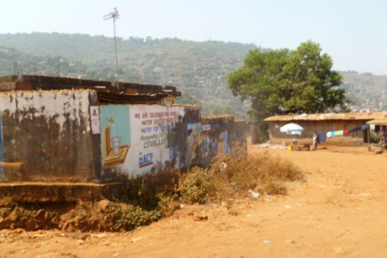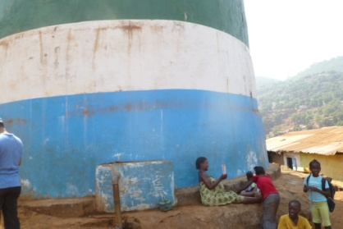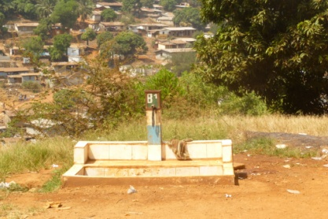
Figure 16: Images of the rehabilitated Mamba Ridge community reservoir, tapping the source of a local spring for water supply in an area of Freetown that does not benefit from supply from the existing Guma reservoir. The WASH consortium through Action contre la faim (ACF) has been implementing a community engagement project at this site in support of Guma Valley’s water supply efforts. The further development of alternative sources of potable water is seen to be an effective climate change resilience building activity.

- DFID “Water Supply, Sanitation and Hygiene Promotion in Schools, Clinics and Communities in rural Sierra Leone” project: This intervention will provide 364,000 people in six target Districts in Sierra Leone (Moyamba, Kenema, Bombali, Tonkolili, Port Loko, and Pujehun) with improved access to sanitation, 693,000 people with access to community-owned WASH facilities; 450 Public Health Units (PHUs) with access to community-owned WASH facilities; and 633,000 school children and teachers in 2,000 schools in the six target districts with access to school-owned WASH facilities. UNICEF and Plan International will undertake work through the oversight of the Ministry of Water Resources. The total budget of the project is £21.5 million over the period February 2012 to February 2015. The project is at the start up phase.

- Other partner’s intervention: The World Bank is supporting Emergency rehabilitation and improving water and sanitation services to these towns and enhancing the institutional and financial capacity of PROWACO; UNDP is providing reliable and safe drinking water for the three most important military barracks in Freetown. UNDP is improving the delivery of social services through the construction and rehabilitation of community and government infrastructure such as water and sanitation systems and the connection of the water distribution lines to the dam and water tank (reservoirs etc.) within rural communities. The AfDB is also in the process of finalizing its support investment in terms of establishing water infrastructure to the three selected districts of this project, namely Pujehun, Kono and Kambia. AfDB is a partner in this project and has recently submitted a standalone PIF to the GEF, building on the experiences from this project - a strong up-scaling strategy. Finally, there is some on-going research into the development of innovative technologies already on-going, with low-cost and safe household level water pumping, purification and storage being pioneered through the Welthungerhilfe, German NGO, in Sierra Leone. Two community-training centers for the replication of the designed and tested technologies exist in Grafting (near Freetown) and Kenema. Currently their work is focused on sustainable water supply mainly, with no specific climate resilience considerations. Finally, Engineers without Borders is to developing a series of water source improvement alternatives, specifically the system maintenance and sustainability of spring box in Baoma, Freetown

- From the PPG phase consultations it emerged that one key problem is the availability of drinking water during the dry season and prolonged dry spells. All communities listed this as their major climate change related vulnerability. The Guma Valley Water Company cannot supply Freetown’s population with water from the dam alone and currently there are no alternative or supplementary options. A few communities rely on springs and some households have rainwater-harvesting mechanisms but these are limited and often not used for drinking water.

- In rural areas, limited infrastructure exists to harness the water from the wet season to be stored for use in the dry season. Communities currently rely strongly on the few open surface wells, which are often riddled with water borne diseases, or have to rely on springs, which periodically dry up. Additionally, problems persist with maintenance of existing hand pumps of wells and lack of capacities or overutilization resulting in decreasing community access to clean water. Current infrastructure and harnessing rainwater innovations are rare and very little exists in terms of climate resilience and adaptation of new technologies to local context.

- Both in Freetown but also in the regions, weak and lacking infrastructure is by far the largest barrier to access to safe water in the face of a changing climate, and urgent adaptive and climate smart infrastructure rehabilitation is an urgent need. The current water supply systems have shown their limitations and are expected to be incompatible with changing climate conditions and increased variability. The projected rainfall from 1961–1990 to 2100 under the General Circulation Models (GCM) output show a decrease in rainfall by about 3% and 10% below current monthly and annual rainfall values respectively. Analysis carried out on local rainfall data and inter-annual variability projections linked more firmly to drier conditions in the near future. This scarcity of surface water during the dry season will limit the use of low lift pumps. Presently, wells are dug deeper during the past season because of the low level of the water table. The NAPA reported that low rainfall in June 2006 resulted in water level at Guma Reservoir, reaching a critical point resulting in widespread rationing. In addition, the public financing shortfalls lead to insufficient coverage of climate-resilient water supply systems. This shortfall highlights the long-term threat to the security of the capital’s and rural community’s water supply.

- No infrastructure exists to harness the water from the wet season to be stored for use in the dry season. Communities currently rely strongly on the few open surface wells which are often riddled with water borne diseases, or have to rely on springs, which periodically dry up. Additionally, problems persist with maintenance of existing hand pumps of wells and lack of capacities or overutilization resulting in decreasing community access to clean water. Current infrastructure and harnessing rainwater innovations are rare and very little exists in terms of climate resilience and adaptation of new technologies to local context.

- At this point reliable and local level information on the climatic risks, vulnerabilities, but also on already existing coping strategies and adaptation action is absent in Sierra Leone and/or not well documented at all, including for the water sector. Limited or no research is supported that would further strengthen the development of locally effective and acceptable techniques and technologies that would help build climate resilience water supply at household, community and even settlement and urban levels

Adaptation alternative:

- In the adaptation alternative the principle baseline initiative in water resources management (AfDB, WASH, and others) will have climate resilience integrated, with infrastructure and storage, but also management principles, improved for Freetown and Pujehun, Kambia and Kono districts.

- In Freetown, innovations for supplementing current water supply through rain water harvesting and securing small sources as well as one larger source will be pioneered. Affordable climate-resilient community based water harvesting capture, storage and distribution systems will have been designed and built on a demonstration basis. More than 100 households in Freetown will have more secured and climate resilient access to water for household and community uses. The beneficiaries are fully aware of related water and climate risk management matters and are in a position to manage and maintain them effectively.

- Appropriate climate resilient adaptation techniques for the water sector are being replicated, improved, tested and implemented in the three pilot districts. Working with at least six communities identified by the District councils and district level WASH supervision officers during the project preparatory phase (Pujehun: Bandajuma Sowa, Gbondapi, Kono: Koeyor community Jaima Sewafe Chiefdom, Kambia: Mambolo Chiefdom, Malambay – see Situation analysis) climate resilient local level water supply and storage systems will be pioneered in these sites. Adapting already existing innovative technologies, a focus will be on water collection during the rainy season and storage for drinking water usage in times of prolonged dry-spells and drought. Hand-in-hand with the establishment of such technologies will be the establishment and training of WASH committees through the district staff of the MWR. More than 100 households will benefit from this targeted dry season water supply.

- Site specific interventions will be guided and informed by local level climate risk analyses, vulnerability assessments and the documentation of existing coping strategies. District level water engineers (from both the public and private sector), NGOS, local community based management committees, youth and women associations and others jointly and in a participatory approach work together as learning partners and engage in meaningful dialogues on climate risks, needs assessments and planning responses, to ensure that functional and long-term solutions to the impeding climate risks in the water sector are being set up, including through community-based water management approaches.

- Stakeholders are capacitated to design and manage climate risk on small-scale water supply systems as well as maintaining climate resilient infrastructure.

- It was additionally recognised, that climate resilience in the water sector can only be achieved if water provision, management and utilization are being addressed in a more inclusive manner, particularly incorporating the end user with a targeted and sensitive gender focused approach and understanding, through analysis, and gender differentiated roles and vulnerabilities. Overall recognition of climate risks and possible adaption responses needs to be generated amongst the water sector technocrats but also amongst the local communities. Therefore a participatory and gender sensitive engagement with the end users and the “deliverers” will be established by this project, in line with the WASH policy and under leadership of MWR.
Costs component 2
Co-financing: US$ 6,450,000
LDCF Grant: US$ 2,100,000

Output 2.a: Pilot demonstrations of innovative climate resilient rainwater collection in at least 3 public building with reservoirs established to support the bottleneck of drink water supply in the dry season
- Currently 90% of the population of Freetown depend on the Guma Reservoir for their water. This puts immense pressure on the reservoir, and leaves the population very vulnerable to one source. In addition, many of Freetown’s inhabitants do not have reliable access to water.

- As part of the PPG phase, a review was conducted of the water harvesting mechanisms in and around Freetown (Annex 4). This included an in-depth literature review, as well as a rapid assessment by undertaking visits to various communities in and around Freetown. The objective of the review was to develop a framework of water harvesting techniques which are already being applied (existing coping mechanisms), determine pre-feasibility assessments of up-scaling current coping mechanisms, or testing new ones; and finally, investigating existing community reservoir projects of Guma at three sites and document soft and hard investments for possible rehabilitation or construction of new reservoirs or cisterns.

208. A strategic partnership between EFA and Architects without Borders exists, and relevant expertise to design the prototype RWH technologies and infrastructure have been sourced and will be partnered with during project implementation – many of the innovative designs for the new rainwater harvesting will be drawn through this partnership It is important that the relevant skills are transferred to local professionals, and that materials used can be sourced locally or at low cost etc. to insure feasibility for later up-scaling of the innovations. It will also be important to partner with Engineers without Borders - an international association of national engineer groups whose mission it is to facilitate collaboration, exchange of information and assistance amongst member groups and to help build the capacity to assist poorer communities.

209. LDCF resources will support the demonstration of rooftop rainwater collection in at least 3 public building with reservoirs established to support the bottleneck of drink water supply in the dry season. The outside office of the MWR, which currently is under re-construction and will be the home of the project implementation unit for this project, will be supported through the integration of rain water harvesting demonstrations on site to ensure that the MWR is positioned to clearly demonstrate and promote practicable climate resilient solutions to its of staff, decision makers and the public.

210. In addition to the office of the MWR, two other buildings (the EFA building, Figure 7, and the hospital in Murray Town) will benefit from pilot demonstrations of rooftop rainwater collection with reservoirs in order to also support the bottleneck of drink water supply in the dry season. Proper consideration should be made with regards to materials needed to enhance and maintain the collected water quality. One of the best-known techniques is a ferro-cement roof – rooftop catchment systems gather rainwater caught on the roof of a house using gutters and down pipes which lead into a very large (or more) storage container (ideally a ferro-cement tank). The tanks will have to be large and appropriate for long terms storage of drinking water (and big enough to collect a lot of water). Preliminary figures and information is given in the table below.

Table 5: Rainwater harvesting values estimated for the EFA building in Freetown
Rainwater harvested | Calculation | Calculation source | Human consumption per day | Approx No of people provided with water for six month period
2 709 000 litres | Southern side:  3500mm x 436.7 x 0.9  Northern side:  3500 x 423.3 x 0.9 | Avg yearly rainfall x roof area x constant (0.9)  http://home.iprimus.com.au/foo7/tank2.html | 25 litres | 602

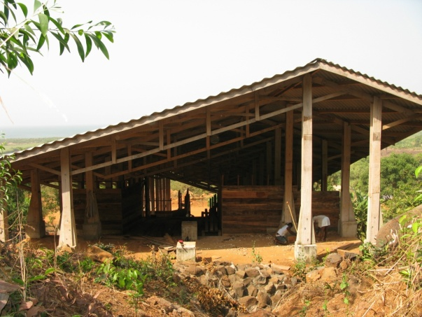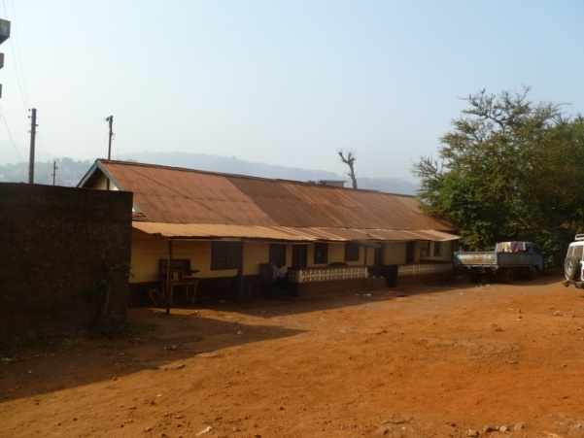
Figure 17: The Environmental and Sustainability Learning Centre of EFA at Lakka (left), and the MWR PIU house (right), both of which will benefit from RWH technologies as demonstrations underpinning trainings and political dialogues, amongst other

- Indicative activities for Output 2.a:

- Conduct relevant assessments to determine feasibility, cost-effectiveness and due-diligence with respect to environmental and other standards;
- Commission design of innovation technologies and infrastructure
- Construct the rooftop rainwater collection with reservoirs in MRW, Murray Town Hospital and EFA buildings. The system will consist to three basic elements: (i) a collection area which is the effective roof area; (ii) a conveyance system usually consists of gutters or pipes that deliver rainwater falling on the rooftop to cisterns or other storage vessels; (iii) and a storage tank or cistern.
- Establish procedures of maintenance including: (i) the procedure for eliminating the "foul flush" after a long dry spell; (ii) the periodical cleaning of the tank; (iii) the cover of the rainfall collection surfaces to reduce the likelihood of frogs, lizards, mosquitoes, and other pests using the cistern as a breeding ground; and (iv) the chlorination of the cisterns or storage tanks.
- Evaluate and map potential sites for replication in large communities in Freetown

Output 2.b: Spring water improvement designed, tested and demonstrated in high density area in Freetown (benefiting at least 200 households)

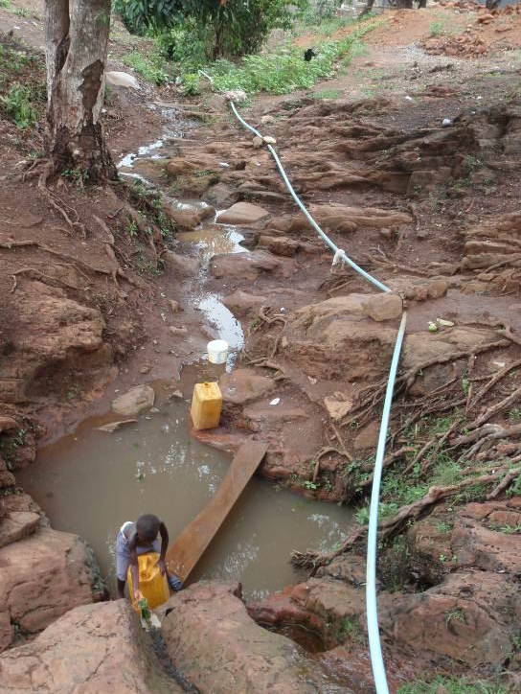
- The current springs, which are utilised around Freetown, are badly maintained.
The construction of spring boxes will be conducted and put in place to protect the springs from vandalism and overutilization. The main objective of spring protection is to avoid spring contamination and increase the capacity, convenience and safety of the potable water system. Just as there are many types of springs, there are also many different kinds of protective structures, such as spring boxes, seepage spring development structures, and horizontal wells. However, spring boxes are typically cheaper, require the least skill, and can be made with locally available materials. In contrast to the generally held belief that discharges decline if the springs are touched, the development of natural springs often leads to improved yields. Partnership will be developed with Engineers without Borders, which already develop similar exercise in Freetown with an additionality component on the resilience of the system to climate changes. Gender sensitive analysis will be an important component with a need to integrate gender considerations throughout these activities – during design, assessment, demonstration, and especially with regards exposure and training programmes toward maintenance and upscaling.

- Additional investments are also expected on stand-alone roofs to supplement these springs and for provision of water in the dry season (e.g. a simple version at household level Figure 6). Gender sensitive analysis will be an important component with a need to integrate gender considerations throughout these activities – during design, assessment, demonstration, and especially with regards exposure and training programmes toward maintenance and up scaling.
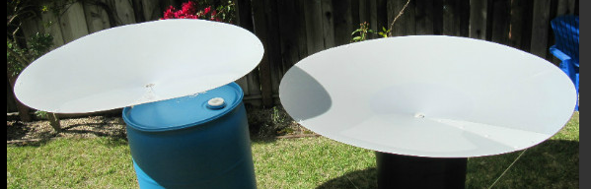

Figure 18: An example of household level stand-alone rainwater harvesting systems (Source: www.rainsaucers.com) – this is a simplified version and the stand-alone roofs would be a much bigger design to serve a community rather than household (in order to collect more rainwater.

Indicative activities for Output 2.b:
- Commission design of innovation technologies and infrastructure and undertake independent feasibility assessment; identify/confirm intervention sites. An initial gender specific assessment will take place when designing through socioeconomic surveys, group consultation and negotiation, and through the use of participatory techniques. Consultation with the local people (both men and women) will be required in choice of technology, arrangement for local maintenance and construction, to determine the roles of men and women in local management and financing etc., for the sustainable operation and maintenance of the water scheme.
- Build and implement innovation demonstrations on spring boxes improvement (at least 5 demo sites);
- Design and run community training programmes for relevant communities. Gender issues will be appropriately highlighted throughout the entire training material;
- Document lessons learnt from this output and inject learning into policy debates and development (component 1).
Output 2.c: Sustainable community reservoirs with 9 stand alone roof-top rainwater harvesting systems (in 3 hospitals and 6 schools), as well as 5 resilient gravity fed water distribution systems designed and pioneered in Kono, Kambia and Pujehun
- Focus of this project intervention would be the improvement partially already exiting community reservoirs e.g. at hospitals and schools, which are partially part of the Unicef and WASH consortium implementation of WASH activities. Focusing on rain water collection for drinking water usage in the dry season, the design of sustainable community reservoirs (Ferro-cement or steal, depending on the local circumstances) with stand alone roof-top rainwater harvesting systems, as well as gravity fed water distribution mechanisms will be pioneered. A proto-type design exists at Makeni hospital in Bombali district, where resident monks had established such a steal infrastructure several decades ago. Although this proto-type is no more functional, it adds a useful adaptation additionnality to other currently pursued designs.
- Indicative activities for Output 2.c:
- Conduct relevant assessments to determine feasibility, cost-effectiveness and due-diligence with respect to environmental and other standards;
- Construct the sustainable community reservoirs with stand alone roof-top rainwater harvesting systems, as well as gravity fed water distribution mechanisms;
- Establish and train WASH management committees of at least 5 members, participation of women/girls ensured, to maintain community reservoirs;

Output 2.d: At least 100 households provided with water storage and treatment systems for drinking water usage in times of prolonged dry-spells and drought in Kono, Kambia and Pujehun

- Initial vulnerability assessments were conducted in the three districts. The assessment found that communities are generally highly vulnerable to climate change (as related to the water sector), as a result of insufficient and outdated infrastructure (war-induced damages) and gaps in capacity.

- Especially gender vulnerabilities have not always been taken into account. During PPG phase community consultations, perceptions were that especially women and children were most vulnerable to water supply constraints – and this is perceived to be exacerbated by climate change.

- Current coping mechanisms are almost non-existent at the consulted pilot communities, with heavy reliance on surface water which makes communities vulnerable to diseases. The urgent need exists to rehabilitate existing infrastructure and construct new infrastructure as necessary. Especially gender sensitive and tailored technology innovations are urgently necessary.

- Therefore appropriate climate resilient adaptation techniques for the water sector are being replicated, improved, tested and implemented at least in the six pilot communities identified. Adapting innovative technologies developed with the support of the Welthungerhilfe, a focus will be on water collection during the rainy season and storage for drinking water usage in times of prolonged dry-spells and drought. Hand-in-hand with the establishment of such technologies will be the establishment and training of WASH committees through the district staff of the MWR.

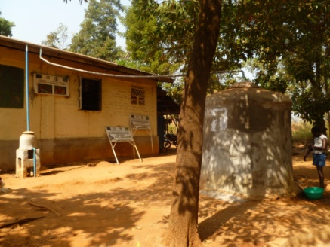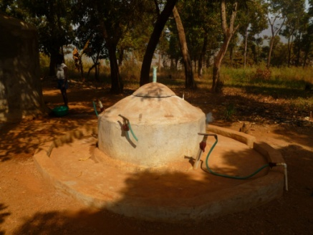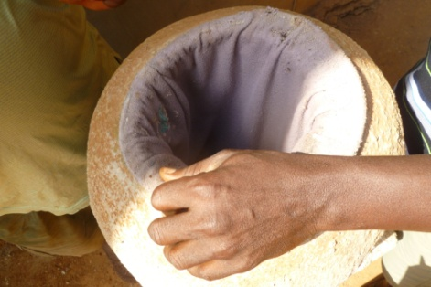
Figure 19: With the support of the Welthungerhilfe, two demonstration and training sites for community water supply techniques and technologies have been established. This project would further add a climate change additionnality component to the already existing innovations and use the centres as training venue for its pilot communities.
- Following the well established replication strategy of the Welthungerhilfe, skilled community members (such as carpenters, and other) will be selected by the project (district MWR staff in association with local leaders, and based on the interest of community members) and will be enrolled in one month training courses at the established training centres at Grafting and Kenema being trained in the building, installation and maintenance of storage tanks, cisterns, and rain water harvesting platform, amongst other. The trained individuals would work in their villages and further afield to upscale the application of these technologies, as well as they would serve as trainers in the future. Trainees would be set up for establishing a new production line and skills that they could market commercially in the form of small enterprises.

- Indicative activities for Output 2.d:
- Assess the current condition of water storage and distribution mechanisms and investigate solutions (e.g.. community systems pioneered by the Welthungerhilfe) and make recommendations on the up-scaling of the most appropriate water storage and distribution at community level. The application of gender sensitive analysis and stakeholder participation will aid to choose acceptable technologies and design of effective management and financial systems.
- Provide water storage and treatment systems to at least 100 households;
- Set-up WASH committees, participation of women ensured, and training programme to support self-promotion of entrepreneurs who would be able to disseminate the climate resilient community water rainwater harvesting, supply and storage infrastructure.
- Track successes and failures and adjust support programme to communities accordingly and in an adaptive manner to ensure long-term sustainability of the investments and climate resilience impacts.

2.5 Key indicators, risks and assumptions

- The proposed project indicator framework follows the GEF-5 Adaptation Monitoring and Assessment Tool (AMAT) and is aligned with the UNDP M&E Framework for Adaptation. Objective level indicators and outcome level indicators are specified according to the UNDP nomenclature of Results Based Management (RBM). The project design further foresees the development of more specific M&E tools, especially at the local implementation level. Participatory local level M&E can be a powerful management and communication tool, especially tracking and demonstrating project results at the demonstration sites. It is foreseen that a more detailed M&E project framework is developed during the project inception phase for national management purposes.
- An overall project M&E plan has been devised and is included in the respective section of the project document below. It foresees the regular progress reporting, a well as audits, a mid-term evaluation and an end of project evaluation.
- Assumptions underlying the project design include that:
- Implementation will follow a bottom-up approach, from needs of communities up to policy planning and infrastructure upgrading and rehabilitation.
- Willingness from all stakeholders to participate fully, develop capacities and improve water access in selected areas.
- Project management and execution is made up of a capacitated team of people.
- A complete Risk Log is included in Annex 1 of the project document. It includes risks identified in the PIF (see below) as well as newly identified risks. Additional barriers are included in the Barrier section above and are generally represented by the risks specified below. Most risks are organizational or strategic in nature, and mainly relate to relatively low current institutional and individual capacities of the public service structure in terms of adaptation. In summary, the following key risks were identified:

- Social resistance hinder the adoption of new resilient practices (PIF);
- Duplication and lack of coordination with other initiatives, resulting in inefficient use of resources, and a loss of opportunity for building climate change resilience in Sierra Leone (PIF);
- Limited capacity of local and national institutions (PIF);
- Reluctance of key stakeholders to endorse and participate in project activities (PIF);
- Too many different/divergent stakeholder interests in target sites may prevent efficient consensual decision-making (PIF);
- Stakeholder relations (PPG);
- Natural disaster: unusual and catastrophic climatic events during project implementation (PPG).

- Mitigation measures for each risk are specified in the Risk Log (Annex 1), and have been systematically addressed in the project design.

2.6 Financial modality

- Sierra Leone is a post-conflict LDC, moving towards a long-term sustainability agenda. The GEF LDCF resources will be provided as a grant.

2.7 Cost-effectiveness
- In order to respond to the greatest and most immediate threats of climate change, the GoSL prepared a National Adaptation Programme of Action (NAPA), which prioritized a number of interventions that should enhance the adaptive capacity of the water sector e.g. institutional strengthening of the water resources sector, promotion of rain rater harvesting, development of An Integrated Management System for Fresh Water Bodies, etc. The proposed interventions outlined in this LDCF project are based on the NAPA priorities weighed for cost-effectiveness and sustainability, before the proposed project components were selected and elaborated. By systematically building climate change resilience in the water sector, long-term costs that would most probably incur due to inappropriate planning and assumptions that do not factor in future climate impacts are foregone. Cost-effectiveness of water-sector investments is thus generally supported.

- The suggested outputs, activities and approaches have been identified and selected to meet the project objective and its expected outcomes in a cost-effective way.

- Under Outcome 1, the suggested approach is to integrate climate change adaptation within current policies such as the National Water and Sanitation Policy (NWSP) and its implementation Plan, the Rural Water Supply Strategy and into the management of the Guma Valley reservoir, along with training and raising awareness of decision makers and other key stakeholders, to allow planning for climate change risks in an efficient way, providing with policy and institutional capacities with a moderate investment. In addition, dialogues undertaken with Private sector will contribute to improve the role of government in enabling and incentivising the private sector to take action in adaptation.

- Under Outcome 2, a number of adaptation options have been assessed during the project design through documentation review, consultations at the national and local levels, and sites visits in every chiefdom that helped to determine the most appropriate technologies that are resilient against climate change induced risks in Freetown and Puhejun, Kambia and Kono districts. Priority adaptation technologies in the water sector identified by stakeholders were the following: (i) in Freetown, some households are applying rooftop rainwater harvesting techniques to complement water supply at a household level, current springs are also utilised but they are badly maintained, over utilised and often even vandalised resulting in poor quality and sufficiency in water; in the rural areas, communities currently rely strongly on the few open surface wells which are often riddled with water borne diseases, or have to rely on springs, which periodically dry up. Some, innovative technologies already on-going, with low-cost and safe household level water pumping, purification and storage but with no specific climate resilience considerations. After careful and in-depth analysis, it has been decided to focus on water collection during the rainy season and storage for drinking water usage in times of prolonged dry-spells and drought. These options have been selected on the basis of their potential for increasing resilience of water system. The project will test new innovations for roofing toward rainwater harvesting to create a collecting mechanism for clean water. The construction of a rooftop rainwater catchment system is simple, and local people can easily be trained to build one, minimizing its cost. It provides an essential reserve in times of emergency and/or breakdown of public water supply systems, particularly during natural disasters. Running costs are low and construction, operation, and maintenance are not labour-intensive. Local communities have used springs boxes as a source of water supply for many years. Their improvement will help to improve the good water quality, and generally very low operation and maintenance costs, coupled with the ease of community management, make them quite effective for supplying rural communities with water for domestic purposes. Protecting these water sources from contamination is a natural way of ensuring the continuity of this supply. Spring protection is an inexpensive in comparison to the development of a conventional point source.

- Finally, district level water engineers (from both the public and private sector), NGOS, local community based management committees, youth and women associations and others jointly and in a participatory approach work together as learning partners and engage in meaningful dialogues on climate risks, needs assessments and planning responses, to ensure that functional and long-term solutions to the impeding climate risks in the water sector are being set up, including through community-based water management approaches.

2.8 Sustainability

- The project addresses key national development priorities spelled out in the PRS, the UNDAF as well as identified and specified through the participatory and bottom-up NAPA process. The project has strong government support as well as buy-in at the district and demonstration site level. Consequently, a strong indicative commitment to carry out project activities and to up-scale and mainstream adaptation learning into long-term policies, plans, and national budgets is given.

- As the project interventions at the pilot sites are needs driven and will be implemented in a participatory manner, a high level of sustainability and absorption of adaptive capacity is also foreseen. It is recognised that infrastructure provision is one thing, but building long-term climate resilience entails the engagement of local stakeholders and users and community-based management and maintenance are equally important. Water resilience and be enhanced and sustainably achieved if key stakeholders are knowledgeable about the climate threat and possible solutions. Consequently the strong capacity building and participation of local stakeholders in project activities contributes to sustainability.

- Capacity building is a key to the approach of the design. Government institutions will be strengthened to be able to deal with climate change risk and adaptation needs. Especially MWR. EPA and the local Universities, as well as district level staff.

- It is asserted that the strategic integration of the learning outcomes from this project intervention into policy debates and processes, as well as the learning materials for trainings of various target groups will lead to sustainability of the outcomes of the intervention.

- Working closely with public and private sector partners, including the donor community, will ensure that critical thinking on climate risks and possible responses in the water sector will be brought forward through this catalytic project intervention.

- The high degree of ownership within MWR is seen to be particularly beneficial to sustainability aspects of this LDCF intervention in Sierra Leone.

2.9 Replicability
- The design principles outlined in Section 2.3 are specifically set out to foster replicability through up-scaling of adaptation learning and mainstreaming into policy processes. As this specific project is very well embedded within the MWR, the Ministry directly responsible for water and water infrastructure management throughout Sierra Leone, a high degree of ownership for the outcomes from this project is foreseen - a good foundation for replication.

- Overall, the design of this intervention is focused on piloting climate change adaptation options, which can be replicated in terms of approach and technologies tested in other communities and districts. The systematic documentation of adaptation learning, as well as the tracking of impacts of project outputs and activities is a key to establishing a knowledge basis from which replication can take place. Knowledge management is a key component of the design and should be carefully followed through on during project implementation.

- The focus on capacity building will generate a pool of technical experts that can be utilised for future replication in other parts of the country.

- Adaptation learning approaches applied to this sector-specific project can be replicated in other sectors as well. The more generic learning and knowledge management components included as principle approaches in this LDCF project can be applied more broadly.

Project Results Framework

This project will contribute to achieving the following Country Program Outcome as defined in CPAP or CPD:
Expected CP Outcome(s):
Transitional Joint Vision for Sierra Leone of the United Nations Family (2013-14): Cluster 3 goal: To ensure that natural resources are sustainably and equitably managed and threats and impacts from natural and man-made disasters are reduced
Country Program Outcome Indicators:
Transitional Joint Vision for Sierra Leone of the United Nations Family (2013-14): Cluster 3 indicators:
- Percentage change in mortality and casualties and economic impacts of natural and man-made disasters compared to 2011
- Percentage change in Sierra Leone’s environmental performance index as compared to 2010 (as measured by UNDP’s Human Development Reports)
Primary applicable Key Environment and Sustainable Development Key Result Area (same as that on the cover page, circle one): 1. Mainstreaming environment and energy OR
2. Catalyzing environmental finance OR 3. Promote climate change adaptation OR 4. Expanding access to environmental and energy services for the poor.
Applicable GEF Strategic Objective and Program: Adaptation to Climate Change: Objective 1: Reduce vulnerability to the adverse impacts of climate change, including variability, at local, national, regional and global level and Objective 2: Increase adaptive capacity to respond to the impacts of climate change, including variability, at local, national, regional and global level
Applicable GEF Expected Outcomes: Outcome 1.1: Mainstreamed adaptation in broader development frameworks at country level and in targeted vulnerable areas, Outcome 1.2: Reduced vulnerability in development sectors, Outcome 2.1: Increased knowledge and understanding of climate variability and change-induced risks at country level and in targeted vulnerable areas, Outcome 2.3: Strengthened awareness and ownership of adaptation and climate risk reduction processes at local level, Outcome 3.1: Successful demonstration, deployment, and transfer of relevant adaptation technology in targeted areas
Applicable GEF Outcome Indicators: (following AMAT tool)
Indicator 1.1.1: Adaptation actions implemented in national/regional development frameworks.
Indicator 1.2.3: Number of additional people provided with access to safe water supply and basic sanitation services given existing and projected climate change
Indicator 2.2.1: No. and type of targeted institutions with increased adaptive capacity to reduce risks of and responses to climate variability.
Indicator 2.3.2: % of targeted population awareness of predicted adverse impacts of climate change and appropriate responses
 | Indicator | Baseline | Targets  End of Project | Source of verification | Risks and Assumptions
Project Objective Enhance the adaptive capacity of decision-makers in the public and private sector involved in water provision to plan for and respond to climate change risks on water resources.  (equivalent to output in ATLAS) | Indicator 2.2.1: No. and type of targeted institutions with increased adaptive capacity to reduce risks of and responses to climate variability. (AMAT indicator 2.2.1) | Technocrats from MWR and EPA in Freetown, but particularly regional technical staffs have extremely limited opportunity for professional updating, and usually find it difficult to address newly emerging technical issues and practices into their ongoing work. One of the major limitations is the lack of capacity to deal with climate risks and understandings of managing these risks in the water sector. | At least capacities of 2 line ministries and 2 Districts Council to mainstream adaptation concerns within water policies and local development plans are strengthened; and capacities of two research /training center to deliver relevant trainings on climate change issues of are strengthened. | Baseline capacity assessment to be undertaken at project onset  APRs/PIR  Policy reviews as part of APRs/PIR  MTR | Unavailability of requisite human resources and data  Insufficient institutional support and political commitment
Outcome 1:  Critical public policies governing the management of water resources revised to incentivize climate smart investment by the private sector.  (equivalent to activity in ATLAS) | Indicator 1.1.1: Adaptation concerns and actions mainstreamed within at least the Guma Reservoir Management process (AMAT indicator 1.1.1) | The overall risk that climate change may pose on the sustainability of water supply to the capital not well integrated into Guma Reservoir management; | CC resilience plan for Guma reservoir established | Policy and resilience plan review  Policy reviews as part of APRs/PIR | Timing of interventions well attuned to policy development/review;  Political will is lacking
 | Indicator 2.2.1: No. and type of targeted institutions with increased adaptive capacity to reduce risks of and responses to climate variability. (AMAT indicator 2.2.1) | Key decision-makers who are supposed to lead the implementtaion of the policy have limited knowledge of climate change impacts or adaptation responses.  Information, including inventory and mapping, is inadequate and staffs from MWR have limited expertise to internalize climate changes into existing local deve plan  Low interplay between public and private sector on adaptation strategies investment  Existing coping strategies and adaptation action not documented at all, including for the water sector. | 15% of staff from targeted institutions aware of predicted impacts of climate change and appropriate responses  60% of targeted stakeholders have access to relevant disseminated adaption experiences from the project | Baseline capacity assessment to be undertaken at project onset  Awareness raising activities  Policy reviews as part of APRs/PIR | Insufficient institutional support and political commitment
Outcome 2:  Water supply infrastructure in Freetown and Puhejun, Kambia and Kono districts made resilient against climate change induced risks.  (equivalent to activity in ATLAS) | Indicator 1.2.3: Number of additional people provided with access to safe water supply and basic sanitation services given existing and projected climate change (AMAT indicator 1.3.1.1) | Type and level: 0  (aside already existing local coping mechanism) | 5.000 at intervention sites in Freetown and three districts | Project reports e.g. trainings, pilot interventions, APRs, PIRs  Local level assessments at demonstration sites (Questionnaire based appraisal - CBA)  APRs/PIR | Target population do not see the benefit of new practices or social conflicts hinder taking up the practices;  Low Capacities of WASH comities to support the implementation of appropriate climate resilient technologies

Total budget and workplan

Award ID: | 00074076 | Project ID(s): | 00086632
Award Title: | Sierra Leone: Building adaptive capacity to catalyze active public and private sector participation to manage the exposure and sensitivity of water supply services to climate change in Sierra Leone
Business Unit: | SLE10
Project Title: | Sierra Leone: Building adaptive capacity to catalyze active public and private sector participation to manage the exposure and sensitivity of water supply services to climate change in Sierra Leone
PIMS no. 4613 | PIMS 4613
Implementing Partner (Executing Agency) | Ministry of Water Resources

GEF Outcome/Atlas Activity | Resp Party/ Implem Agent | Fund ID | Donor Name | Atlas Code | ATLAS Budget Description | Amount Year 2013 | Amount Year 2014 | Amount Year 2015 | Amount Year 2016 | Amount Year 2017 | Total | Budget Note
OUTCOME 1: Critical public policies governing the management of water resources revised to incentivize climate smart investment by the private sector | MWR | 62160 | GEF | 71200 | International consultants | 0 | 12,000 | 28,200 | 22,800 | 0 | 63,000 | a
 |  |  |  | 71300 | Local Consultants | 0 | 12,000 | 18,600 | 15,900 | 4,500 | 51,000 | b
 |  |  |  | 71400 | Contractual services - Individual | 18,000 | 45,000 | 36,000 | 12,000 | 6,000 | 117,000 | c
 |  |  |  | 71600 | Travel | 9,261 | 26,341 | 66,521 | 24,682 | 27,220 | 154,025 | d
 |  |  |  | 72100 | Contractual services - Companies | 0 | 0 | 56,000 | 70,000 | 21,000 | 147,000 | e
 |  |  |  | 72400 | Communication & Audio Visual Equip | 10,000 | 7,000 | 7,000 | 7,000 | 5,000 | 36,000 | f
 |  |  |  | 72500 | Supply | 0 | 30,000 | 30,000 | 30,000 | 30,000 | 120,000 | g
 |  |  |  | 74500 | Miscellaneous | 1,000 | 3,000 | 3,000 | 3,000 | 1,975 | 11,975 | h
Subtotal GEF |  |  |  |  |  | 38,261 | 135,341 | 245,321 | 185,382 | 95,695 | 700,000
Subtotal Component 1 |  |  |  |  |  | 38,261 | 135,341 | 245,321 | 185,382 | 95,695 | 700,000
OUTCOME 2: Water supply infrastructure in Freetown and Puhejun, Kambia and Kono districts made resilient against climate change induced risks | MWR | 62160 | GEF | 71200 | International consultants | - | 36,000 | 69,000 | 36,000 | 28,800 | 169,800 | i
 |  |  |  | 71400 | Contractual services - Individual | 4,500 | 38,000 | 38,000 | 38,000 | 38,000 | 156,500 | j
 |  |  |  | 71600 | Travel Tickets International | 9,000 | 53,160 | 57,060 | 51,120 | 43,140 | 213,480 | k
 |  |  |  | 72100 | Contractual services - Companies | 0 | 24,000 | 564,000 | 394,000 | 364,000 | 1,346,000 | l
 |  |  |  | 75700 | Training, Workshop and Conf. | 0 | 0 | 9,000 | 40,000 | 43,000 | 92,000 | m
 |  |  |  | 72500 | Supply | 6,000 | 8,000 | 8,000 | 8,000 | 5,000 | 35,000 | n
 |  |  |  | 72200 | Equipment and furniture | 20,000 | 5,000 | 5,000 | 5,000 | 5,000 | 40,000 | 0
 |  |  |  | 73400 | Rental and maintenance | 2,000 | 5,000 | 5,000 | 5,000 | 5,000 | 22,000 | p
 |  |  |  | 74200 | Audio visual &Print Prod Costs | 2,000 | 3,000 | 3,000 | 3,000 | 4,000 | 15,000 | q
 |  |  |  | 74500 | Miscellaneous | 1,500 | 2,000 | 2,500 | 2,220 | 2,000 | 10,220 | r
 | MWR |  |  |  | Subtotal GEF | 45,000 | 174,160 | 760,560 | 582,340 | 537,940 | 2,100,000
 | MWR | 0400 | UNDP | 71300 | Local Consultant | - | - | 9,000 | - | 9,000 | 18,000 | s
 |  |  |  | 71400 | Contractual Services - Individual | 1,800 | 7,200 | 7,200 | 7,200 | 7,200 | 30,600 | t
 |  |  |  | 71500 | UNV | - | 10,000 | 10,000 | 10,000 | 10,000 | 40,000 | u
 |  |  |  | 71600 | Travel local | - | - | 1,840 | - | 1,840 | 3,680 | v
 |  |  |  | 72200 | Transportation equipment | - | 40,000 | - | - | - | 40,000 | w
 |  |  |  | 73400 | Rental and maintenance | - | 5,720 | 3,000 | 3,000 | 3,000 | 14,720 | x
 |  |  |  | 74500 | Miscellaneous | 500 | 500 | 500 | 500 | 1,000 | 3,000 | y
Subtotal UNDP |  |  |  |  |  | 2,300 | 63,420 | 31,540 | 20,700 | 32,040 | 150,000
Subtotal Component 2 |  |  |  |  |  | 47,300 | 237,580 | 792,100 | 603,040 | 569,980 | 2,250,000
 | MWR | 62160 | GEF | 71400 | Contractual Services - Individual | 4,900 | 22,100 | 22,100 | 22,100 | 22,100 | 93,300 | z
 |  |  |  | 71200 | International Consultant | - | - | 18,000 | - | 18,000 | 36,000 | aa
 |  |  |  | 71600 | Travel Tickets International | - | - | 3,000 | - | 3,000 | 6,000 | ab
 |  |  |  | 74500 | Miscellaneous | 700 | 1,000 | 1,000 | 1,000 | 1,000 | 4,700 | ac
Subtotal Project Management costs |  |  |  |  |  | 5,600 | 23,100 | 44,100 | 23,100 | 44,100 | 140,000
Total GEF |  |  |  |  |  | 88,861 | 332,601 | 1,049,981 | 790,822 | 677,735 | 2,940,000
Total UNDP |  |  |  |  |  | 2,300 | 63,420 | 31,540 | 20,700 | 32,040 | 150,000
TOTAL PROJECT |  |  |  |  |  | 91,161 | 396,021 | 1,081,521 | 811,522 | 709,775 | 3,090,000

Summary of Funds
 | Amount | Amount | Amount | Amount | Amount | Total
 | Year 1 | Year 2 | Year 3 | Year 4 | Year 5 | Total
GEF/LDCF (Cash) | 88,861 | 332,601 | 1,049,981 | 790,822 | 677,735 | 2,940,000
UNDP (Cash) | 2,300 | 63,420 | 31,540 | 20,700 | 32,040 | 150,000
UNDP (In kind –Grant) | - | 400,000 | 300,000 | 150,000 | 150,000 | 1,000,000
MWR (Grants) | 360,000 | 1,350,000 | 3,060,000 | 2,430,000 | 1,800,000 | 9,000,000
TOTAL | 451,161 | 2,146,021 | 4,441,521 | 3,391,522 | 2,659,775 | 13,090,000

Co-financing:
Co-financing has been confirmed for the following partners. The letters of co-financing are provided in Annex 4
Government of Sierra Leone-Ministry of Water Resources (Grant) | 8,500,000
Government of Sierra Leone-Ministry of Water Resources (In-Kind) | 500,000
UNDP (Cash) | 1,150,000
Total | 10,150,000

Budget notes
Budget Notes | Description
a | International consultants: Output 1a/Climate risks expert for training and update water point mapping (65 days)/Output 1b Climate risks expert to develop the Guma Reservoir Contingency plan (40 days) at 600US$/per day
b | Output 1a: Climate risks expert for training and update water point (65 days); Policy expert for roadmap on budgeting (15 days)/ Output 1c: Climate changes expert to develop awareness material and conduct 10 awareness campaign + 2 WASH comity training in Freetown and target districts (80 days)/ Output 1d: Private sector specialist (10 days) 300USD@day
c | CTA 125 days at 600@day; communication officer 12000 USD/year for 3.5 yrs
d | Output 1a: 3 tickets for Climate risk expert/Output 1b: 2 Tickets for climate risks expert; 3 tickets for CTA / Output 2e: 4 tickets for PMU to share projects results/3000@ticket  Output 1a: Climate risks expert (25 days)/ Output 2b: Climate risks expert (25 days); CTA 125 days at 204@day  Output 1e: 2 exchanges visits per year for 50 pers.; 150@per round trip/pers.; communication expert trips to documents project lessons learned (2 to 4 trip per year); 2 trip of media networks in projects sites (20 people) - 37,800 budgeted.  Output 1a Climate risks expert for training and update water point (25 days at 56@day-$1400); Output 1c Climate risks expert for awareness campaign (40 days at 56@day- $2240); Output1e: DSA for exchanges visits (2 visits, 4 days each for 50 people at 56@day-$22400) and communication officer meeting travelling in project sites to document lessons learned and experiences (4 visits per year -10 days per visit at 56@day-$2240*4 years =$8960); DSA for media networks to visits projects sites and realizations (2 visits for 20 pers for 4 days- $ 8960) = $43960
e | Output1a: 4 training for 50 staffs/ Output 1b. 1 training for Guma Staff; Output 1 c: 2 training workshop for WASH comities and 10 awareness campaigns; 2 policy dialogues and 2 national workshops for sharing projects experiences / 7000 USD per workshop/ training
f | Communication material
g | Training and workshop materials, publication
h | Contingencies related to inflation, currency exchange fluctuations and other external shocks and contingencies, which would increase the cost of travel and materials.
i | Output 2a: International consultant to design and supervise works the resilient rooftop rainwater systems and train on maintenance (45 days at 600@day); Output 2b: International consultant to design, supervise works for the improvement of spring boxes and train on maintenance (80 days at 600@day); Output 2c: International consultants to design and supervise works on rooftop rainwater harvesting and gravity rainfed systems in rural areas and train on maintenance (80 days at 600@day); International evaluator MTR&FE (60 days)
j | M&E specialist 20000/year & Admin Finances (18000@year)
k | 13 tickets for 4 IC (3000@ticket)  DSA 5 IC (160 days at 204@day)  Travel PMU Staff (4 travel/year/2000@travel)  DSA PMU staff (5 staffs/5days/5 sites at 56@day)
l | Reinforcement/establishment of 10 WASH comity and support for fields monitoring fees (10 WASH comity/200USD/month per comity  Output 2a: construction of 3 rooftop RWH in Freetown (50000@system); Output 2b: improvement of 5 spring boxes (10000@spring box); Output 2c: construction of 6 rooftops RWH and 10 gravity systems in rural areas (50000@system);Output 2e: provision of 100 households water storage and treatment systems (2000@system)
m | Output 2a: 3 training on rooftop maintenance (1000@training); Output 2b: 5 training on Spring boxes maintenance (3000@training); Output 2c: 6 training on rooftop maintenance (1000@training), Training on the maintenance of gravity system (5000@training); Output 2e 5 training on maintenance of water storage and treatment systems (5000@training)
n | Office & training and workshop materials, publication
o | PMU equipment (3 laptop, 3 All-in-One Printer/ photocopier/scanner/fax; 1 LCD projector and screen; 4 mobile phones and 2 GPS Cameras;
p | PMU material maintenance
q | Office printing costs
r | Contingencies related to inflation, currency exchange fluctuations and other external shocks and contingencies, which would increase the cost of travel and materials.
s | National evaluator 60 day at 300 per day
t | Salary Driver (7200@year)
u | UNV salary and other costs including audit fees (5,000 U$ to be set aside yearly for audit purpose)
v | Travel national consultant  DSA for international experts (15 days at 64 USD/day
w | Project vehicle and UNV Moto
x | Maintenance of vehicle and Moto
y | Contingencies related to inflation, currency exchange fluctuations and other external shocks and contingencies, which would increase the cost of travel and materials.
z | Project manager and PMU related costs
aa | International evaluator 60 day at 600 per day
ab | Ticket international Evaluator (MTE &FE)
ac | Costs related to bank charges and contingencies

Management Arrangements
- The project will be implemented by the UNDP under its National Implementation (NIM) Modality and Harmonized Approach to Cash Transfer (HACT) procedures. The project is a four year intervention from expected to run from 01 July 2013 to July 2017. The executing agency in Sierra Leone is the MWR. The project will be executed in close collaboration with EPA, the AfDB financed-baseline project and the selected pilot communities, responsible for the local level pilot interventions of the project.
- The MWR is a competent execution partner, with the countries major water management mandate. The Ministry has a track record of successfully implementing programmes such as large support from DFID, JICA and other donor support programmes in the water sector. It is envisioned that the project team be housed at MWR. The EPA has the major mandate for coordinating climate change related programmes and policies, and as such will execute relevant outputs under the policy-focused component, component 1 of the project. EPA will chair the Steering Committee of the project.

Project Manager
MWR – Project coordinator
Project Board
Senior Beneficiary:
Ministry of Finance and Economic Development
Executive:
MWR

Senior Supplier:
UNDP

Project Assurance
UNDP

Project Organisation Structure
Project Steering Committee (EPA)

Component 1
EPA & MWR
EFA learning centre
Consultants

Project Implementation Unit
1 Project Coordinator
1 Chief Technical Advisor (Part time)
1 M&E expert
1 UNV covering 2 Districts
1 Finance & Admin staff
1 Driver

Component 2
WASH committees
Grafting & Kenema community training centres
Consultants

- The Project Board is responsible for making management decisions for a project in particular when guidance is required by the Project Manager. The Project Board plays a critical role in project monitoring and evaluations by quality assuring these processes and products, and using evaluations for performance improvement, accountability and learning. It ensures that required resources are committed and arbitrates on any conflicts within the project or negotiates a solution to any problems with external bodies. In addition, it approves the appointment and responsibilities of the Project Manager and any delegation of its Project Assurance responsibilities. Based on the approved Annual Work Plan, the Project Board can also consider and approve the quarterly plans (if applicable) and also approve any essential deviations from the original plans.

- In order to ensure UNDP’s ultimate accountability for the project results, Project Board decisions will be made in accordance to standards that shall ensure management for development results, best value money, fairness, integrity, transparency and effective international competition. In case consensus cannot be reached within the Board, the final decision shall rest with the UNDP Project Manager.

- Potential members of the Project Board are reviewed and recommended for approval during the PAC meeting. Representatives of other stakeholders can be included in the Board as appropriate. The Board contains three distinct roles, including: (1) An Executive: the individual representing the project ownership to chair the group, which will be the MWR. (2) The Senior Supplier: individual or group representing the interests of the parties concerned which provide funding for specific cost sharing projects and/or technical expertise to the project. The Senior Supplier’s primary function within the Board is to provide guidance regarding the technical feasibility of the project. In the case of this project this will be UNDP. (3) The Senior Beneficiary: individual or group of individuals representing the interests of those who will ultimately benefit from the project. The Senior Beneficiary’s primary function within the Board is to ensure the realization of project results from the perspective of project beneficiaries. This is the Ministry of Finance and Economic Development, on behalf of the Government of Sierra Leone.

- The Project Assurance role supports the Project Board Executive by carrying out objective and independent project oversight and monitoring functions. The Project Manager and Project Assurance roles should never be held by the same individual for the same project. UNDP fulfils the Project Assurance role.

- On request by the various stakeholders consulted during the PPG phase, a Project Steering Committee fulfilling the functions of a Technical Support Mechanism will be established. The EPA will chair this committee. The Project Manager or the Technical Project Coordinator will serve as Secretary to the SC. The composition of the SC will be inclusive of public and private sector representatives, representatives of research institutions, University, NGOs and civil society, as well as interested donors; where appropriate members of the National Climate Change Committee will be part of the SC. As the management of the project is overall overseen by the Project Board, the functions of the SC will be mostly technical and management oriented.

- Project Manager: The Project Manager has the authority to run the project on a day-to-day basis on behalf of the Implementing Partner within the constraints laid down by the Board. The Project Manager’s prime responsibility is to ensure that the project produces the results specified in the project document, to the required standard of quality and within the specified constraints of time and cost.

- Project Support – Project Implementation Unit: The Project Support role provides project administration, management and technical support to the Project Manager as required by the needs of the individual project or Project Manager. The project unit will be staffed by a project coordinator, Chief Technical Advisor and an M&E expert. UNDP is investigating possibilities to additionally source the support of one UNV, who would be supporting the district level project activities. A full-time Finance and Admin Manager will be hired, as well as a drive.

- Project implementation will be supported by implementation teams under the two outcomes of the project design.

Monitoring Framework and Evaluation
- The project will be monitored through the following M& E activities. The M& E budget is provided in the table below. The M&E framework set out in the Project Results Framework in part III of this project document is aligned with the AMAT and UNDP M&E frameworks.

- Project start: A Project Inception Workshop will be held within the first 2 months of project start with those with assigned roles in the project organization structure, UNDP country office and where appropriate/feasible regional technical policy and program advisors as well as other stakeholders. The Inception Workshop is crucial to building ownership for the project results and to plan the first year annual work plan
.
- The Inception Workshop should address a number of key issues including:
- Assist all partners to fully understand and take ownership of the project. Detail the roles, support services and complementary responsibilities of UNDP CO and RCU staff vis à vis the project team. Discuss the roles, functions, and responsibilities within the project's decision-making structures, including reporting and communication lines, and conflict resolution mechanisms. The Terms of Reference for project staff will be discussed again as needed.
- Based on the project results framework and the relevant GEF Tracking Tool, in this case the LDCF related AMAT set out in the Project Results Framework in section III of this project document, and finalize the first annual work plan. Review and agree on the indicators, targets and their means of verification, and recheck assumptions and risks.
- Provide a detailed overview of reporting, monitoring and evaluation (M&E) requirements. The Monitoring and Evaluation work plan and budget should be agreed and scheduled.
- Discuss financial reporting procedures and obligations, and arrangements for annual audit.
- Plan and schedule Project Board meetings. Roles and responsibilities of all project organisation structures should be clarified and meetings planned. The first Project Board meeting should be held within the first 12 months following the inception workshop.

- An Inception Workshop report is a key reference document and must be prepared and shared with participants to formalize various agreements and plans decided during the meeting.

- Quarterly:
- Progress made shall be monitored in the UNDP Enhanced Results Based Managment Platform.
- Based on the initial risk analysis submitted, the risk log shall be regularly updated in ATLAS. Risks become critical when the impact and probability are high. Note that for UNDP GEF projects, all financial risks associated with financial instruments such as revolving funds, microfinance schemes, or capitalization of ESCOs are automatically classified as critical on the basis of their innovative nature (high impact and uncertainty due to no previous experience justifies classification as critical).
- Based on the information recorded in Atlas, a Project Progress Reports (PPR) can be generated in the Executive Snapshot.
- Other ATLAS logs can be used to monitor issues, lessons learned. The use of these functions is a key indicator in the UNDP Executive Balanced Scorecard.

- Annually: Annual Project Review/Project Implementation Reports (APR/PIR): This key report is prepared to monitor progress made since project start and in particular for the previous reporting period (30 June to 1 July). The APR/PIR combines both UNDP and GEF reporting requirements.

The APR/PIR includes, but is not limited to, reporting on the following:
- Progress made toward project objective and project outcomes - each with indicators, baseline data and end-of-project targets (cumulative)
- Project outputs delivered per project outcome (annual).
- Lesson learned/good practice.
- AWP and other expenditure reports
- Risk and adaptive management
- ATLAS QPR
- Portfolio level indicators (i.e. GEF focal area tracking tools) are used by most focal areas on an annual basis as well.

Audit:
- The Project will be audited in accordance with UNDP Financial Regulations and Rules and applicable audit policies.

- Periodic Monitoring through site visits: UNDP CO and the UNDP RCU will conduct visits to project sites based on the agreed schedule in the project's Inception Report/Annual Work Plan to assess first hand project progress. Other members of the Project Board may also join these visits. A Field Visit Report/BTOR will be prepared by the CO and UNDP RCU and will be circulated no less than one month after the visit to the project team and Project Board members.

- Mid-term of project cycle: The project will undergo an independent Mid-Term Evaluation at the mid-point of project implementation (insert date). The Mid-Term Evaluation will determine progress being made toward the achievement of outcomes and will identify course correction if needed. It will focus on the effectiveness, efficiency and timeliness of project implementation; will highlight issues requiring decisions and actions; and will present initial lessons learned about project design, implementation and management. Findings of this review will be incorporated as recommendations for enhanced implementation during the final half of the project’s term. The organization, terms of reference and timing of the mid-term evaluation will be decided after consultation between the parties to the project document. The Terms of Reference for this Mid-term evaluation will be prepared by the UNDP CO based on guidance from the Regional Coordinating Unit and UNDP-GEF. The management response and the evaluation will be uploaded to UNDP corporate systems, in particular the UNDP Evaluation Office Evaluation Resource Center (ERC). The relevant GEF Focal Area Tracking Tools (in this case LDFC AMAT as set out in the Project Results Framework in section III of this project document) will also be completed during the mid-term evaluation cycle.

- End of Project: An independent Final Evaluation will take place three months prior to the final Project Board meeting and will be undertaken in accordance with UNDP and GEF guidance. The final evaluation will focus on the delivery of the project’s results as initially planned (and as corrected after the mid-term evaluation, if any such correction took place). The final evaluation will look at impact and sustainability of results, including the contribution to capacity development and the achievement of global environmental benefits/goals. The Terms of Reference for this evaluation will be prepared by the UNDP CO based on guidance from the Regional Coordinating Unit and UNDP-GEF.

- The Terminal Evaluation should also provide recommendations for follow-up activities and requires a management response which should be uploaded to PIMS and to the UNDP Evaluation Office Evaluation Resource Center (ERC).

- The relevant GEF Focal Area Tracking Tools (in this case LDFC AMAT as set out in the Project Results Framework in section III of this project document) will also be completed during the final evaluation.

- During the last three months, the project team will prepare the Project Terminal Report. This comprehensive report will summarize the results achieved (objectives, outcomes, outputs), lessons learned, problems met and areas where results may not have been achieved. It will also lay out recommendations for any further steps that may need to be taken to ensure sustainability and replicability of the project’s results.

- Learning and knowledge sharing: Results from the project will be disseminated within and beyond the project intervention zone through existing information sharing networks and forums.
The project will identify and participate, as relevant and appropriate, in scientific, policy-based and/or any other networks, which may be of benefit to project implementation though lessons learned. The project will identify, analyze, and share lessons learned that might be beneficial in the design and implementation of similar future projects.

- Finally, there will be a two-way flow of information between this project and other projects of a similar focus.

M& E workplan and budget
Type of M&E activity | Responsible Parties | Budget US$  Excluding project team staff time | Time frame
Inception Workshop and Report | - Project Manager (MOA)  - PIU  - UNDP CO, UNDP GEF | Indicative cost: 10,000 | Within first two months of project start up
Measurement of Means of Verification of project results. | - UNDP GEF RTA/Project Manager will oversee the hiring of specific studies and institutions, and delegate responsibilities to relevant team members.  - PIU, esp. M&E expert | To be finalized in Inception Phase and Workshop. | Start, mid and end of project (during evaluation cycle) and annually when required.
Measurement of Means of Verification for Project Progress on output and implementation | - Oversight by Project Manager (MOA)  - PIU, esp. M&E expert  - Implementation teams | To be determined as part of the Annual Work Plan's preparation.  Indicative cost is 20,000 | Annually prior to ARR/PIR and to the definition of annual work plans
ARR/PIR | - Project manager (MOA)  - PIU  - UNDP CO  - UNDP RTA  - UNDP EEG | None | Annually
Periodic status/ progress reports | - Project manager and team | None | Quarterly
Mid-term Evaluation | - Project manager (MOA)  - PIU  - UNDP CO  - UNDP RCU  - External Consultants (i.e. evaluation team) | Indicative cost: 30,000 | At the mid-point of project implementation.
Final Evaluation | - Project manager (MOA)  - PIU  - UNDP CO  - UNDP RCU  - External Consultants (i.e. evaluation team) | Indicative cost : 45,000 | At least three months before the end of project implementation
Project Terminal Report | - Project manager  - PIU  - UNDP CO | None | At least three months before the end of the project
Audit | - UNDP CO  - Project manager (MOA)  - PIU | Indicative cost per year: 3,000 (12,000 total) | Yearly
Visits to field sites | - UNDP CO  - UNDP RCU (as appropriate)  - Government representatives | For GEF supported projects, paid from IA fees and operational budget | Yearly
TOTAL indicative COST  Excluding project team staff time and UNDP staff and travel expenses |  | US$ 117,000  (+/- 5% of total GEF budget)

Legal Context
- If the country has signed the Standard Basic Assistance Agreement (SBAA), the following standard text must be quoted:
This document together with the CPAP signed by the Government and UNDP which is incorporated by reference constitute together a Project Document as referred to in the Standard Basic Assistance Agreement [or other appropriate governing agreement] and all CPAP provisions apply to this document.
Consistent with the Article III of the Standard Basic Assistance Agreement, the responsibility for the safety and security of the implementing partner and its personnel and property, and of UNDP’s property in the implementing partner’s custody, rests with the implementing partner.
The implementing partner shall:
- put in place an appropriate security plan and maintain the security plan, taking into account the security situation in the country where the project is being carried;
- assume all risks and liabilities related to the implementing partner’s security, and the full implementation of the security plan.
UNDP reserves the right to verify whether such a plan is in place, and to suggest modifications to the plan when necessary. Failure to maintain and implement an appropriate security plan as required hereunder shall be deemed a breach of this agreement.
The implementing partner agrees to undertake all reasonable efforts to ensure that none of the UNDP funds received pursuant to the Project Document are used to provide support to individuals or entities associated with terrorism and that the recipients of any amounts provided by UNDP hereunder do not appear on the list maintained by the Security Council Committee established pursuant to resolution 1267 (1999). The list can be accessed via http://www.un.org/Docs/sc/committees/1267/1267ListEng.htm. This provision must be included in all sub-contracts or sub-agreements entered into under this Project Document.

- If the country has not signed the SBAA, the following standard text must be quoted:
This document together with the CPAP signed by the Government and UNDP which is incorporated by reference constitute together the instrument envisaged in the Supplemental Provisions to the Project Document, attached hereto.
Consistent with the above Supplemental Provisions, the responsibility for the safety and security of the implementing partner and its personnel and property, and of UNDP’s property in the implementing partner’s custody, rests with the implementing partner.
The implementing partner shall:
- put in place an appropriate security plan and maintain the security plan, taking into account the security situation in the country where the project is being carried;
- assume all risks and liabilities related to the implementing partner’s security, and the full implementation of the security plan.
UNDP reserves the right to verify whether such a plan is in place, and to suggest modifications to the plan when necessary. Failure to maintain and implement an appropriate security plan as required hereunder shall be deemed a breach of this agreement.
The implementing partner agrees to undertake all reasonable efforts to ensure that none of the UNDP funds received pursuant to the Project Document are used to provide support to individuals or entities associated with terrorism and that the recipients of any amounts provided by UNDP hereunder do not appear on the list maintained by the Security Council Committee established pursuant to resolution 1267 (1999). The list can be accessed via http://www.un.org/Docs/sc/committees/1267/1267ListEng.htm. This provision must be included in all sub-contracts or sub-agreements entered into under this Project Document.

Annexes

- Annex 1: Risk Log
- Annex 2. TOR of key staff
- Annex 3. Stakeholder consultations during PPG phase
- Annex 4. Summary of reports from PPG phase

Annex 1: Risk Log

Project Title: Sierra Leone: Building adaptive capacity to catalyze active public and private sector participation to manage the exposure and sensitivity of water supply services to climate change in Sierra Leone | Award ID: 4613 | Date: February 2013

# | Description | Date Identified | Type | Impact &  Probability (1-5) | Countermeasures / Mngt response | Owner | Submitted, updated by | Last Update | Status
1 | Social resistance hinder the adoption of new resilient practices | December 2011 (PIF) | Environmental:  Social and Cultural | I=3  P=3 | One of the first activities is the full development of the implementation plan and stakeholder involvement plan. In addition, the project will enter into strategic partnerships at the local level, not just with local government, but in particular with local NGOs and community based organisations on the choice of technologies, specifically for women. Furthermore, local governments and technical services will have a key role in supporting this adoption. | MWR, UNDP
2 | Duplication and lack of coordination with other initiatives, resulting in inefficient use of resources, and a loss of opportunity for building climate change resilience in Sierra Leone | December 2011 (PIF) | Strategic:  Leadership and Management | I=2  P=2 | At the government level, the MWR is the national executing agency, and as the key water player in Sierra Leone is part of all initiatives. In addition, detailed delivery strategy will clearly identify the roles and responsibilities of specific institutions for the overall management of the project. Better programmatic coordination with development partners (UNDP, DFID, EU, etc) will be ensured through coordination mechanisms established by the UN Joint vision and by giving periodically information about project progress and tools. | MWR, UNDP
3 | Limited capacity of local and national institutions | December 2011 (PIF) | Organisational:  Human resources Processes and Procedures | I=4  P=3 | Government capacity is not likely to represent a risk for the project because there is a strong policy will behind the project. While capacities are weak, efforts will be made to develop the capacities of key institutions to participate fully in the project implementation. The risk of non compliance will be mitigated by mobilising the capacity of different actors, projects, programmes and bilateral agencies to work intensively with government and transfer skills to government counterparts. | MWR, UNDP
4 | Reluctance of key stakeholders to endorse and participate in project activities | December 2011 (PIF) | Strategic Partnerships failing to deliver: | I=4  P=2 | The risk of reluctance of stakeholders is low. Nevertheless it will be addressed by local participation in project formulation and implementation. In particular, existing areas where income has been generated from adaptation activities will be demonstrated to other communities and replicated where possible. | MWR, UNDP
5 | Too many different/divergent stakeholder interests in target sites may prevent efficient consensual decision-making | December 2011 (PIF) | Strategic Partnerships failing to deliver: | I=3  P=3 | During the PPG, efforts were focused on the identification of appropriate government agencies – a PIU will be set up within the Water Department of the MWR to execute the project. A project steering committee will oversee the project. | MWR, UNDP
6 | Stakeholder relations | January 2013 | Strategic | I=4  P=2 | The PPG phase suggested that the project be implemented under a partnership arrangement between government, UNDP and competent NGOs/institutions/ individual experts (national and international). This established commitment to a partnership approach to implementation should build the foundation for a good success for project implementation. | MWR, UNDP
5 | Natural disaster: Unusual and catastrophic climatic events during project implementation | January 2013 | Environmental | I=4  P=2 | Unusually difficult climatic circumstances could threaten the demonstration projects and set up of infrastructure – the rehabilitation and construction should take into account resilience during construction and rehabilitation. | MWR, UNDP

Types of Risks
Environmental | Financial | Organizational | Political | Operational | Regulatory | Strategic | Other
Natural Disasters: storms, flooding, earthquakes | EXTERNAL economic factors: interest rates, exchange rate fluctuation, inflation | Institutional Arrangements | Corruption | Complex Design (size: larger/multi-country project; technical complexity; innovativeness, multiple funding sources) | New unexpected regulations, policies | Partnerships failing to deliver | Other risks that do not fit in an of the other categories
Pollution incidents | INTERNAL: | Institutional/ Execution Capacity | Government Commitment | Project Management | Critical policies or legislation fails to pass or progress in the legislative process | Strategic Vision, Planning and Communication | Might refer to socioeconomic factors such as: population pressures; encroachment – illegal invasions; poaching/illegal hunting or fishing
Social and Cultural | Co-financing difficulties | Implementation arrangements | Political Will | Human Error/Incompetence |  | Leadership and Management | Poor response to gender equity efforts
Security/Safety | Use of financing mechanisms | Country Office Capacity (specific elements limiting CO capacity) | Political Instability | Infrastructure Failure |  | Program Alignment
Economic | Funding (Financial Resources) | Governance | Change in Government | Safety being compromised |  | Competition
 | Reserve Adequacy | Culture, Code of Conduct and Ethics | Armed Conflict and Instability | Poor monitoring and evaluation |  | Stakeholder Relations
 | Currency | Accountability and Compensation | Adverse Public opinion/media intervention | Delivery |  | Reputation
 | Receivables | Succession Planning and Talent Management |  | Program Management |  | UN Coordination
 | Accounting/Financial Reporting | Human resources Processes and Procedures |  | Process Efficiency |  | UN Reform
 | Budget Allocation and Management |  |  | Internal Controls
 | Cash Management/Reconciliation |  |  | Internal and External Fraud
 | Pricing/Cost Recovery |  |  | Compliance and Legal
 |  |  |  | Procurement
 |  |  |  | Technology
 |  |  |  | Physical Assets
Annex 2. TOR of key staff

- Project Coordinator (of the Project Implementation Unit)
- International CTA
- M&E expert
- National UNV
- Finance and Admin staff (of the PIU)

    - Project Coordinator
- Reports to the Project Steering Committee
- Oversees the implementation of the project
- Plan the activities of the project and monitor progress against the initial quality criteria.
- Mobilize goods and services to initiative activities, including drafting TORs and work specifications;
- Monitor events as determined in the Project Monitoring Schedule Plan, and update the plan as required;
- Manage requests for the provision of financial resources by UNDP, using advance of funds, direct payments, or reimbursement using the FACE (Fund Authorization and Certificate of Expenditures);
- Monitor financial resources and accounting to ensure accuracy and reliability of financial reports;
- Responsible for preparing and submitting financial reports to UNDP on a quarterly basis;
- Manage and monitor the project risks initially identified, submit new risks to the Project Board via the Project Manager for consideration and decision on possible actions if required; update the status of these risks by maintaining the Project Risks Log;
- Be responsible for managing issues and requests for change by maintaining an Issues Log;
- Prepare the Project Progress Report (progress against planned activities, update on Risks and Issues, expenditures) and submit the report to the Project Board and Project Assurance;
- Prepare the Annual Review Report, and submit the report to the Project Board and the Outcome Board;
- Annual Performance Report (APR)/Project Implementation Review (PIR)
- Prepare the AWP for the following year, as well as Quarterly Plans if required;
b. International CTA
- Reports to the Project Coordinator
- Develops the content for all capacity building initiatives (with expert facilitation consultants)
- Supports the risk management plan at Guma Reservoir, collates and supports the water harvesting mechanisms in Freetown
- Supports the process of all water infrastructure for the rural pilot sites in Puhejun, Kono and Kambia districts
- Works closely with the Project Coordinator to mobilize funding for all infrastructure needed at all project sites
- Liaises directly with all stakeholders

c. M&E expert
- Provide technical expertise and guidance to all project components, and support the PM in the coordination of the implementation of planned activities under the LDCF project as stipulated in the project document/work plan
- Specifically responsible for the technical input into the development of a M&E framework and its implementation and follow-up with all relevant stakeholders at national, district and community level
- Compile M&E information on project implementation for adaptive project planning and implementation
- Ensure that technical contracts meet the highest standards; provide input into development of Terms of Reference for sub-contracts, assist with selection process, recommend best candidates and approaches, provide technical peer function to sub-contractors; provide training and backstopping were necessary
- Provide technical inputs into the work of the Steering Committee and other relevant institutions implicated n the project management and implementation arrangements
- Track and document project lessons learnt; facilitate the integration of lessons learnt from project implementation into policy dialogues, relevant knowledge management mechanism and other
- Undertake regular reporting in line with project management guidelines.

d. National UNV
- Facilitate project implementation at district and pilot community level (Puhejun, Kono, Kambia)
- Report to project coordinator
- Detailed TORs to be developed during project inception

e. Finance and Admin Manager
- Set up and maintain project files
- Collect project related information data
- Update plans
- Administer Project Board, SC and other relevant meetings
- Administer project revision control
- Establish document control procedures
- Compile, copy and distribute all project reports
- Responsible for the financial management tasks under the responsibility of the Project Coordinator
- Review technical reports
- Monitor technical activities carried out by responsible parties

Annex 3. Stakeholder consultations during PPG phase

Inception (July 2013)
The inception mission for the PPG phase of the project commenced from 23 July to 28 July 2012. The national water expert (Francis Moijue), the international LDCF programming expert (Juliane Zeidler) supported by the Regional Technical Advisor of UNDP (Mame Dagou Diop) and the UNDP CO team (Mariatu Swaray and Hellal Uddin) set out the work programme for the PPG phase and commenced with critical stakeholder consultations (see a list of people consulted in Annex 1).
Consultations during the mission included:
- Lamin Souma Acting Chief Engineer, Water Supply Division,
Ministry of Energy and Power, and Water Resource.
- Mrs. Haddijatu Jalloh Executive Chairman
Environmental Protection Agency- Sierra Leone
- Dr. Tom Winnebah Board Member EPA-SL
Lecturer, Environmental Science Department,
Njala University College.
- Mr. Denis Sombi Lansana Director of Meteorological
UNFCCC Focal Point, IPCC Focal Point.
- Alpha Bockarie Assistance Director, Meteorological Department
- Mohamed M. Kamara Programme Manager
Environmental Protection Agency- Sierra Leone
- Dr. Reynold Johnson Co-ordinator,
Climate Change Project –Sierra Leone
- Martin Walshe Infrastructure Adviser, DFID Sierra Leone.
- Mr. Mohamed Tejan-Kelleh Project Coordinator IFAD Project, Sierra Leone
- Rogers Lubunga Water Sector TASK MANAGER of AFDB
- St John Day Technical Adviser ASI
Ministry of Energy and Water Resource Engineer
- George Square Consultant, Ministry of Energy and Water Resource
- Dr. Kolleh Bangura GEF Focal Point and Director
Environmental Protection Agency- Sierra Leone
- Claire Seaward Sierra Leone Advocacy and Campaign Manager, Oxfam

On 26 July the PPG phase inception workshop was conducted successfully. The inception workshop was held on 26 July 2012. The workshop aimed to:

- Inform participants about the process of the preparation activities: LDCF, GEF project cycle, PIF process in Sierra Leone, and objectives of the Preparatory phase.
- Presentation of the PIF: Objectives, outcomes and Outputs; budget, institutional arrangement;
- Proposition and discussions on national steps of the Preparatory Phase;
- Linkages with on-going initiatives, stakeholder’s engagement and partnership
- Formulate measures of a successful implementation of the preparation of project document.

Mrs. Haddijatou Jallow, Executive Chairperson of the Environmental Protection Agency Sierra Leone (EPASL), officially opened the One Day Workshop. Representatives of UNDP and other UN Agencies as well as other key stakeholders attended it from government institutions, NGOs, INGOs, Civil Society representatives, academia and journalists. More than 50 representatives participated in the workshop.

Community Consultations (November 2013)
National consultants visited the three project sites during the PPG phase, guided by a Vulnerability Assessment Guide developed by the International Consultant (using e.g. the H-form). These consultations aimed to provide climate risk information for Sierra Leone in general for the planned pilot districts in particular including, Freetown. To further clearly define Climate Change risks in the water sector relevant to these “sites”. (E.g. determine if at site (a) the climate change risks are increase in a flood risks, drought risks, frequency of extreme events etc, and how this would affect the community or household e.g. increased risk of disease, damages to houses and property etc.). The target group included community elders, government functionaries, women, and youth, but also practitioners in the water sector and council members.During the consultations, the participants were asked to share their experience to date with regard to climate change, particularly to access to water and water supply, including their concerns and feedback. For each question according to the H-form, they were asked to identify the degree of severity of climate change risks and to identify a solution or how they would like to see the risks situation reduced in order to address their concern. Participants were also informed about the development of the project document to address the issues of climate related risks to the water sector. Most of this information was subsumed within the introduction to the project sites.

In addition, the National Consultant performed a short assessment of rainwater harvesting mechanisms and through community consultations in Freetown specifically to assess what is already being done and by whom, what works and what hasn’t and what the general demands and issues are – as well as buy in by community members toward rainwater harvesting mechanisms around Freetown to supplement dry season water access issues. A visit and meeting with the Guma Valley Water Company about the needs and actions on improving the water monitoring system was also conducted successfully.

Second International Consultant Visit (January 2013)
Final project preparatory consultations were undertaken during Janaury 2013, and a final project design verification workshop was conducted. Site visits to the Graftings training centre, the Mamba Ridge community reservoir, the Guma water scheme/Reservoir and EFA Learning Centre were undertaken.
The following individuals were consulted specifically:

Lamin Souma | Director Water Supply Division, Ministry of Water Resource
Mr. Gowa | Chief Water Engineer MWR
Dr. Kolleh Bangura | GEF Focal Point and Director , Environmental Protection Agency- Sierra Leone
Mbaluh Sesay | Assistant Deputy Director, Field operations & Extension, EPA
Mohammed Abchir | UNDP Dep. Res.Rep
Tommy Garnett | Director Environment Forum Africa (EFA)
Oxfam/WASH | Sofia Goinhas; link up to WASH staff
Welthungerhilfe | Telephonically through MWR
Grafting centre | Site visit
Guma | Site visit and chief engineer interview
Dr. Reynolds | National consultant: Climate risk
Dr. Dante Bendu | National consultant: Socio-economics
Francis Mojue | Water Engineer MWR & national consultant
Gavin Iley | UNDP Wash support project with SL Met Services
Timothey Ferreira | UNDP SL EWS project preparation consultant

Annex 4. Summary of reports from PPG phase

The following key reports were produced as part of the PPG phase, based on detailed TORs developed during the first inception of the PPG phase/work planning:

PPG report 1: Proceedings on building adaptive capacity to catalyze active public and private sector participation to manage the exposure and sensitivity of water supply services to climate change in Sierra Leone Workshop
  - Vulnerability and adaptation of the water resources sector
  - National steps of preparatory phase
  - Group discussions

PPG report 2: Sierra Leone’s Water Related Sector’s Policy Review: opportunities and barriers to addressing climate risk and adaptation
- Tabled policy, with brief description of each policy, its relation to water, the addressing of climate risks and alignment with other policies
- Recommendations for climate change integration into current policies

PPG report 3: A Review of Water Harvesting in and around Freetown
- Existing rainwater harvesting mechanisms at household and community level
- Inventory of existing and recommendations of upscaling and rehabilitating

PPG report 4: Site consultations and local level planning
- Vulnerability assessments
- Site descriptions
- Participatory planning
Annex 5. PPG Report 2: Review of policies in Sierra Leone for integration of climate change in the water sector

Policy/Strategy Name | Brief description | Relation to water | Is climate change integrated, and how? | Alignment with other policies, how?
Development plans
Agenda for Change: Second Poverty Reduction Strategy (PRSP II, 2008-2012) | A poverty reduction strategy which aims to reduce poverty and improve livelihoods of Sierra Leoneans through priority interventions | Makes links between health and access to safe water; prioritises access to safe water through urgent investment to improve water supply and access (mostly through wells and gravity fed water systems), has a section on water and sanitation | Mentions that climate change related issues should urgently be tackled, states compliance with UNFCCC, also makes note of signing up with REDD and using carbon markets under enhancing forestry contributions | Makes recommendations for policy alignments; prioritises decentralisation policy; environmental management; energy policy
Sierra Leone Vision 2025: “Sweet-Salone” | Sierra Leone's development vision for 2025, clarifies the long term aspirations and vision of Sierra Leoneans. It lays down the guidelines for ensuring the sustainable and effective utilisation of natural resources within the environmental boundaries. | Makes links between Economic and Social Integration of the Youth through its national public works program improvement and access to safe water. | Mentions climate change as one of the key threats/barriers to development priorities. | Is in alignment with the Local Council Act 2004, and the country’s Poverty Reduction Strategy.
Joint Vision of Sierra Leone of the United Nations Family | This is a Joint Vision of the UN Family for Sierra Leone that defines their common priorities that will guide their activities and outline a set of underlying criteria and comparative advantages which will shape their programs and projects through a conflict-sensitive approach. | In the UNDAF, UNICEF has a program of support to the WASH sector | Not directly | Sets out its desire for a number of joint planning, implementation and coordination mechanisms.
United Nations Development Framework for Sierra Leone UNDAF (2008-2010) | The United Nations Country Team supports to Sierra Leone’s national effort, to improve the lives of its citizens, especially the poorest and the most vulnerable | UNDAF 2008 – 2010, under Outcome 2, Improved Environment and Energy  management, it was envisaged to increase support to environmental priorities | Addressed through identified areas for interventions in housing and informal settlements, disaster and risk reduction, waste management, deforestation, flood and erosion control and climate change. | Set to reduce transaction costs associated with their assistance, in conformity with the Paris Declaration.
Water Sector-specific Policies and legal framework
Draft Rural Water Supply Strategy | This strategy document describes an approach for extending and sustaining rural water supply service delivery across Sierra Leone. | The guide is intended primarily to support stakeholders working directly and indirectly in the water supply and sanitation sector. | The document does not mention climate change directly. But notes that some communities will be more susceptible to risks of seasonal flooding and disease outbreaks, as well as other shocks (p.23). These communities need to be identified and visually mapped so that robust contingency plans can be established. | Aligned with the National Water and Sanitation Policy and other sector strategy documents
Water, Sanitation and Hygiene (WASH) Policy | This water and sanitation policy responds to the urgent need in Sierra Leone for integrated and  cross-sectoral approaches to water management and development as well as the provision of safe and adequate water and adequate sanitation facilities. It provides overall direction for addressing the challenges in the WASH sector currently and in the future. | The policy document covers thematic areas of the water sector such as  Water Resources Management,  Urban Water Supply and Sewerage  Rural Water Supply,  Hygiene and Sanitation,  Legal, Regulatory and Institutional Framework | The policy recommends the assessment of water resources, both surface and groundwater, quantitatively and qualitatively as part of water resources planning. Noting that the assessment and analysis of water resources availability and the impact of climate change and catchments degradation on water resources are routinely carried out satisfactorily. | Is in alignment with the Local Council Act 2004, and the country’s Poverty Reduction Strategy, the Agenda for Change.
WASH Policy Implementation Plan | This is a compendium of proposed policy strategies that were identified by the Ministry in support of the WASH Policy implementation. It presents a general list of prioritized activities by each Sub Sector within the Ministry and provides the necessary guidance during the formulation of a detailed National WASH Action Plan. | The Ministry in charge of waters’ Policy direction for various sub-sectors. | CC not specifically mentioned.  But mentions strategies associated with adaptation measures such as utilizing water conservation techniques like as rainfall harvesting,  conservation and promotion of local participation in the management of the water resource. | Aligned with the National Water and Sanitation Policy and other sector strategy documents
Draft Water Resources Management Bill | The purpose of this Bill is to set out the core and fundamental principles for the management of water resources; provide for the equitable, beneficial, efficient and sustainable use and management of the country’s water resources and establish a body to regulate and manage water resources. | The Bill is about water, with the purpose of separating water resources management from water supply agencies to enable the latter concentrate on the core mandate of meeting the task of providing quality drinking water for the people. | Addressed through the adoption and implementation of sustainable water resources management principles and concepts. | Aligned with the PRSP, the National Water and Sanitation Policy and other sector strategy documents
Other sector Policies relevant to water
NATIONAL HEALTH SECTOR STRATEGIC PLAN  2010-2015 | This Plan provides the framework that will guide the efforts of the Ministry of  Health and Sanitation (MoHS) and its partners over in attaining  the health related MDGs. | States the case that the availability of clean water and safe sanitation is a major factor affecting the health status of the  population. | CC risks not mentioned directly
Climate change related Policies
NAPA  National Adaptation Programme of Action | This document describes the set of priority activities to be undertaken to meet Sierra Leone’s immediate needs and response required with regard to adaptation to the adverse effects of climate change in the country | The NAPA clearly presents the case that water resources is one of the key sectors in the country where adverse effects of climate change is anticipated. | The NAPA addresses Climate Change risks in the country through firstly identifying key adaptation needs and how these could be addressed by the selection of priority activities | The NAPA preparation process was carried out by synthesizing the major economic sectors of the country, the National and local development policies and strategies, and of course the International associated commitments.
National Sustainable Agriculture Development Plan (2010-2030) | The National Sustainable Agriculture Development Plan (NSADP) provides the roadmap for moving agriculture, forestry and fisheries forward to both address Sierra Leone’s growing needs due to population growth and to create additional income to the national economy. | Notes that  - of the total water potential of the country , very little is used in agriculture  - potential for irrigation remains largely unexploited and argues the need to utilise the annual rainfall for extending the growing season into the six-month dry season. | Notes that farming practices are expected to change with a move towards practices better adjusted to erratic rainfall such as photo-insensitive rice varieties for more flexibility in planting times, potentially more sorghum and millet for dry field crops, and greater demand for drying equipment. | Is in alignment with the country’s Poverty Reduction Strategy , the Agenda for Change.
Forestry Policy | There is no formally adopted Forest Policy for Sierra Leone yet, but rather an evolution of practice in response to changing priorities of the day. Latterly, these include decentralisation, community roles, gender issues and the  linkages to other sectors - in particular, agriculture, fisheries, energy, water catchment, medicinal services, mining  industry and rural development. | Makes links to water through the conservation and protection of water catchment areas in order to maintain sustained water yield for inland valley swamp development and cultivation, inland fisheries and general fresh water livestock productivity. | Strongly recommends for the  The conservation and protection of water catchment areas in order to maintain sustained water yield | Is in alignment with the Local Council Act 2004, and the country’s Poverty Reduction Strategy , the Agenda for Change.
Local council plans relevant to water
Kono district Development Plan 2011-2012 | This is the plan which guides development in the Kono District Council locality consisting of 8 national political constituencies, 24 local council wards, 14 chiefdoms, etc. in providing basic services to communities.  The Development Plan notes that mining activity is the main occupation of the people and that about 50 to 55 percent of the district total population (360,000) depends directly or indirectly on mining. The predominant form of mining is alluvial, and this is household practice. | Mining and its associated activities is impacting on the environment, polluting water courses, water wells, degrading the environment, etc | Climate change is not addressed directly in the plan. But the plan expresses issues around degrading environment from mining activities, threat to biodiversity, etc | The Kono District Development plan is in alignment with the Local Council Act 2004, and the country’s Poverty Reduction Strategy , the Agenda for Change.
Pujehun District Council Development Plan 2012 - 2014 | Pujehun District Council locality in the south of the country borders the Atlantic Ocean the republic of Liberia.  It has a a population of 238,919, with 12 chiefdoms and 22 political local council wards.  The Pujehun District Development Plan, (2012-2014) summarizes the development aspirations of the District and notes that the plan “strives to harness the available Resources in the District and all other external funding windows that can be utilised to bring improvement in the living conditions of its citizenry” | The District covers a total surface of 4,105 km² and the vegetation is a mixture of forest and grassland zones.  The District is well traversed by the Wanje,Moa and Mano riversas as well as their tributaries.  Water and Sanitation service provision ranks as a priority in its human development improvement in the plan.  In fact provision of water services is ranked 3rd as a priority for the District. | “Climate change” jargon is not mentioned in the plan.  However, the plan notes the district’s potential in mining and consequences thus making the case for education and awareness raising.  The Plan also notes pollution of the environment due to lack of inadequate environmental practices associated with lack of proper water and sanitation services. | The Pujehun District Development Plan (2012-2014) is in alignment with the Local Council Act 2004 and the country’s Poverty Reduction Strategy , the Agenda for Change.
Kambia District Council Development Plan 2011 - 2013 | Kambia District consist of 7 chiefdoms, 25 elected ward councilors and Chairman. It is in the north-western region of Sierra Leone, and it and the Atlantic Ocean.  This District is the home of the cholera epidemic in Sierra Leone as every year, on a seasonal basis, the cholera epidemic comes from the riverine areas of this District. .  The 2011-2013 Development Plan for the Kambia District Council is approached with a view to overcome the critical challenges and backlogs of addressing poverty and all its complications within our District. | The Plan has as a priority  - Ensure clean and water supply and keeping safe environment | Climate change though prevalent n this District, are not specifically mentioned and so addressed.  However, attributes of Climate Change are noticeable in the District. There are symptoms of Climate Change in this riverine District. | The Kambia District Development Plan (2011-2013) is in alignment with the Local Council Act 2004 and the country’s Poverty Reduction Strategy, the Agenda for Change.

Annex 6. Co-financing letters

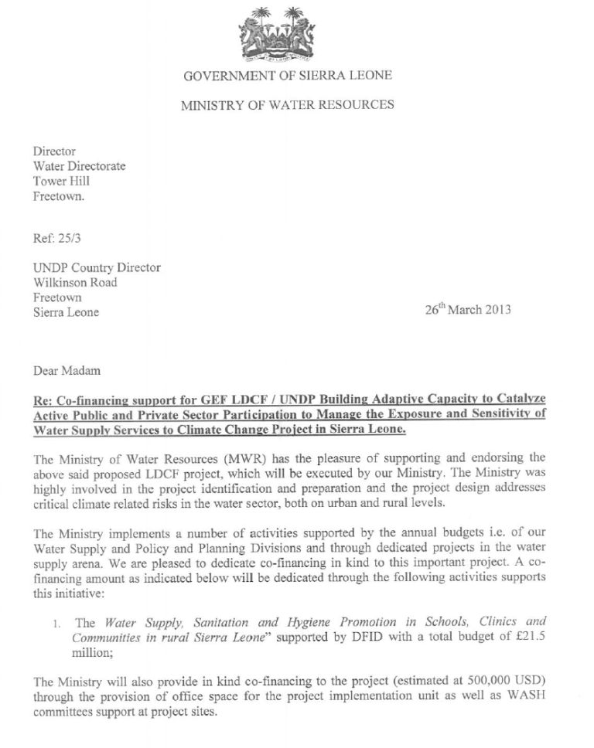

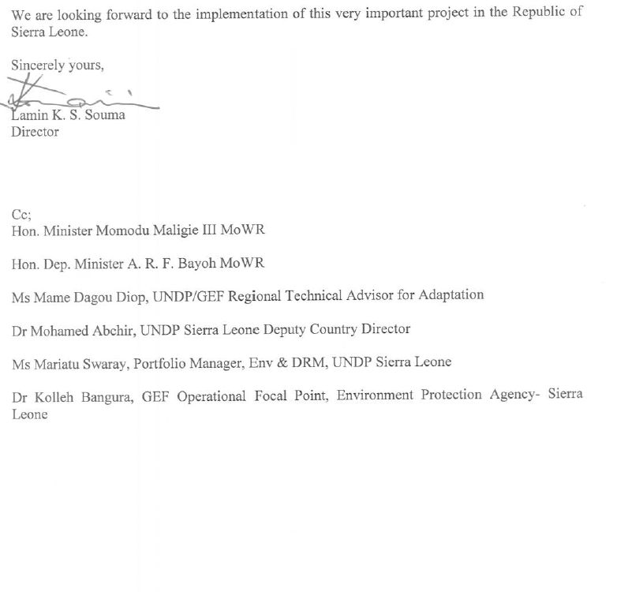

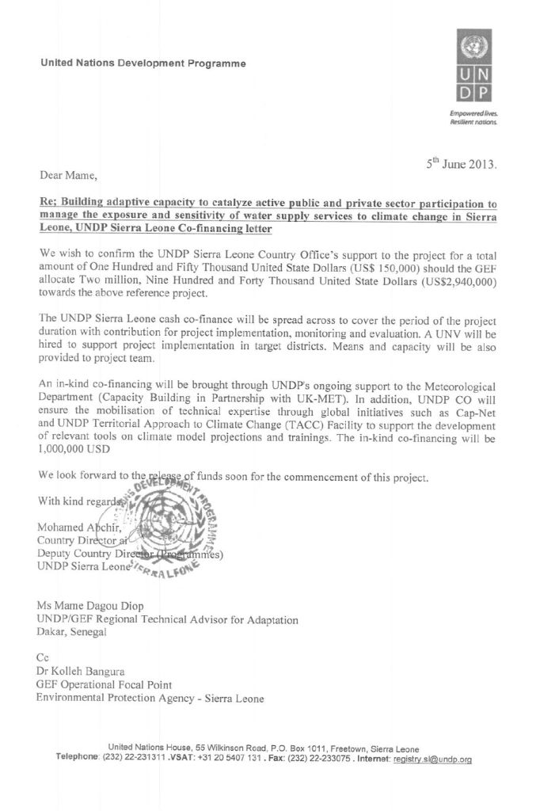

For UNDP-supported GEF-funded projects as this includes GEF-specific requirements
Based on the “Transitional Joint Vision for Sierra Leone” of the United nations Family 2013-2014
http://independent.academia.edu/NickBrooks/Papers/452054/Assessing_and_enhancing_adaptive_capacity; Brooks and Adger
UNDP Climate Change Country Profiles (http://country profiles.geog.ox.ac.uk)
UNDP Climate change Country Profiles- Sierra Leone (C. McSweeney, M. New and G. Lizcano), School of Geography and Environment, University of Oxford. Tyndall Centre for Climate Change Research. (http://country_ profiles.geog.ox.ac.uk)
Previously referred to in the development plan as Water and Sanitation (WATSAN) committee.
World Bank: Sierra Leone Public Expenditure Review for Water and Sanitation 2002 To 2009, retrieved on 7 November 2012
http://www.mofed.gov.sl/index.php?option=com_content&task=view&id=80&Itemid=1).
http://www.architectswithoutborders.com/
http://www.ewb-international.org/
Ferro-cement roofing offers unmatched speed of construction and is used for schools, residences, community buildings, among many others.
Objective (Atlas output) monitored quarterly ERBM and annually in APR/PIR
All outcomes monitored annually in the APR/PIR. It is highly recommended not to have more than 4 outcomes.

