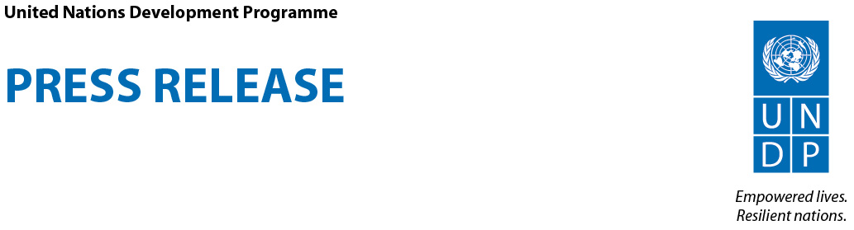

UNDP Announces the Climate Action Hackathon in Zambia
Up to 25 Full Travel Scholarships Will Provide Software and Application Developers with the Opportunity to Create Innovative Climate Information and Early Weather Alert Messaging Apps

UNDP’s Programme on Climate Information for Resilient Development in Africa (CIRDA) is inviting software developers, mobile application gurus and innovation specialists to Livingstone, Zambia from March 15-17 to participate in the Climate Action Hackathon. This exciting event will generate ideas and early prototypes for mobile and online applications to provide climate and weather information to protect the lives and livelihoods of vulnerable African communities adapting to climate change.

The UNDP will provide up to 25 travel scholarships for “hackers” to cover their travel, lodging and meals during this event that will run in parallel to the UNDP workshop “The Last Mile: Saving lives, improving livelihoods and increasing resiliency through tailored weather information services for a changing climate.”

“Hackers” will work individually or in teams to create mobile applications, messaging solutions or data management systems that address Africa’s persistent challenges in adapting to climate change, and share early warnings and accurate climate information across the continent. Climate Action Hackathon participants will be supplied with raw weather and climate data as well as access to global experts in meteorology, climatology, technology, and communications from the UNDP, IRI and the Brown Institute- a collaboration between Columbia University and Stanford University designed to encourage and support new endeavors in media innovation.

“The main goal of the hackathon is to find ways the application development community can help African weather services bridge the last mile with practical solutions to help people prepare and protect themselves from more frequent and severe storms, erratic weather patterns and long-term climate change,” said CIRDA Programme Manager Bonizella Biagini.

Resources
- Learn more about the Climate Action Hackathon and apply for a travel scholarship at http://www.undp-alm.org/climate-action-hackathon. Deadline is February 17.
- Project Brief
- Terms and Conditions

The CIRDA Programme
UNDP’s Programme on Climate Information for Resilient Development in Africa (CIRDA) supports Climate Information and Early-Warning Systems Projects in 11 of Africa’s Least Developed Countries in their missions to save lives and improve livelihoods. By building capacity to issue extreme weather warnings, sharing new technological advances in weather monitoring and forecasting, and facilitating innovative partnerships with the private sector, the programme works to foster regional cooperation, support strong institutions and build resiliency to climate change.

The Brown Institute for Media Innovation
The Brown Institute was established in 2012 by a gift from Helen Gurley Brown, long time editor of Cosmopolitan Magazine, in honor of her late husband David Brown, a filmmaker producing works like Jaws and Driving Miss Daisy. The Institute is a bi-coastal collaboration between Stanford’s School of Engineering and Columbia’s Graduate School of Journalism. Its mission is to sponsor thinking, building and speculating about how stories are discovered and told in a networked, digitized world.

The International Research Institute for Climate and Society (IRI)

IRI was established in 1996 by the U.S. National Oceanic and Atmospheric Administration (NOAA) and Columbia University as the world’s first international institute with a mission to apply climate science in the service of society. IRI uses a science-based approach to enhance society’s capability to understand, anticipate and manage the impacts of climate in order to improve human welfare and the environment, especially in developing countries.

### ### ###
UNDP partners with people at all levels of society to help build nations that can withstand crisis, and drive and sustain the kind of growth that improves the quality of life for everyone. On the ground in more than 170 countries and territories, we offer global perspective and local insight to help empower lives and build resilient nations.

