**Climate Information for Resilient Development for Africa (CIRDA)**

**Strengthening Climate Information and Early Warning Systems Projects Data Rescue Assessment**

**Sierra Leone**

**Early Warning Systems Priority Data Rescue Project**

The Sierra Leone Meteorological Department is a Department in the Ministry of Transport and Aviation. And had its beginning as part of the British West African Meteorological Services which was established in 1925. It came into being as the Sierra Leone Meteorological Department when the country gained its independence on 27th April 1961.

The decade long civil war led to the destruction of most of our weather stations. However, presently the following stations are operational:

* Four (4) Agro-met Stations were installed in Kenema, Kailiahun, Kono and Kabala in April, 2014 with support from the International Fund for Agricultural Development (IFAD)
* Two (2) Manual stations were installed since 1950 at Lungi International Airport and Makeni but these stations are still below required standards in terms of instrumentation.
* Of the five (5) Automatic Weather Stations installed by the UKMET office in 2012, only Four in Freetown, Fourah Bay College, Kenema, Lungi and Njala are currently functional but the MET Observers are unable to retrieve and use the data

The Sierra Leone Meteorological Department presently has Fifty two (52) Technical staff as indicated below:

* Two (2) Graduates who will be leaving shortly for their Master’s program in the United Kingdom.
* Four (4) Forecasters are presently undergoing training in Nigeria for WMO Class 2.
* One (1) Forecaster presently undergoing training in Kenya for WMO Class 2.
* Seven (7) Meteorological Superintendent attached at Lungi and Bo division with WMO Class 3
* One (1) Forecaster attached at the Lungi international Airport with WMO Class 2
* Thirty- Five (35) Meteorological Observers awaiting sponsorship for oversea training.
* Two (2) Instrumentation Technicians

**Products and Services Provided By Sierra Leone Meteorology Services Department**

* Historical data to researchers and other end users
* Forecast for the Aviation sector
* Forecast for the Artisanal fishermen Association in Tombo and Portee community in Freetown. This includes warning for strong wind, state of the sea and the overall weather situation.

The **Sierra Leone** Met service would like to help farmers to increase their productivity by helping them to improve on their farming practices by providing them with a seven days forecast. Currently there is a period in the rainy season that the country experience a continuous down pour for days and as a result some fields get flooded and crops especially newly transplanted seedlings get washed away affecting the productivity. There is need to provide farmers with a 7-day weather forecast to improve the planning of their farming activities. For example it will give them a fair knowledge as when to transplant their seedlings to the field or apply fertilizers on their crops.

There is also a period in the dry season that favours insect (grasshoppers) invasion into farmer’s crops, especially cassava causing significant damage. If the Met Department can project such weather conditions that favour insect invasion to farmers crops, it will help both extension workers and farmers in putting preventive mechanisms in place before the occurrence of the event by getting the necessary insecticides ready. It is against this background that the Met Department would like to undertake historical data rescue as a base together with the current data to provide future projections that will improve the lives of our farmers and the economy as a whole.

The Met Department has identified 4 Agro-met stations, 2 manual stations, and 4 synoptic Automated Weather Stations (AWS) for a pilot study to use historical data test and pilot the 7 day forecast. The 10 weather stations have an estimated number of 9600 pages to be rescued and digitized. The key parameters to be digitized to provide the forecast are: maximum and minimum temperature, wet and dry bulb temperature, soil temperature, humidity, wind speed, wind direction, radiation, precipitation and pressure.

The climate products to be provided to farmers are flood warnings, heavy and prolong precipitation warning and warnings for conditions that favors insect invasion into farmer’s crops. The 7 day forecast will be disseminated to the farmers through short message services (SMS), use of community radio stations and extension workers.

Key assumptions for data rescue:

* Imaging time per page: 30 Seconds
* Digitization time per page: 45 Minutes
* Number of pages to be Digitized 9600 (Met Form 003) pages

**Climate Information for Resilient Development for Africa (CIRDA)**

**Strengthening Climate Information and Early Warning Systems Projects Data Rescue Assessment**

**GAMBIA**

**Early Warning Systems Priority Data Rescue Project**

With Support from UNECA/Africa Climate Policy Centre (ACPC) the Gambia has been able to image all its historical data from the oldest station opened in 1886 to 2012

The Gambia has also digitized its historical observations for all stations up to 2012 and is currently digitizing incoming returns for each month.

The Met Department needs support to image records from 2013 to date as they have again accumulated paper data in their archive with no digital images.

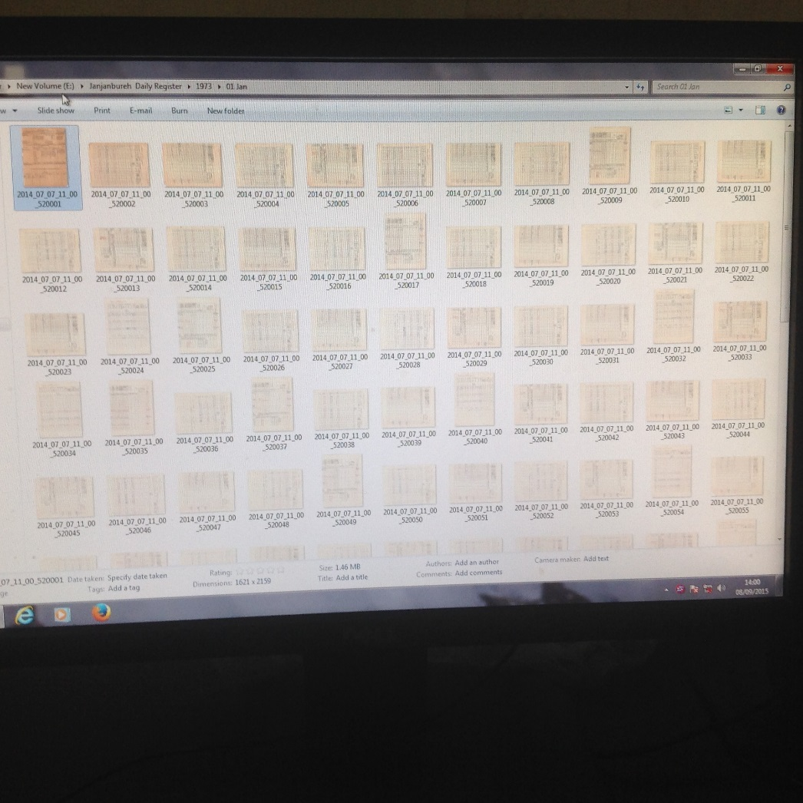

**Figure1: Example of a JPG image of a Register**

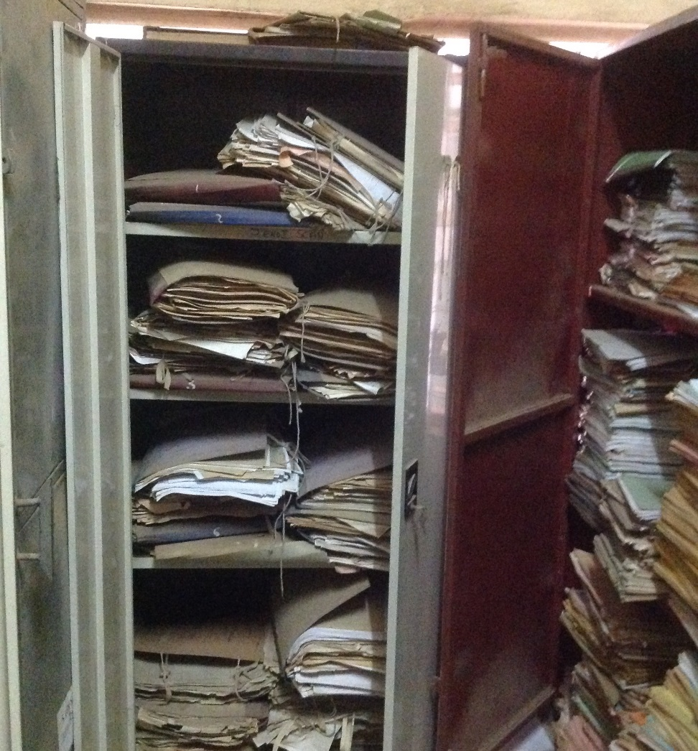

The Archive is not in a good state, but recent records are intact

**Suggested Pilot project with Rescued Data**

***Enhancement of the 10 day Early Warning Bulletin for Food security in the Gambia produced by the National Multidisciplinary working Group, Headed by the Department of Water Resources***

The department of water resources issues the early warning bulletin for food security in The Gambia. It focuses mainly on the dissemination of hydro meteorological information in order to enhance resilience in the agricultural sector

Current Bulletin gives hydro-met situation observed in the last 10 days and a Crop forecast situation pertaining but does not provide forecast / projections of weather related situation for next 10 days that may affect the crop and other livelihoods

A 10 day hydro-met forecast that covers expected precipitation and / or expected rainstorms, dry-spell occurrence and duration will help farmers and other users plan their livelihood activities more effectively and manage potential risks more effectively

The enhancement can also include riverine flood forecasting and salinity advance and retreat predictions necessary in early warnings for potential increases/decrease in irrigated crop areas

**Proposed Improvements to the Bulletin**

Incorporation of a dekadal outlook forecast on essential hydro meteorological variables to enhance planning and resilience. This requires historical and recent data on:

* Rainfall
* Temperatures
* Wind speed and direction
* Humidity
* Sunshine duration
* River Discharge
* Salinity
* Surface Water levels

The number of pages to be scanned for the period 2013-2015 is estimated at 145,548

**Basis for Cost estimates**

* A 4 and A 3 Optical Character Recognition (OCR) scanners
* External backup disk drives of one terra-byte plus
* JPG Software database
* Hardware set-up and Data rescue orientation training
* Scanners can do 60 pages per minute translating into 5 days of an 8 hour working day.
* More time will be spent on sorting and preparing the pages for scanning.

**UGANDA**

The mission in Uganda started with a courtesy call meeting with the UNDP Country Office and was attended by the Country Director and the Environment and Energy Cluster lead under which the Strengthening Early Warning System Project is institutionally housed. During this meeting the SCIEWS Project Manager reiterated the response from the Uganda National Meteorology Authority that Uganda was receiving full support from GiZ for Data Rescue. He further elaborated that GiZ was committed to supporting the initiative to the end, so that they can track their progress and can write a success story out of it without difficulties of attribution if CIRDA was also to support data rescue. It was noted and acknowledged that there would be no need to duplicate efforts and resources if GiZ was providing this support. In this regard the mission would the CIRDAS Data Rescue mission would therefore assess other data rescue needs for UNMA particularly the additional needs/gap to support software for data transfer and management in general and specifically to explore supporting the experts from CLIMSOFT(Nairobi) to build the capacity of UNMA in the use of the new version of CLIMSOFT software and to support UNMA in pilot testing a program that Makerere University ICT Unit has developed on meteorological forecasting. A need to consider hydrological water discharge and water levels data rescue with Ministry of Water Resources was identified as a potential important area for CIRDA support especially for early warning systems related to potential flooding events.

The second meeting was held with the UNMA Director for Applied Meteorology and Data Management to review and confirm the support GiZ was providing on Data Rescue and explore any potential gaps for CIRDA support consideration.

The Director gave an overview of the Climate Data status in the country. He stated that the first 2 weather stations were established in the country in 1896 and the majority of the stations were established in 1921 under the management of the East Africa Community. Given the long period of data records from the stations, the Director indicated that a lot of data was held in the Districts in various formats (hard copies, flop disks, tapes).

On the GiZ Support, the Director indicated that to-date they have stated investing in infrastructure and rehabilitated the data archive, provided computers and established a data entry and digitization lab in the Department and supported collection of data from the districts which has been stored in the archive. He further stated that GiZ had supported digitization of 20 % of all the weather data and that they were committed to digitize all the remaining data in the archive.

He pointed out that the key gap on the data Inventory was the huge volumes of data collected and held by other agencies such as Department of Agriculture and many voluntary institutions country wide which include schools. He indicated that it was necessary to get all these data into the central archive at UNMA and that this was one important area that CIRDA support would be much needed and appreciated. The other potential support areas he identified for CIRDA are:

1. Support the piloting and testing of the meteorology forecasting software developed by Makerere University and to train the UNMA staff on its applications.
2. Support a team of CLIMSOFT experts from Kenya to train the UNMA staff on the application of the new version of CLIMSOFT, including training of new staff on the software
3. Support an expert to integrate the CLIMSOFT and Makerere University generated data sets into one data set in place and using one system
4. Support UNMA with capacities for digitization of weather data at the weather stations country-wide for current data observations

In order to have an informed understanding of the volume of data rescue work in the country, a full inventory of what exists needs to be determined and then support apportioned for various stages of Data rescue to various organizations.

A visit to the rehabilitated archive was made and it was in a very good and impressive state. It has in metal lockable storage cabinets all the historical and up-to-date weather data.

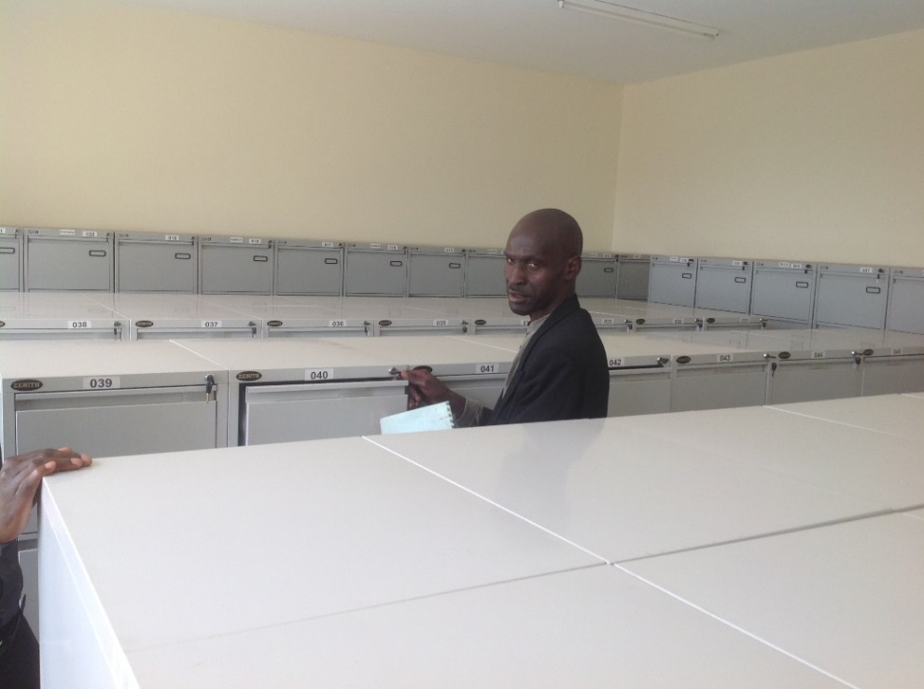

Archive at UNMA Headquarters in Kampala

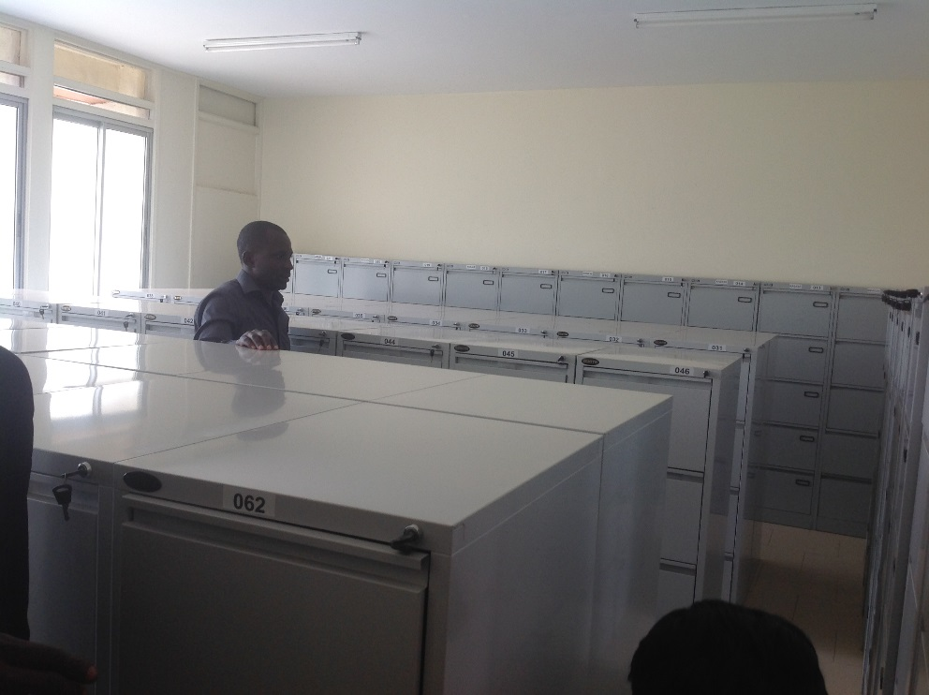

The Agency also has an active data lab where staff are imaging all the historical data using a handheld scanner for smaller data pages and a multiple bigger scanner for larger data pages. These are linked desktop computers and images once scanned are cropped, indexed by name of station, year, and parameter and stored in a saver. The staff are able to image up to 100 pages per day (8 hour working day).

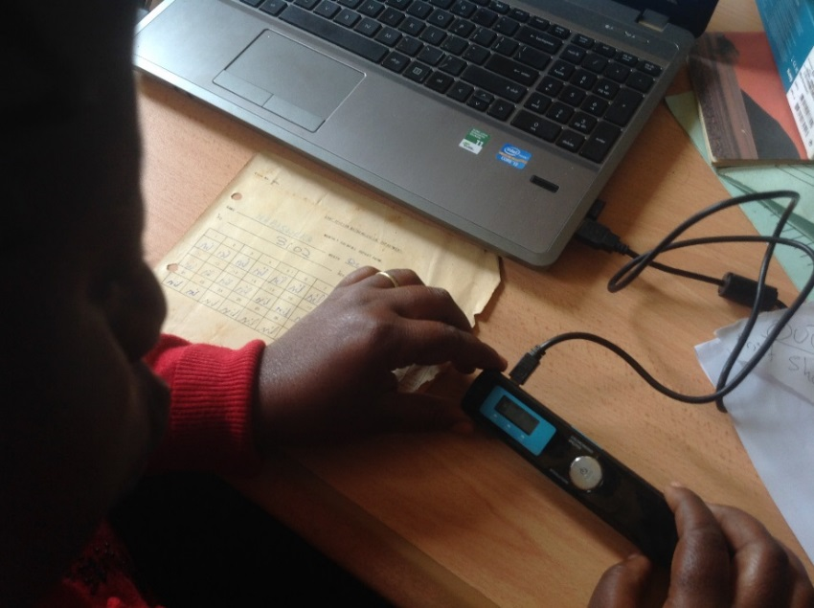

Data Digitization using a Handheld Digitizer at UNMA

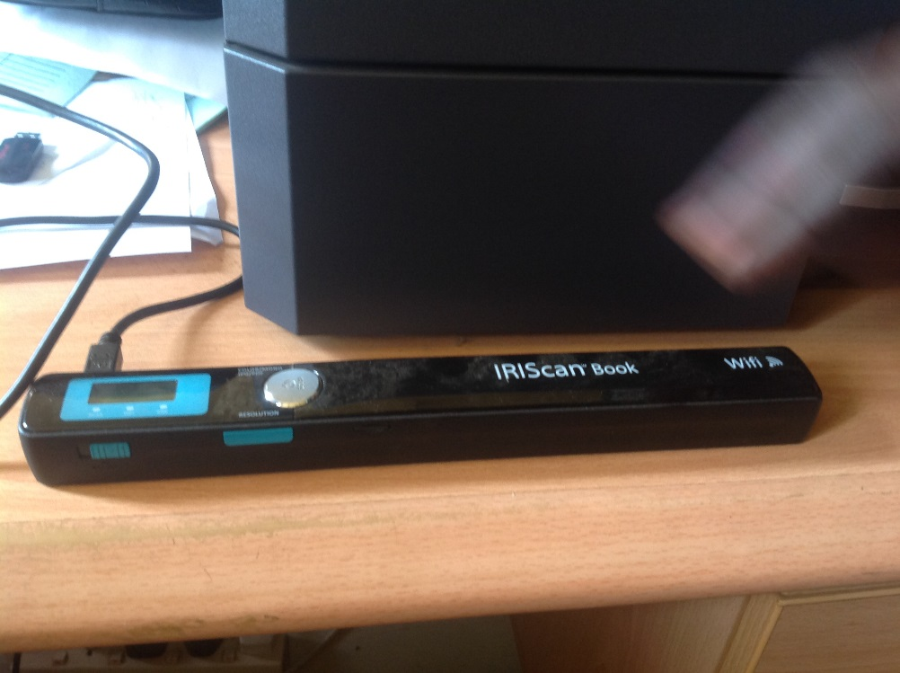

Clearly UNMA are more interested in the overall data rescue need for the country and are not prioritizing any specific data rescue need linked to the SCIEWS project urgent needs.

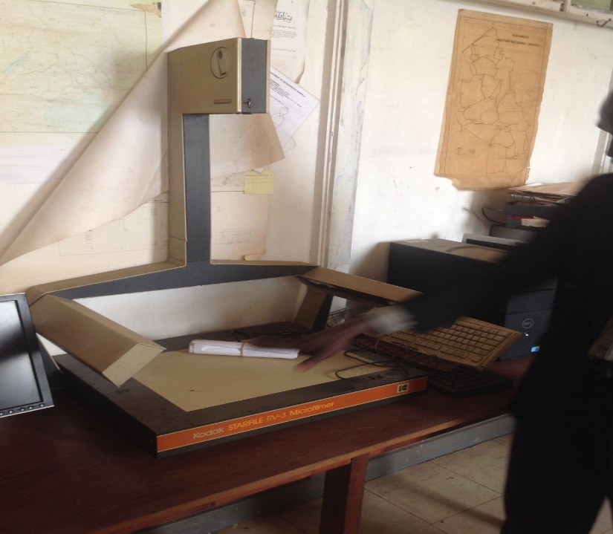

The DARE project Old Digitizer at UNMA

A meeting was held with the Project Manager for the SCIEWS project to find out if the project has any specific data rescue needs that would help the project achieve its objectives in a demonstrated way. It appears no really thought has been put to that and was not at all apparent if data digitization was an urgent need for the scope of the SCIEWS project. He did however, indicate that the project priority / pilot area was involving 28 districts in three regions and that he will have to think through it a little more to be able to identify a specific data rescue need for the project.

A third meeting was held with the Commissioner of the Uganda National Emergency Coordinating and Operations Centre (NECOC) who is responsible the country’s overall emergency early warning system.

The NECOC coordinates over 18 emergency /early warning related institutions in the country. Each of these agencies have a huge volume of historical and recent data sets that are a key input to the Emergency and early warning system. The Commissioner indicated that most of these data held in the different agencies is not yet digitized and face various risks of loss. He further indicated that these data are held in different formats, forms and using different unstandardized data bases. This makes it extremely difficult to access and use it for trend analysis and other energy monitoring applications. He also indicated that NECOC was in the process of developing a National Atlas on disaster risks and hazards that will take into account disaster occurrences, severities and observed intensities over the years. This will require having digitized data sets dating back many years.

The NECOC proposed that a key need and priority for data rescue would be to focus on the eastern region of the country in and around Mt Elgon Area which needs improved flood early warning system. The area is prone to flooding due to high deforested catchment areas and poor water retention soils that lead to frequent flush floods that impact on the subsistence farming systems practised in the area. More often than not, farming activities are adversely affected by flooding and a good early warning system informed by an elaborate set of historical weather and hydro-met data for improved trend analysis would be a good needs based case study. The SCIEWS project should therefore focus on data rescue for river flow levels, river discharges and rainfall for the region and develop a tailor made early warning system. The Commissioner indicated that they would engage with the SCIEWS Project Manager to confirm this data rescue priority need.

The fourth meeting was with the Makerere University Meteorology Unit and the ICT (WIMEA-ICT) department who are piloting a Weather forecasting system for improving Weather Information Management in East Africa for effective service provision through the application of suitable ICTs.  
The team outlined the weather-related challenges faced in the region that include:

* Low agricultural productivity
* Deaths due to weather related diseases
* Delayed delivery times in the construction and energy industry
* Weather-related accidents: on Lake Victoria about 3000 poeple die every year, mudslides and floods lead to loss of lives, property, infrastructure and displacement of people.

This was attributed to the indigenous and outdated methods of weather predictions currently being used in the East African region whose shortcomings for the lack of timely meteorological observations and numerical predictions were itemised as:

* existing manual and automatic weather stations do not function
* data transmission from the weather stations to collection centers is too slow and often unreliable
* prohibitive cost of communication as well as maintenance and purchase of standard weather stations (10,000 - 50,000 USD per station)
* manual data processing due to lack of computers, software and expertise
* available weather information is neither properly packaged nor readily accessible
* insufficient number of meteorologists to operate the NMSs
* lack of continuous professional / career development to cope with emerging trends in weather prediction and analysis
* existing curricula at Makerere University, University of Juba and Dar es Salaam Institute of Technology is not responsive to the current trends in weather info management

The aim of the Makerere University Project is to improve the accuracy of and access to weather information by the communities in the East African region through suitable ICTs for increased productivity (in the agricultural, energy, water resources and construction sectors) and safety (in the aviation, disaster management, fishing, health, mining, and defence sectors). The proposed project has five components.

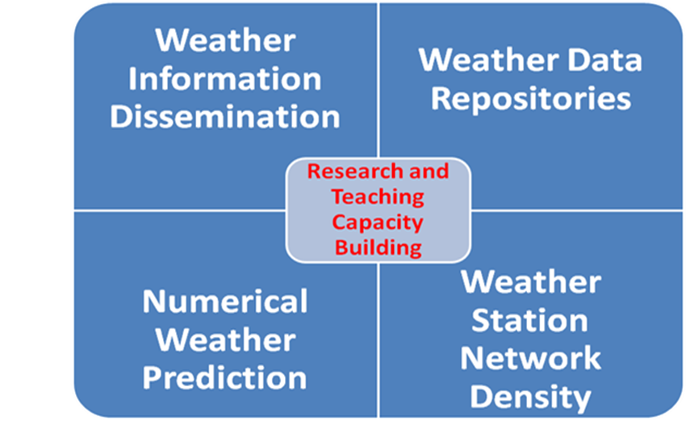

The project activities are:

* Establishing operational Numerical Weather Prediction (NWP) models in the three countries based on WRF
* Improving the density of the weather station network in the region
* Development of a low-cost automatic weather station with data transmission to a central server (max. 2000 USD/unit)
* deployment of 70 units in the 3 countries
* digitizing manual weather records to create reliable data repositories suitable for research purposes
* Improving/automating decentralized weather information dissemination systems for different stakeholder groups
* capacity building by research and teaching:
  + 8 PhD projects
  + 14 MSc scholarships
  + BSc. & MSc curriculum revision
  + Training researchers in media and policy interactions
  + training of technical personal (instrumentation and modelling)
  + Training administrative staff in project management
  + Gender outreaches

The fifth meeting was with the Commissioner of Water Resources Management responsible for monitoring and management of Water Resources under the Department of Water Resources. The Department has a good system of current data observations which are digitized within seven days once received from the gauging stations country wide at the end of each month. This is done for both surface and ground water records. Most of the historical surface water and ground water records have already been digitized. A few data that are on Strip charts have not been digitized up to about 2002 but a plan is in place to digitize these data as well.

A meeting was scheduled to be held on Friday the 7th of August between UNMA, NECOC and the SCIEWS project Manager to determine and confirm the priority data digitization need for Uganda. Unfortunately this meeting did not take place. The SCIEWS Project Manager promised to provide this information by Friday the 14th of August 2015.

**TANZANIA**

The mission in Tanzania started with a meeting with the Tanzania Meteorology Department (TMA). The meeting was attended by the TMA Director- Forecasting / SCIEWS focal point and his senior staff, the TMA Director Research and Applied Meteorology and his senior staff, the SCIEW Project manager, a representative from the Ministry of Water resources and a representative from the Ruvuma Basin Water Board. The representation from both TMA and the Ministry of Water Resources is because the two work together and both are supported by the SCIEW project. Meteorological and hydrological data for the two districts need to be digitized for climate and early warning applications by the SCIEWS project. As such it was agreed that separate assessment of resource needs to digitize hydro-met data will have to be assessed.

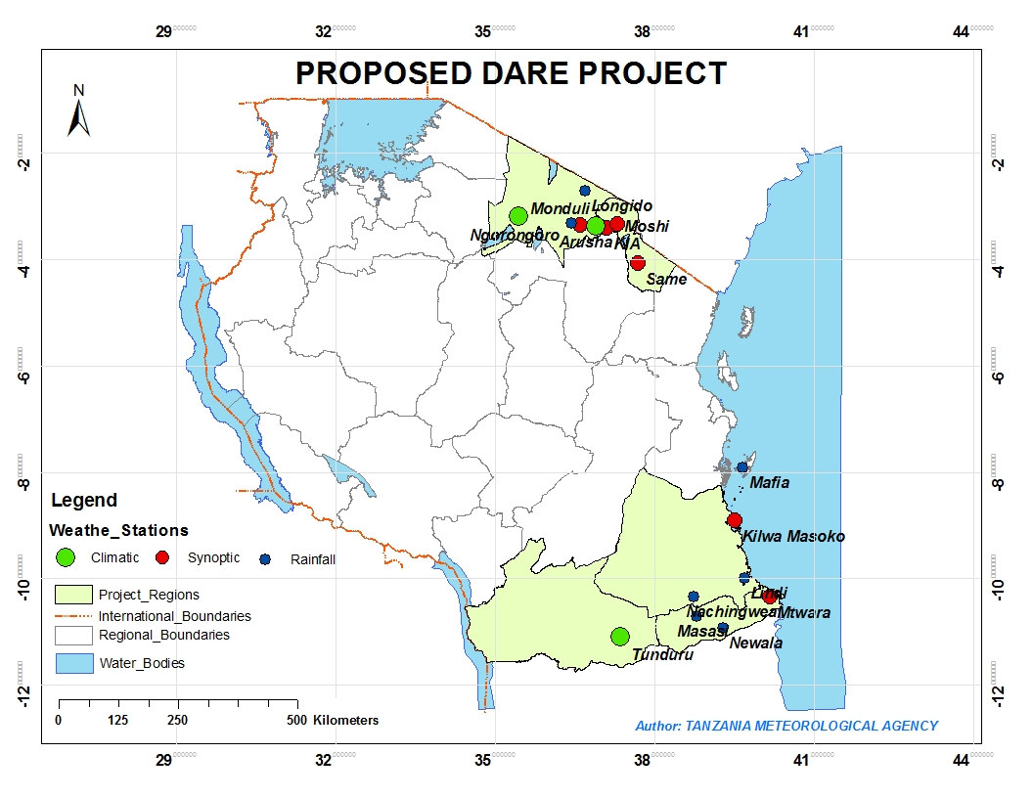

**Proposed Data Rescue Stations**

**Data Rescue Priority Focus for Tanzania**

The exercise of rescuing, digitize and archive historical data will be carried out in the two SCIEWS project pilot districts: Liwale in the southern part of Tanzania and Arumeru in the northern part of Tanzania. The 2 districts are among the most climate change vulnerable in the country and focus areas of the country. The data rescue will focus on 10 Meteorology stations in the 2 districts namely: Arusha, Kilimanjaro, Same, Moshi, Engeru, Monduli, Mtwara, Kilwa Masoko, Mafia and Masasi. The initiative will ensure availability of historical data which will be used by Water basin Boards in collaboration with Tanzania Meteorological Agency to perform various tasks including applications of flood management that include real-time local flood forecasting based on hydrological and precipitation data. The digitized data will also help in development of GIS-based flood risk maps. This will support decision making, better management of hydraulic structures and environmental monitoring.

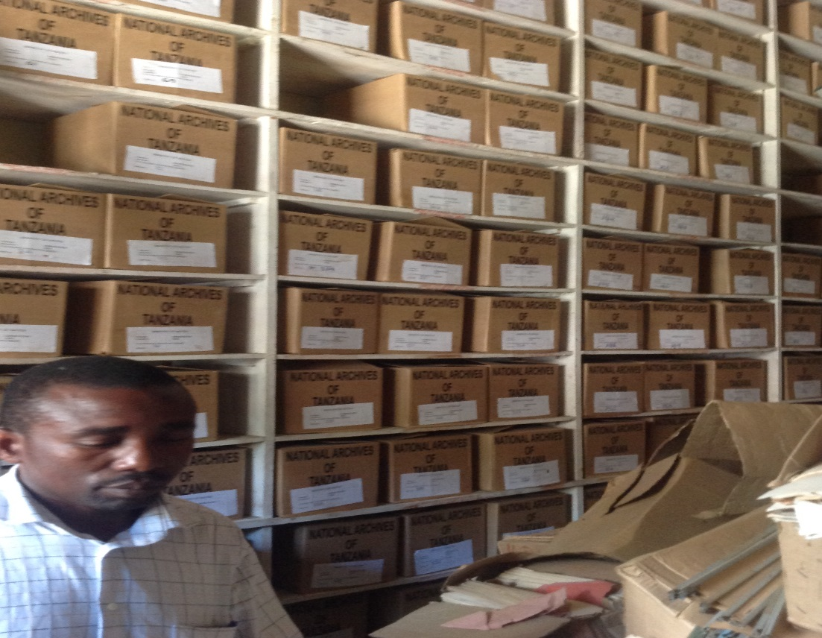

The Data Archive at TMA

The SCIEWS project priority need is to digitize surface observation data for the 2 Districts of Arumeru and Liwale. The 2 districts are among the most climate change vulnerable in the country and focus areas for the SCIEWS project. The data rescue will focus on 10 Meteorology stations in the 2 districts. The station are Arusha, Kilimanjaro, Same, Moshi, Engeru, Monduli, Mtwara, Kilwa Masoko, Mafia and Masasi as shown on the map below.

Five parameters namely daily Rainfall, Maximum and Minimum Temperatures, Dry and Wet Bulb Temperatures will be rescued and digitized. Some of these parameters in the 10 stations have already been digitized, thus this effort will focus on digitizing the data not yet digitized to fill the digitised data gaps. Preliminary gap analysis work has already been done by the Tanzania Meteorology Agency this week and provided in the tables below:

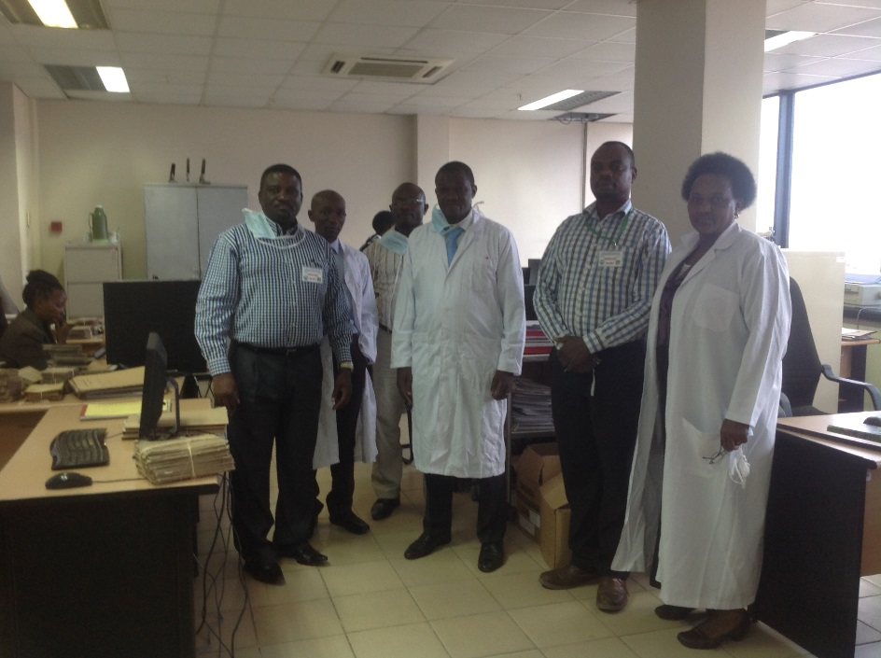

Data Processing Lab at TMA

**NUMBER OF PAGES TO BE DIGITIZED FOR RAINFALL (10 METEOROLOGICAL STATIONS)**



**NUMBER OF PAGES TO BE DIGITIZED FOR MAX AND MIN TEMPERATURES**

**(10 METEOROLOGICAL STATIONS)**



**NUMBER OF PAGES TO BE DIGITIZED FOR DRY AND WET TEMPERATURES**

**(10 METEOROLOGICAL STATIONS)**



**Total pages for 5 parameters = 3756**

A separate meeting was held at the Ministry of Water Affairs to determine the data volumes to be digitized. The focus will be to digitize three parameters in the Arumeru and Liwale Districts and surrounding catchment areas. The proposed 3 parameters are daily rainfall, river discharge, and water levels.

The number of pages of data records to be digitized in the Pangani and Ruvuma Basins is provided below. A further assessment of hydrological data records that need to be digitized in the project priority districts of Arumeru and Liwale have also been determined below:

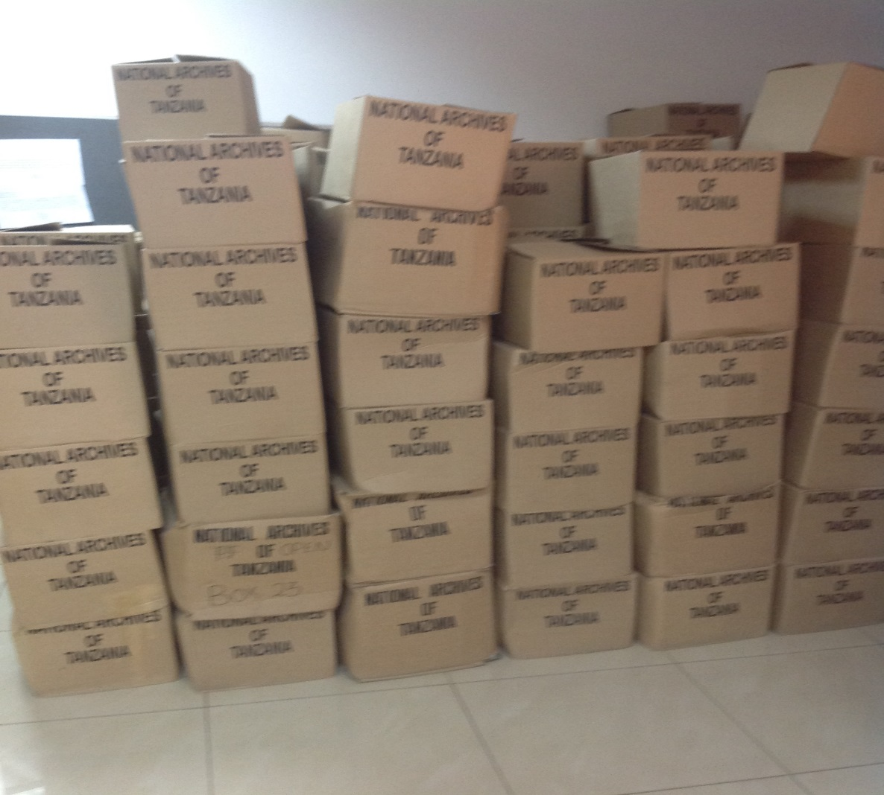

Temporal Archive at Ministry of Water

**PANGANI BASIN WATER BOARD**

**EARLY WARNING SYSTEM PROJECT-FACILITATED UNDER PMO-DMD/UNDP**

**Data rescue and digitization in Arumeru District and nearby stations**

|  |  |  |
| --- | --- | --- |
| **S/No:** | **Parameter in all Stations** | **Total Number of Pages Not Digitized in all Stations** |
| 1. | Water Level | **3060** |
| 2. | Discharge | **517** |
| 3. | Rainfall | **6738** |
|  | **Total for Number of pages to be digitized in all stations** | **10315** |

**RUVUMA AND SOUTHERN COAST BASIN WATER BOARD**

***Data to be digitized for hydrometric stations***

|  |  |  |
| --- | --- | --- |
| **S/No:** | **Parameter in all Stations** | **Total Number of Pages to be Digitized in all Stations** |
|  | Water Level | **8,818** |
|  | Discharge | **350** |
|  | Rainfall | **4,581** |
|  | Rainfall +Dry &wet, max &min temperature | **361** |
|  | **Total for Number of pages to be digitized** | **14,110** |
| **Water Boards Data Volumes** | | |
|  | **Pangani** | **10315** |
|  | **Ruvuma** | **14,110** |
|  | **Grand Total for Number of pages to be digitized for Pangani and Ruvuma Basins** | **24425** |

|  |
| --- |
| **DATA DIGITIZATION FOR ARUMERU AND LIWALE DISTRICTS** |

The Ministry of Water have not indicated the number of items in the table above and once that is got a full equipment and labour Cost estimate will be made for Hydrological Data digitization.

**ZAMBIA**

**Early Warning Systems Priority Data Rescue Project**

**Priority Issue**

Zambia is interested in rescuing surface observations for 3 specific locations on approximately 15,330 pages of their total of 167,000 pages. The data is at an hourly time resolution and one page is equivalent to one month of observations. Digitizing the data from the three stations will take approximately 2 years.

The equipment requirements are: Computers and screens, external hard drives, cameras, and camera stands. The CIEWS project priority need is to digitize surface observation data for the 3 Districts (Sesheke, Chipepo, and Mambwe) in which they are focusing on as pilot areas.

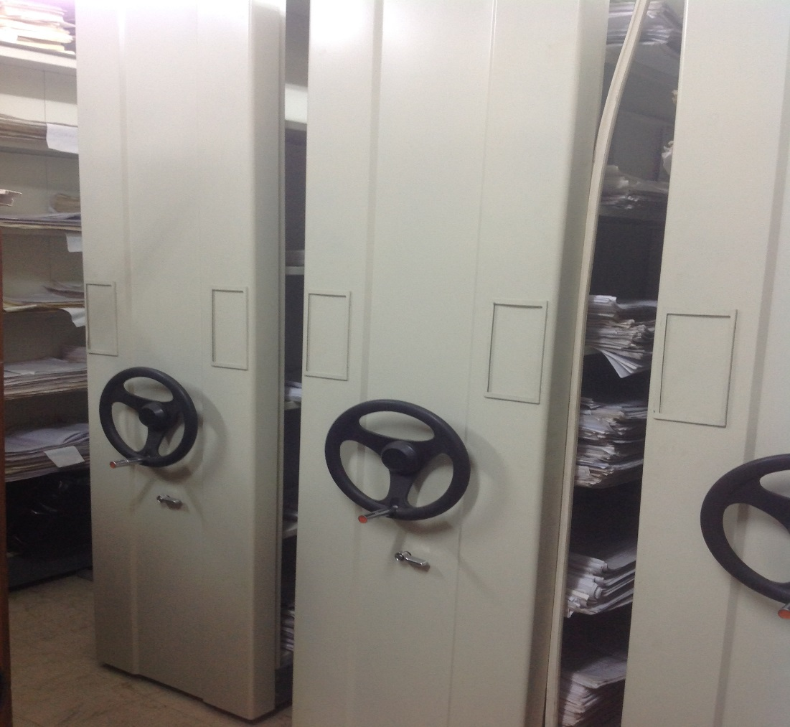

The Data Archive at ZMD, Zambia

**BENEFITS OF PRIORITY ISSUE**: aid to early warning through improved data availability over a longer time series which is necessary for better analysis for provision of improved climate products/services, forecasts and other user requirements for improved planning and early warning of potential climate events or hazards.

**Background understanding**

Most of the rainfall data from 1935 is already digitized

Rainfall data for about 20 stations prior to 1935 is yet to be digitized including Sesheke – thus a total of 30 pages of Rainfall data will need to be imaged and digitized

Most of the surface observation data for the 39 ZMD stations are not imaged and a big proportion not digitized

**Focus: 3 Stations (one existing per district)**

30 pages of Rainfall data for Sesheke

120 pages x 5 parameters (temperature, humidity, evaporation, Wind speed and direction) in the 3 stations = about 15300 pages + 30 Pages of rainfall, this is basing the estimate on the assumption that the three stations have been operational since 1935. However the actual dates of establishment of the stations is as follows: Chipepo – 1993, Mfuwe - 1979, and Sesheke – 1950.

Below is an estimate of the time required to image and digitize the surface observations and rainfall discussed yesterday. The rainfall, 750 pages, accounts for periods prior to 1935 as later data is already digitized. And the surface daily observations account for about 167,000 pages.

Assuming a 15 minute digitization time per page for the rainfall, estimates suggest a total of 188 labour hours and would require 2-3 months (counting for holidays and weekends) for one person to accomplish the digitization assuming working between 3-6 hours a day. Prior to the digitization, imaging would only take about 1 week. Therefore, total labour time, not including set up, and training should require no more than 13 weeks.

**Imaging**

Imaging 15330 pages will take a maximum of 1 week and is to be done by ZMD staff

**Digitising**

45 Minutes digitization time for a 900 character page = 449 days to digitize

5 People working 5 hours a day will take about 2 years to digitize the 15330 pages

10 People will take 1 year.

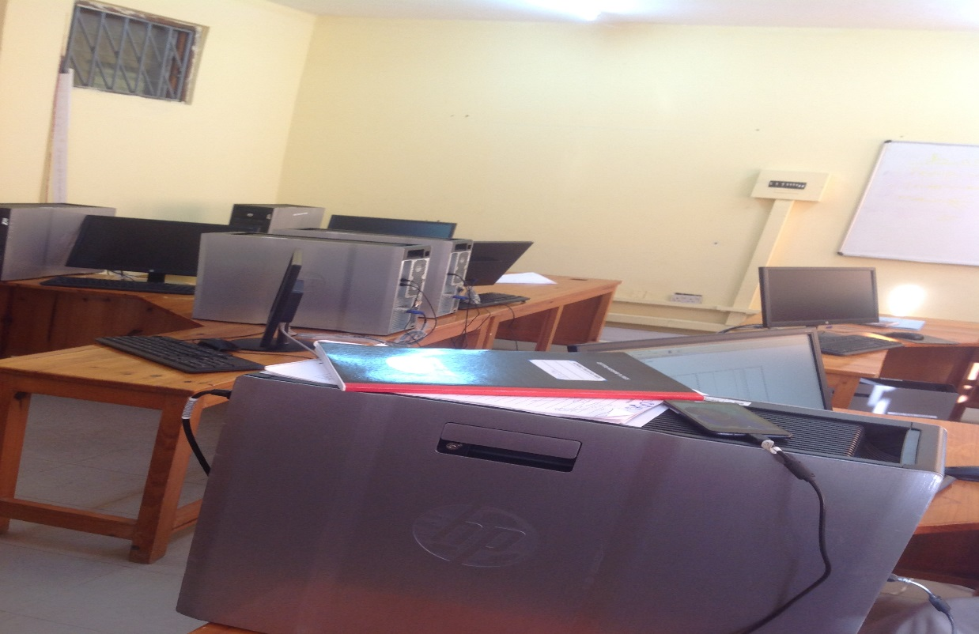

**Data Lab at ZMD**

**National Priority – Imaging of all Surface Data**

39 ZMD Stations

806 800 pages of 6 parameters (rainfall, temperature, humidity, evaporation, Wind speed and direction)

Approximately 4 months to image and much longer for digitization. This has not been determined as it clearly require more time and labour costs beyond the scope of the CIRDA data rescue initiative.

**Labour Costs for Digitization**

Recruitment of 10 part-time staff for data digitization @ about USD400 per month

**Equipment needs**

5 computers

5 x 1-2 terabytes External hard drives

15 screens/monitors

5 Cameras and stands

Software

Surge protectors for the computers and servers for the digitized data

Hardware set-up and Data rescue orientation training

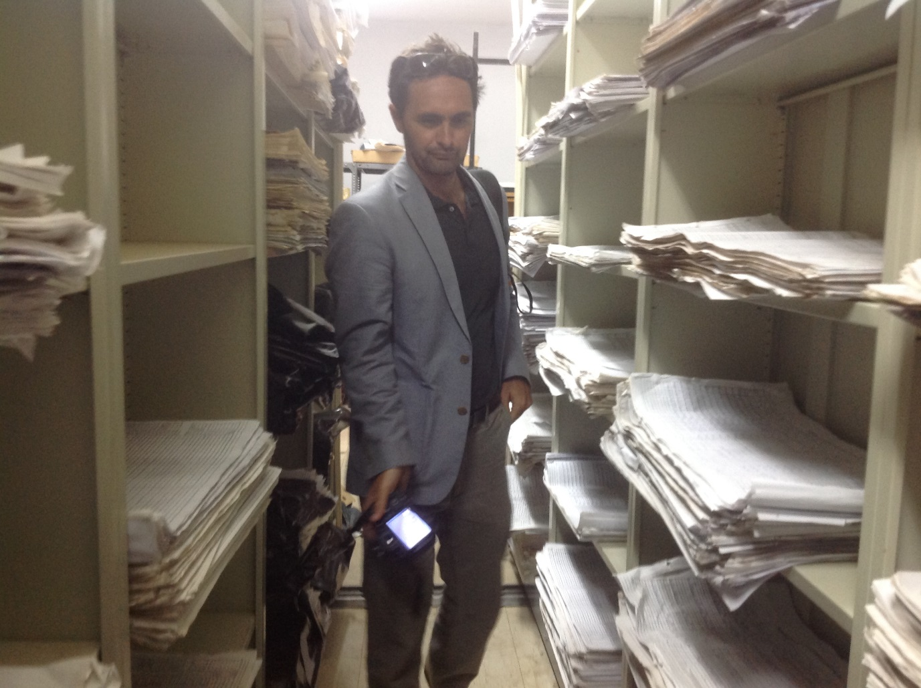

**Walking through the ZMD Archive**

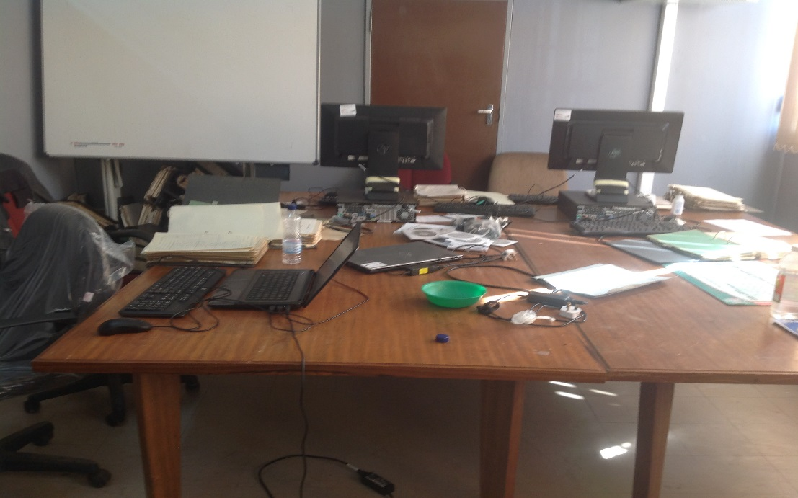

**Rainfall Data Digitization Lab at ZMD**

**MALAWI**

Malawi has proposed a priority to support a user defined need that is totally lacking in current monitoring and forecasting. They have proposed to digitize the wind speed and direction data from each of the six stations along Lake Malawi. This would help them meet the data requests from clients and monitoring and forecasting services over the lake where winds are known to exceed 40kts causing waves over 2m high and accidents involving fishers are very prevalent. Drownings occur during high wind events and conditions become very hazardous for small canoe travel. Also, there has been demand from various sectors to provide weather and climate information along the lake. Therefore, the interest to digitize daily wind speed and direction data is driven by a user requested specific application that is currently missing from the DCCM services. This followed discussions to ascertain that the data rescue work being undertaken by the Shire River Management Project would not overlapping or duplicate efforts.

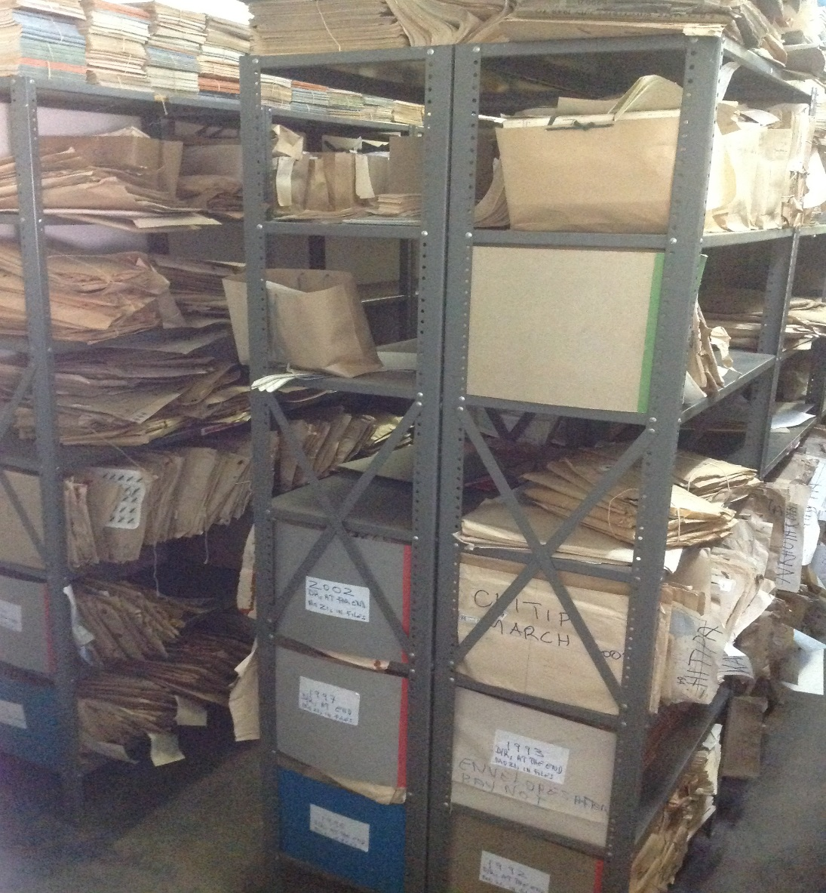

The Archive at NCCMS

The priority need translates into a compact and useful project achievable in a short time frame that a tremendous potential to showcase a user-targeted need for data rescue that produces deliverable quality data in a short time period with a very well elaborated application intention or plan for use.

**BENEFITS OF PRIORITY ISSUE**: aid to early warning through forecasts and monitoring that support awareness of high waves, high wind, drownings, risk to fishers

This would involve the scanning and entry of about 5,000 pages, which could be done in about one and half years.

**Labour cost estimates**

Two scenarios were presented and discussed as follows:

**Scenario 1:** ASSUME a working team of 20 people dedicating 2 weeks in a conference arrangement

A preliminary evaluation of the data quality suggests that the majority if not all of the pages are in excellent condition and values can be clearly distinguished by the user. It is estimated that after all computational installation and training is complete, digitization would take approximately 10 minutes per page. Using one station, Karonga from 1940-present, we estimate that there are 900 pages in the station record. At 10 minutes per page, it would take 9,000 minutes or 150 hours to digitize the entire record. If this time commitment was distributed between 20 people, then it would take approximately 8 hours per person to complete the entire digitization for the Karonga station.

Realistically, it would take 2 full days at most to complete the station digitization. Since Karonga has the longest period of record, then we can safely assume that it would take no more than 2 days to digitize each of the other stations as well. Therefore, in 3 workweeks (12 working days) the complete 6 station record could be digitized. To this should be added time for QC, which would require a designated supervisor to provide support during the digitization phase. However, real QC can occur once the digital data is ingested into either the climsoft or CDT software.

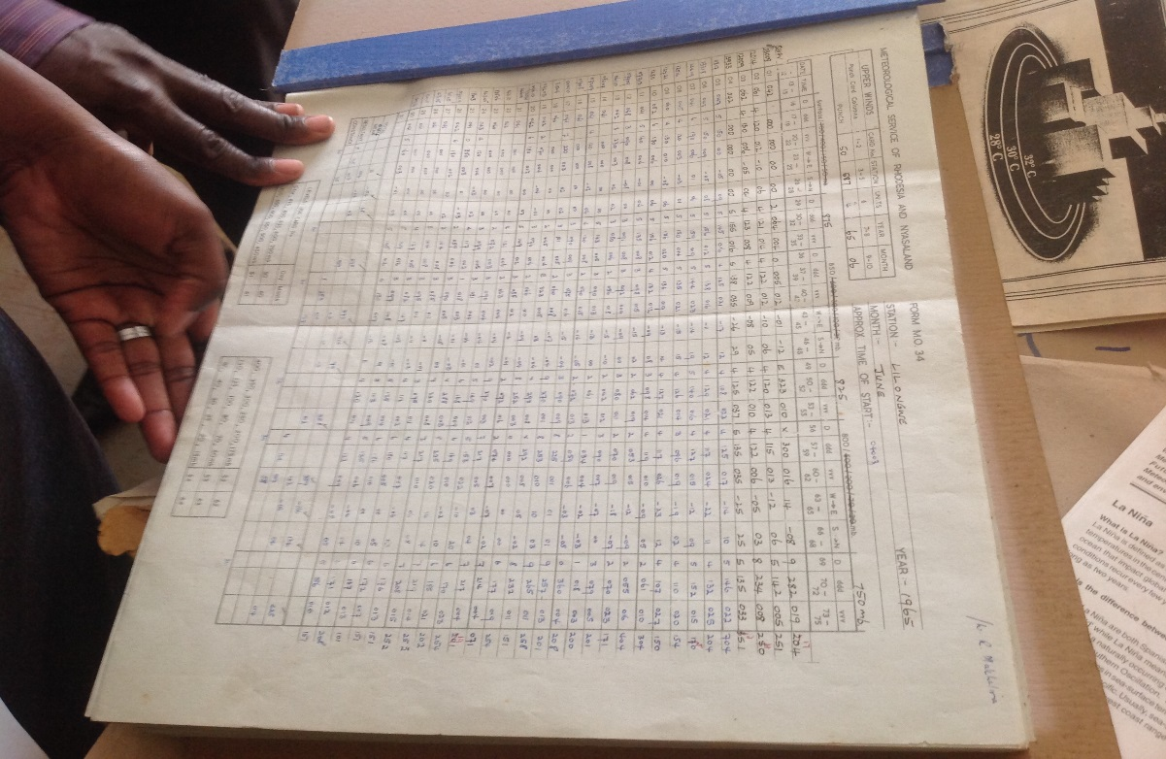

An Hourly Data Form at NCCMS

**Summary:**

* A working team of 20 people in a remote conference working location would cost about MK17 million for Full Board and MK2 million for conference room. This will give a total cost of MK 19 Million or USD 42, 000 for a two week period.
* Time frame: About 6-8 months project time

**Scenario 2:** ASSUME a 6 member team working locally at DCCMS

Assuming a working team of 6 people working at the DCCMS location and applying the same estimates and calculations from above, it would take approximately 2 months to accomplish the same work that 20 people could do in 12 days. The difference in time involves the disruptions that would inevitably occur from working at DCCMS versus a remote location.

Summary:

* DCCMS members working at the local office would not involve any labour cost
* Timeframe: About 12-8 months for full operational data to be available

Scenarios 1 is recommended to ensure that the data digitization is undertaken in time for applications to be made during the SCIEWS timeframe. To expect the DCCMS staff to do the extra work in addition to their daily responsibilities is a very risk and unlikely to be achieved.

**Equipment needs**

* 5 Computers with 2 screens
* External Hard-drive – 2 Terra bites
* 5 Cameras
* 3 desks and chairs

Recalculation using 15 seconds for imaging per page and 45 minutes for digitization:

Inventories for 9000 pages

1 day by 6 staff working for 5 hours at DCCMS

**Imaging**

Assuming 15 seconds for imaging per page

1. 15 secs x 9000 = 135000 secs
2. 135000 / 60 = 2250 Minutes
3. 2250 minutes / 60 = 37.5 hours
4. 37.5 hours / 5 working hours = 7.5 days
5. Labour calculation = 0

**Digitization**

Assuming 45 minutes digitization time per page

a) 45 minutes x 9000 = 405000 minutes

b) 405000minutes / 60 = 2817 Hours

d) 6750 Hours / 24 = 282 days

e) 282 days / 20 staff working at a remote location = 14 days per staff / about 2 weeks

**Full Board Accommodation for 2 weeks** = USD 42000

**National Need to digitize data from the rest of the 17 DCCMS station**

Despite the desire to implement this project focusing on wind data along the lake, there is also a demand to digitize wind data from all 23 stations. While this is needed, digitizing the additional 17 stations would far exceed the timeline of the CIRDA UNDP project; which lasts until 2017. A quick estimate suggests that there are approximately 150,000 pages of daily data for all 6 lake stations. Some station records extend to 1940 while others begin in 1979. Including all 23 stations would push the total to well over a half a million pages, which is impossible to complete by 2017 let alone the associated cost.

|  |  |  |  |  |  |
| --- | --- | --- | --- | --- | --- |
| **Country** | **Parameter** | **Estimated number of paper data pages to be digitised** | | | |
| Zambia | Rainfall | 600 000 | | | |
| Temperature | 39 780 | | | |
| Wind | 39 780 | | | |
| Humidity | 39 780 | | | |
| Evaporation | 39 780 | | | |
| Upper air | 7 680 | | | |
| Total Number of Pages | 759120 | | | |
|  |  |  |  |  |  |
| Uganda | Rainfall | 946 176 000 | | | |
| Temperature | 10 457 600 | | | |
| Wind | 1 432 992 | | | |
| Humidity | 8 307 600 | | | |
| Evaporation | 14 220 | | | |
| Upper air | 7 250 | | | |
| Total Number of pages | 956,655,070 | | | |
|  | |  | | | |
| Malawi |  |  |  |  |  |
|  |  |  |  |  |  |
|  |  |  |  |  |  |
|  |  |  |  |  |  |
|  |  |  |  |  |  |
| Tanzania | Rainfall | 1200000 | | | |
| Temperature | 86400 | | | |
| Wind | 26400 | | | |
| Humidity | 26400 | | | |
| Evaporation | 26400 | | | |
| Upper air | 8400 | | | |
|  | Total Number of pages | 1,374,600 | | | |
|  | |  | | | |